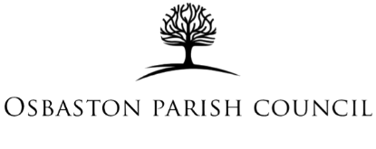

Date 3rd March 2026
Title: Youth Sports Programme – Proposal and Next Steps
Background
Osbaston Parish Council ringfenced funding for a 12-week youth sports programme to address anti-social behaviour and provide structured activities for young people in Barlestone and Osbaston. The programme was intended to be delivered during Easter 2026 by Molly’s Gift.

Current Position
Securing a venue has been challenging. Barlestone Community Centre and St Giles Football Club are unable to accommodate the programme. Barlestone Primary School has confirmed it can host the sessions; however, no dates have been agreed.
Of greater concern is the provider’s level of engagement. The Clerk has repeatedly had to chase Molly’s Gift to confirm their availability and to liaise directly with the school to agree mutually suitable dates so the programme can be promoted in advance of Easter 2026.
Despite providing all relevant contact details and information, the Clerk has had to follow up on more than eight occasions. Communication and ongoing dialogue has been difficult, and the most recent response stated only that they had “responded” to the school but had not yet received a reply. As a result, there are still no confirmed arrangements or delivery timetable despite several pushes for updates.
The coordination of this project is currently being led by the Parish Clerk rather than the provider, who should reasonably be taking the lead. This lack of proactive management raises concerns about reliability and the risk of further delay, potentially pushing delivery back to Summer 2026.

Council Consideration
Council is asked to consider:
- Setting a clear and immediate deadline for the provider to confirm agreed dates and arrangements.
- Withdrawing from the current arrangement and seeking an alternative provider if satisfactory progress is not made within a specified timeframe.

