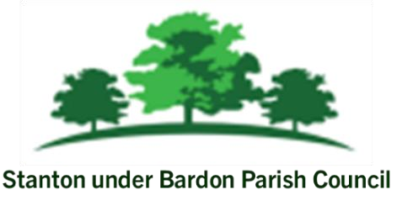

All Members of Stanton under Bardon Parish Council are hereby summoned to attend the Annual Parish Council Meeting on **Wednesday 3rd July 2024** starting at **7:00pm** at Stanton under Bardon Village Hall, 2 St John Cole Crescent, Stanton under Bardon, LE67 9AE for the purpose of transacting the business shown below:

**PUBLIC PARTICIPATION**

Members of the public may make representations, give evidence, or answer questions in respect of any matters included on the agenda

Updates from Borough Councillors Clare Harris and Chris Lambert

Updates from County Councillor Peter Bedford

**AGENDA**

1. **APOLOGIES** 
   1. To receive apologies for absence and to consider whether to approve the reasons given

1. **DECLARATIONS OF INTEREST PECUNIARY AND NON-PECUNIARY** 
   1. To receive declarations of pecuniary and non-pecuniary interests and requests for dispensations in respect of items on the agenda

1. **PREVIOUS MINUTES** 
   1. To consider the adoption of the draft minutes from the Parish Council Meeting held on 5th June 2024
2. **NEIGHBOURHOOD PLAN**
   1. To note an update on the Neighbourhood Plan
   2. To consider how Stanton under Bardon can support the Neighbourhood Plan group with progressing the Neighbourhood Plan
3. **COUNCIL FINANCE**
   1. To approve the Council’s revised budget for financial year 2024-25
   2. To approve the list of payments scheduled for July 2024
   3. To review and approve the financial statement for June 2024
   4. To review and approve bank statements and bank reconciliations for June 2024
4. **CLERKS REPORT**
   1. To receive updates from the Clerk relevant to the Parish Council activities
5. **ALLOTMENTS**
   1. To consider the draft bee keeping policy for allotment tenants requesting to have bees on allotment plots in Stanton under Bardon
   2. To consider a request from an allotment tenant to replace a greenhouse with a polytunnel on an allotment plot at St John Cole Crescent allotments.
6. **COMMUNITY PROJECTS**
   1. To discuss options for installing a flagpole outside Stanton under Bardon Village Hall
   2. To discuss options for the future management of car parking spaces on St John Cole Crescent
   3. To consider authorising the closure of Stanton under Bardon Village Hall Trust
7. **PLANNING**
8. To consider whether to submit formal responses to the following applications
   * 1. **4/10069/PREMAJ** - Reserved matters application for 50 Dwellings with associated

landscaping and access / Land South Of 295 Main Street Stanton Under Bardon Leicestershire

* + 1. To consider any other planning applications submitted following the publication of the agenda

1. **PROPOSAL OF CLOSED SESSION**
   1. In accordance with the Public Bodies (Admission to Meetings) Act 1960 section 1 paragraph 2, to consider excluding the public and press for the following items for the reason that matters appertain to staff employment that are of a confidential nature.
      1. To consider applications to the caretaker position at Stanton under Bardon Village Hall

Signed: 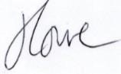 Dated: 27th June 2024

Stanton under Bardon Parish Clerk, Stanton under Bardon Village Hall, 2 St John Cole Crescent, Stanton under

Bardon, LE67 9AE