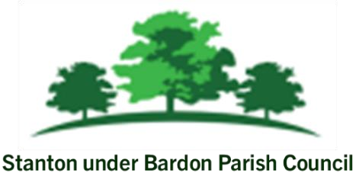
All Members of Stanton under Bardon Parish Council are hereby summoned to attend the Extraordinary Parish Council Meeting on Thursday 25 June 2026 starting at 7:00pm at Stanton under Bardon Village Hall, 2 St John Cole Crescent, Stanton under Bardon, LE67 9AE for the purpose of transacting the business shown below:

AGENDA
- PUBLIC PARTICIPATION
Members of the public are welcomed to the meeting to make representations or ask questions in respect of any matters included on this agenda

- APOLOGIES
To RECEIVE apologies for absence and to consider whether to approve the reasons given

- DECLARATIONS OF INTEREST PECUNIARY AND NON-PECUNIARY
To RECEIVE declarations of pecuniary and non-pecuniary interests and to note or consider requests for dispensations in respect of items on the agenda
- TEMPORARY CLERK AND RFO
TO CONSIDER the appointment of Mrs Mary Briggs as Temporary Clerk and RFO. This appointment to last until the appointment of a Locum Clerk or Permanent Clerk, whichever is the soonest. FURTHER to give Mrs Briggs access to all areas of the Parish Council whilst in post
- PREVIOUS MINUTES
To CONSIDER the adoption of the draft minutes from the Extraordinary Parish Council Meeting held on 3 June 2026

- AUDIT 2025-26
  - To receive and approve the End of Year Bank Reconciliation for Financial Year 2025-26
  - To approve and accept the Internal Auditor’s Report for Financial Year 2025-26
c. To approve the Annual Governance Statement for Financial Year 2025-26
d. To approve the Accounting Statement for Financial Year 2025-26
e. To approve the Explanation of Variances for Financial Year 2025-26
f. To approve the Breakdown of Reserves held Financial Year 2025-26
g. To note the appointment of date for the examination of electors’ rights

- Neighbourhood Plan – To CONSIDER the report of the Examining Inspector.
- Date of Next Meeting

Signed: N. Barrett Dated: 19 June 2026

