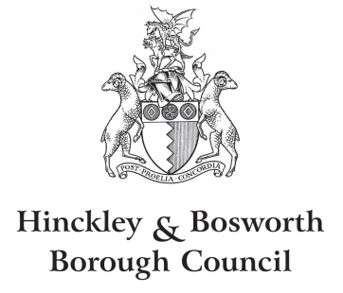

Bagworth Thornton Stanton Under Bardon Neighbourhood Plan Review

Decision Statement – X June 2026

Regulation 18 of The Neighbourhood Planning (General) Regulations 2012 (as amended)

Summary
Following an independent examination on the review of Bagworth Thornton and Stanton Under Bardon Neighbourhood Plan, the council have considered all of the information available and this Decision Statement outlines the Local Planning Authority’s (LPA) decision to “make” the Bagworth Thornton and Stanton Under Bardon Neighbourhood Plan.
The neighbourhood plan will be subject to a referendum.
This Decision Statement will be made available on the Borough Council’s website and for in-person inspection at the Council offices by pre-appointment only.

Background
In June 2017, Hinckley and Bosworth Borough Council formally designated the Bagworth Thornton and Stanton Under Bardon neighbourhood area for the purpose of producing a neighbourhood development plan. The neighbourhood area encompasses both Bagworth and Thornton Parish, and Stanton Under Bardon Parish. Bagworth & Thornton Parish Council are the Qualifying Body for the Neighbourhood Plan.
The neighbourhood plan was subject to a Regulation 14 consultation between 15 March 2021 to 4 May 2021, and a Regulation 16 submission consultation between 12pm Friday 14 March 2025 to 12pm Tuesday 29 April 2025.
The Borough Council, with the agreement of Bagworth and Thornton Parish Council, as the Qualifying Body, appointed an independent Examiner, Mr Timothy Jones to examine whether the Neighbourhood Plan met the relevant legislative and regulatory requirements, including the Basic Conditions.
There was a further consultation held during examination on a limited remit, between 12 noon on Wednesday 7 January 2026 and 12 noon on Wednesday 4 February 2026. The final examiners report was issued on 4 June 2026. The examination concluded the plan could proceed to referendum following modification.
The Examiner’s Report recommends modifications to policies and modifications to the supporting content in the Plan, including corrections, to provide clarity in order to ensure that the Basic Conditions are met. However, overall the Examiner’s Report (June 2026) concludes by stating:
“I commend the Draft NDP for the effort that has gone into its creation.
I recommend that the Draft NDP be modified in the terms specified in Appendix A to this report to meet basic conditions and to correct errors. I am satisfied with all parts of the Draft NDP to which I am not recommending modifications.
With those modifications, the Draft NDP will meet all the basic conditions and human rights obligations.
I recommend that the modified NDP proceed to a referendum, the referendum area being the area of the Draft NDP, i.e. the parishes of Bagworth and Thornton and Stanton-under-Bardon.”

Decision
The Neighbourhood Planning (General) Regulations 2012, Regulation 18 requires the local planning authority to outline what action to take in response to the recommendations of an examiner made in a report under paragraph 10 of Schedule 4a to the Town and Country Planning Act 1990 (as applied by Section 38A of the Planning and Compulsory Purchase Act 2004).
Having considered the recommendations made in the examiner’s report, and the reasons for them, Hinckley and Bosworth Borough Council has agreed to accept the modifications made to the draft plan under paragraph 12(6) of Schedule 4B to the Town and Country Planning Act 1990 in response to the Examiner’s recommendations/ modifications. Details of the modifications and the Council’s decision on each of the modifications can be found attached to this statement at appendix 1.
As per the decision by the Examiner, the Bagworth Thornton and Stanton Under Bardon Neighbourhood Plan can proceed to referendum.
This notice will be passed to the Elections Team at Hinckley & Bosworth Borough Council for them to arrange and administer the referendum process.

