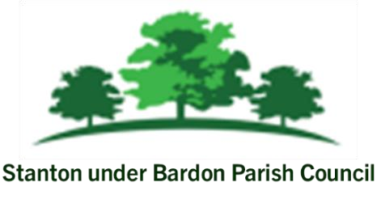

All Members of Stanton under Bardon Parish Council are hereby summoned to attend the Parish Council Meeting on Wednesday 11th June 2025 starting at 7:00pm at Stanton under Bardon Village Hall, 2 St John Cole Crescent, Stanton under Bardon, LE67 9AE for the purpose of transacting the business shown below:

PUBLIC PARTICIPATION
- Members of the public are welcomed to the meeting to make representations or ask questions in respect of any matters included on this agenda
AGENDA

- APOLOGIES
  - To RECEIVE apologies for absence and to consider whether to approve the reasons given

- DECLARATIONS OF INTEREST PECUNIARY AND NON-PECUNIARY
  - To RECEIVE declarations of pecuniary and non-pecuniary interests and to note or consider requests for dispensations in respect of items on the agenda

- PREVIOUS MINUTES
  - To CONSIDER the adoption of the draft minutes from the Parish Council Meeting held on 7th May 2025

- RESIDENT REQUESTS
  - To CONSIDER a request from a resident regarding overgrown land to the rear of their property and the allotments on St John Cole Cresent
  - To CONSIDER a request from a resident to temporarily obstruct Access Road off Main Street for property maintenance

- COMMUNITY PROJECTS
  - To CONSIDER the purchase of a public computer available for residents to use at Stanton under Bardon Village Hall
  - To CONSIDER quotations for the supply and installation of Emergency Assembly Point sign and post for Stanton under Bardon Village Hall
  - To CONSIDER the purchase of cashless payment card reader at Stanton under Bardon Village Hall

- CLERKS REPORT
  - To RECEIVE updates from the Clerk relevant to the Parish Council activities during May 2025

- COUNCIL FINANCE
  - To REVIEW and APPROVE the monthly financial report for May 25
  - To REVIEW and APPROVE bank statements and bank reconciliations for May 2025
  - To REVIEW and APPROVE the budget monitoring report at the end of Q1
  - To REVIEW and APPROVE the list of payments scheduled for June 2025
  - To NOTE and APPROVE amendments to CCLA’s mandate for the Public Sector Development Fund
  - To CONSIDER closing the Council’s HSBC Community account

- PLANNING
- To CONSIDER any planning applications submitted following the publication of the agenda

Signed: 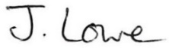 Dated: 6th June 2025

Stanton under Bardon Parish Clerk, Village Hall, 2 St John Cole Crescent, Stanton under Bardon, LE67 9AE

