Caddick are proposing a sustainable new employment hub adjacent to Junction 22 of the M1, which will create a wide range of new jobs and boost the local economy. To better understand local priorities, we have launched a consultation to share our initial plans and gather your feedback.
The site provides an exciting opportunity to deliver high-quality and sustainable employment hub set in an extensive network of green space, meeting industry demand, and creating over 1,000 new jobs to benefit local people and the wider Leicestershire area. The site benefits from easy access to the A50, M1 and wider strategic road network and has been identified in the emerging Hinckley and Bosworth 2020 – 2041 Local Plan to meet an established need for new employment space in the region.
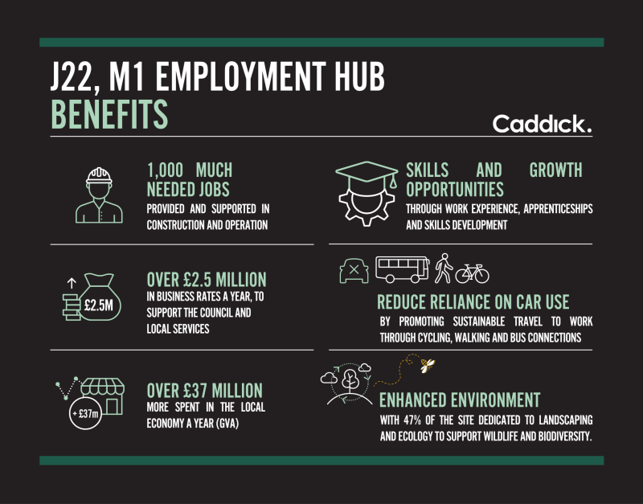
About Caddick
The Caddick Group, which includes Caddick Developments, Caddick Construction, and Moda Living, is one of the UK’s largest privately owned property and construction groups. Growing from our northern roots 43 years ago, we take pride in being a family business, as well as a proven and responsible developer.
We are committed to being a good neighbour and to constructive dialogue with the local community throughout the planning and construction processes.
To find out more about us, please visit our website here. caddick.co.uk

