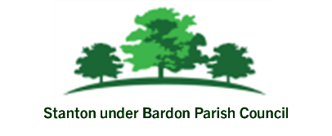

Date: 27th June 2025 To: All Councillors From: Parish Clerk

Report to Council: Maturity of Fixed-Term Savings Accounts – Redwood Bank and Charity Bank

This report informs the Council that its two annual fixed-term savings accounts held with Redwood Bank and Charity Bank are approaching their maturity dates. The Council is requested to consider and options on how this investment can be reinvested.
Two fixed-term savings accounts that the Council holds are reaching maturity:

- Redwood Bank – 12-Month Business Savings Bond
  - Original Investment: £85,000
  - Interest Rate: 5.08% AER
- Charity Bank – 1-Year Fixed Rate Business Account
  - Original Investment: £85,000
  - Interest Rate: 4.80% AER

Both accounts were opened in July 2024 to achieve a better return on reserves while ensuring the capital remained secure and FSCS-protected.

Top 5 Fixed-Rate Options for Councils

1. Cambridge & Counties Bank – 1 Year Business Bond
- Rate: 4.25% AER
- Deposit range: £50,000–£5 million (per account)
- Interest: Paid at maturity

2. Redwood Bank – 1 Year Business Savings Bond
- Rate: 4.10% AER
- Deposit range: £10,000–£1 million
- Interest: Monthly
- Access: Locked in for 12 months

3. United Trust Bank – 12 Month Business Bond
- Rate: 4.00% AER (fixed)
- Deposit range: From £5,000 upward (up to at least £1 million)
- Interest: Paid on maturity

5. Charity Bank – Ethical 1 Year Fixed-Rate Account
- Rate: 3.91% gross (paid annually)
- Deposit range: £10,000–£500,000 (or higher if pre-approved)
- Eligibility: Charity, club, community organisations—including parish councils
- Interest: Paid each anniversary

