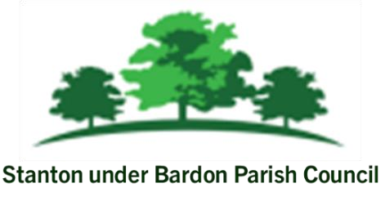
All Members of Stanton under Bardon Parish Council are hereby summoned to attend the Parish Council Meeting on Wednesday 16th July 2025 starting at 7:00pm at Stanton under Bardon Village Hall, 2 St John Cole Crescent, Stanton under Bardon, LE67 9AE for the purpose of transacting the business shown below:

PUBLIC PARTICIPATION
- Members of the public are welcomed to the meeting to make representations or ask questions in respect of any matters included on this agenda
- Updates from Borough Councillors Clare Harris and Chris Lambert
AGENDA

- APOLOGIES
  - To RECEIVE apologies for absence and to consider whether to approve the reasons given

- DECLARATIONS OF INTEREST PECUNIARY AND NON-PECUNIARY
  - To RECEIVE declarations of pecuniary and non-pecuniary interests and to note or consider requests for dispensations in respect of items on the agenda

- PREVIOUS MINUTES
  - To CONSIDER the adoption of the draft minutes from the Parish Council Meeting held on 11th June 2025

- CLERKS REPORT
  - To RECEIVE updates from the Clerk relevant to the Parish Council activities during June 2025

- COUNCIL INVESTMENTS – REINVESTMENT OPTIONS
  - To DISCUSS and CONSIDER reinvestment options for Council investments

- PARISH ASSISTANT PROPOSAL
  - To DISCUSS and CONSIDER the proposal of a Parish Assistant at Stanton under Bardon Parish Council

- VILLAGE HALL MANAGEMENT COMMITTEE
  - To NOTE the draft minutes from the Village Hall Management Committee Meeting on 21st May 2025

- S106 UPDATE
  - To DISCUSS and CONSIDER the S106 update from Hinckley and Bosworth Borough Council

- COUNCIL FINANCE
  - To REVIEW and APPROVE the financial report up until June 2025
  - To REVIEW and APPROVE bank statements and bank reconciliations for June 2025
  - To REVIEW and APPROVE the budget monitoring report and forecast at the end of Q1
  - To REVIEW and APPROVE the list of payments scheduled for July 2025
  - To NOTE and APPROVE amendments to update the bank mandate for Redwood Bank

- PLANNING
- To CONSIDER whether to submit formal responses to the following applications:
    - 25/00598/FUL: Construction of a new classroom LOCATION : Stanton Under Bardon Community Primary School Main Street Stanton Under Bardon Markfield Leicestershire
    - J22 M1 Employment Hub – Caddick Developments
- To CONSIDER any planning applications submitted following the publication of the agenda

Signed: 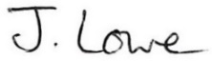 Dated: 11th July 2025

Stanton under Bardon Parish Clerk, Village Hall, 2 St John Cole Crescent, Stanton under Bardon, LE67 9AE

