Date: 10th September 2025 To: All Councillors From: Parish Clerk

Report to Council: **Request to Install a Concave Mirror – Off Main Street**

**Background**

The Parish Council has received a request for the installation of a **concave traffic mirror** at the following location off Main Street, Stanton under Bardon.

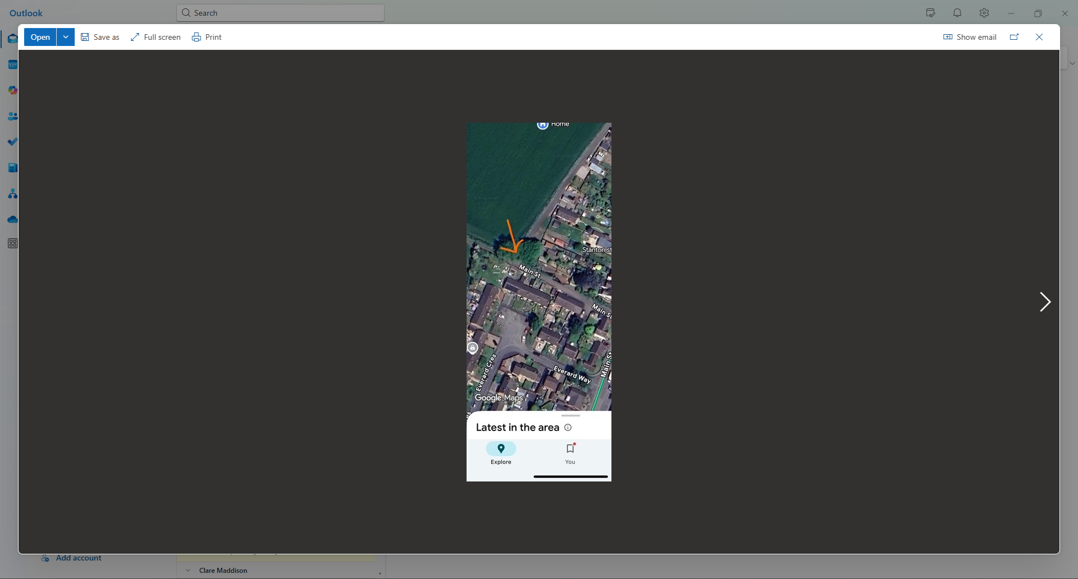

The purpose of the mirror would be to improve visibility for drivers and assist vehicle movements where sight lines are currently restricted.

**Recommendation**

Given the restricted sight lines and potential safety benefits, it is **recommended that a concave mirror be installed** at the location.

The cost for installation will be

Responsibility for installation, maintenance, and liability would remain with the Parish Council unless otherwise agreed.

**Costs**

* Concave Mirror: **£29.99**
* Handyman: **£20 per hour** (installation expected to take approximately 1 hour)