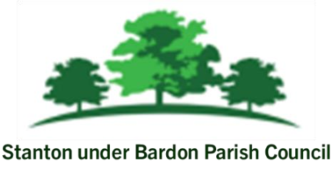
All Members of Stanton under Bardon Parish Council are hereby summoned to attend the Parish Council Meeting on Wednesday 8th October 2025 starting at 7:00pm at Stanton under Bardon Village Hall, 2 St John Cole Crescent, Stanton under Bardon, LE67 9AE for the purpose of transacting the business shown below:

PUBLIC PARTICIPATION
- Members of the public are welcomed to the meeting to make representations or ask questions in respect of any matters included on this agenda
- To receive updates from Borough Cllr Chris Lambert and Borough Cllr Clare Harris
- To receive updates from County Cllr Chris Lambert and Borough Cllr Clare Harris

AGENDA
- APOLOGIES
  - To RECEIVE apologies for absence and to consider whether to approve the reasons given

- DECLARATIONS OF INTEREST PECUNIARY AND NON-PECUNIARY
  - To RECEIVE declarations of pecuniary and non-pecuniary interests and to note or consider requests for dispensations in respect of items on the agenda

- PREVIOUS MINUTES
  - To CONSIDER the adoption of the draft minutes from the Parish Council Meeting held on 10th September 2025

- PARISH COUNCILLOR VACANCY
  - To RECEIVE and CONSIDER applications for the Parish Councillor vacancy for Stanton under Bardon Parish Council

- NEIGHBOURHOOD PLAN
  - To RECEIVE nominations and election of members to Bagworth, Thornton and Stanton Neighbourhood Plan Group
  - To RECEIVE an update on Bagworth, Thornton and Stanton Neighbourhood Plan

- S106 SPENDING
  - To RECEIVE an update on S106 funds available to Stanton under Bardon Parish Council
  - To DISCUSS and CONSIDER potential uses for improvements to the recreation ground
  - In line with agenda item 6b, to CONSIDER quotations for the repair of existing footpaths and the construction of a new footpath to the southern section of the recreation ground

- CLERKS REPORT
  - To RECEIVE updates from the Clerk relevant to the Parish Council activities during September 2025

- MEMBER REPORTS
  - To RECEIVE updates from Parish Councillors during September 2025 (information only)

- COUNCIL FINANCE
  - To REVIEW and APPROVE the monthly financial report for September
  - To REVIEW and APPROVE bank statements and bank reconciliations for September 2025
  - To REVIEW and APPROVE the budget monitoring statement for the end of Q2
  - To REVIEW and APPROVE the list of payments scheduled for October 2025

- COUNCIL AUDIT 24/25
  - To NOTE the external auditor’s report for audit year 24/25

- PLANNING
- To CONSIDER any planning applications submitted following the publication of the agenda

- PROPOSAL OF CLOSED SESSION
  - In accordance with the Public Bodies (Admission to Meetings) Act 1960 s(10) paragraph 2, to CONSIDER excluding the public and press for the remainder of the meeting due to the confidential nature of the business to be discussed.

- CONTRACTS and STAFF
  - To DISCUSS and CONSIDER the suitability and effectiveness of a Council contract
  - To DISCUSS and CONSIDER current staff capacity

Signed: 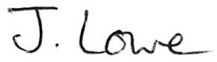 Dated: 3rd October 2025

Stanton under Bardon Parish Clerk, Village Hall, 2 St John Cole Crescent, Stanton under Bardon, LE67 9AE

