

Clerk Report – October 2025

UPCOMING MEETINGS / DATES FOR DIARY
HBBC Rural Conference – Thursday 12th March 2026 – Mythe Barn, Witherley
Next Parish Council Meeting – Wednesday 12th November– 7:00pm

- A resident contacted the Clerk to ask how frequently the bins are emptied by HBBC. HBBC confirmed that collections take place fortnightly, and this information was passed on to the resident.
- The Clerk met with Roam, the EV charging organisation working with local Borough Councils on the Green Living Grant. A site suitability assessment was completed, and the two parking spaces nearest the kitchen and meeting room were identified as the most suitable locations.
- The Clerk contacted Planning Enforcement to confirm whether changes to the play area design required further consultation. Allison Homes confirmed that the overall footprint of the play area will remain the same, and only design amendments are being made, which is permitted.
- A resident reported overgrown shrubs on the recreation ground. The handyman has been instructed to carry out the necessary maintenance.
- The Clerk contacted Russell George and the Clerk at Bagworth and Thornton Parish Council to offer assistance with the requests received from the Examiner.
- A weekly timesheet and task list have been created for the caretaker, outlining both weekly and quarterly duties.
- Two residents have contacted the Clerk regarding ongoing issues with the Allison Homes development, including road closures and breaches of the traffic management plan.
- Following the closure of the HSBC bank accounts, some direct debits were transferred to the Lloyds account. Although some companies initially applied late payment fees, the Clerk successfully arranged for these charges to be refunded.
- The next Village Hall event will be a Halloween Murder Talk by Mathew Morris. Promotion will include a leaflet drop this week, the village banner, and an advert in the Herald.
- 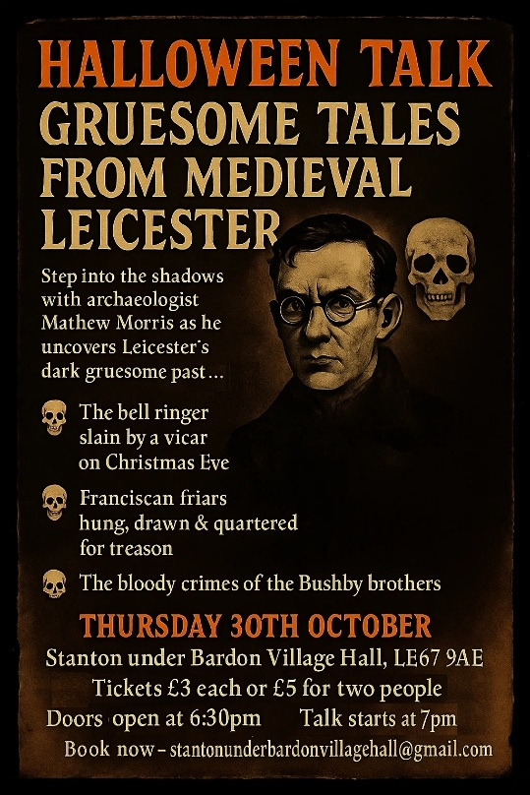
- The Clerk received another complaint regarding the cleanliness of the meeting room.
- The alarm was serviced under the Council’s contract with East Midlands Security and Fire. A faulty rear door sensor was replaced at a cost of £50 + VAT.
- Four residents contacted the Clerk expressing support regarding the new development and raising concerns about the road closure at the bottom of Main Street.
- A request was received for a roller disco at the Village Hall; however, the organisers decided the hall was too small for the event. (For information.)
- The Clerk has been liaising with a resident on Main Street planning home improvement works and has offered to write to nearby residents two weeks before the work begins. A start date is awaited.
- Regarding the new village sign installation, LCC were unable to confirm whether utilities are located beneath the proposed site. However, the Council’s grounds contractor can obtain this information and has offered to construct a suitable base for the sign, avoiding the need for deep excavation.
- The handyman has been instructed to undertake one day of work to complete the following tasks:
- Remove ivy from the recreation ground and a resident’s fence
- Cut back overgrown bushes in the recreation ground car park
- Install wall mounts for fire extinguishers in the Main Hall
- Fit a security lock on the trade waste bin
- Two new volunteers have joined the Village Hall team, with regular meetings now taking place to plan the events programme. The latest cinema night was a success, attracting 26 attendees.
- The Indoor Car Boot Sale on 28th September hosted 16 vendors and approximately 100 visitors.
- Following a complaint, the Clerk emailed all St John Cole Crescent allotment holders to remind them that water must not be taken off-site.

