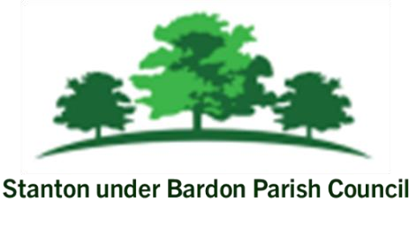
All Members of Stanton under Bardon Parish Council are hereby summoned to attend the Parish Council Meeting on Wednesday 12th November 2025 starting at 7:00pm at Stanton under Bardon Village Hall, 2 St John Cole Crescent, Stanton under Bardon, LE67 9AE for the purpose of transacting the business shown below:

PUBLIC PARTICIPATION
- Members of the public are welcomed to the meeting to make representations or ask questions in respect of any matters included on this agenda
- To receive updates from Borough Cllr Chris Lambert and Borough Cllr Clare Harris
- To receive updates from County Cllr Charles Whitford

AGENDA
- APOLOGIES
  - To RECEIVE apologies for absence and to consider whether to approve the reasons given

- DECLARATIONS OF INTEREST PECUNIARY AND NON-PECUNIARY
  - To RECEIVE declarations of pecuniary and non-pecuniary interests and to note or consider requests for dispensations in respect of items on the agenda

- PREVIOUS MINUTES
  - To CONSIDER the adoption of the draft minutes from the Parish Council Meeting held on 8th October 2025

- FOOTPATH EXTENSION ON RECREATION GROUND
  - To CONSIDER quotations for the repair of existing footpaths and the construction of a new footpath to the southern section of the recreation ground

- ELECTRIC VEHICLE CHARGING POINTS
  - To CONSIDER the installation of two Electric Vehicle Charging points in the car park of Stanton under Bardon Village Hall

- VILLAGE SIGN
  - To DISCUSS and CONSIDER options regarding the production and installation of the Village Sign in Stanton under Bardon.

- CLERKS REPORT
  - To RECEIVE updates from the Clerk relevant to the Parish Council activities during September 2025

- MEMBER REPORTS
  - To RECEIVE updates from Parish Councillors during September 2025 (information only)

- COUNCIL FINANCE
  - To REVIEW and APPROVE the monthly financial report for October 2025
  - To REVIEW and APPROVE bank statements and bank reconciliations for October 2025
  - To REVIEW and APPROVE the list of payments scheduled for November 2025

- PLANNING
- To DISCUSS and CONSIDER a formal response to the Local Plan Consultation
- To CONSIDER any planning applications submitted following the publication of the agenda

Signed: 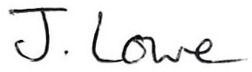 Dated: 7th November 2025

Stanton under Bardon Parish Clerk, Village Hall, 2 St John Cole Crescent, Stanton under Bardon, LE67 9AE

