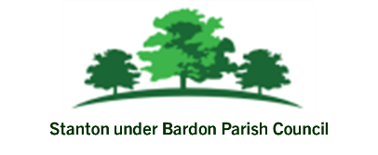

Date: 5th May 2025 To: All Councillors From: Parish Clerk

Report to Council: Community Café – Update Report

The Community Café delivered at Stanton under Bardon Village Hall is a Parish Council-led initiative supported by three fantastic volunteers and is continuing to grow as a welcoming and friendly space for local residents. Open every Tuesday from 9:00am to 11:00am, the café offers tea, coffee, and cake, alongside puzzles, books, and games for anyone who wants to drop by and enjoy good company. Attendance is steadily increasing, with 5–8 people each week. While the café currently operates at cost to the Parish Council, its community value is becoming more evident with each session.
Encouragingly, the café is now attracting the support of local organisations who want to work in partnership. Community development officers from Orbit Housing Association will begin using Hazel’s Café as a place to meet and speak with residents, and health inequalities officers from both Leicestershire County Council and Hinckley & Bosworth Borough Council have also shown a keen interest in connecting with attendees at the café, offering further advice and support to residents.
To help raise awareness, the Parish Council has reached out to the local school to share information with parents. The volunteers are also very enthusiastic and committed to the future of the café, and are planning another leaflet drop in the village soon. The Parish Council will also be promoting the café again through its social media channels.

