

Date: 21st July 2025 To: All Councillors From: Parish Clerk

Report to Council: Temporary Obstruction of Access Track Adjacent to 98 Main Street for External House Repairs

Purpose
To further details regarding a request from the resident of 98 Main Street, seeking permission to temporarily obstruct the Council owned private road adjacent to their property in order to carry out necessary external repair and repainting works to the side wall of their house.

Background
- 98 Main Street shares a boundary with the access track used by allotment tenants to access the Top Allotments and residents accessing the rear of their properties.
- The resident has reported that the render on the side elevation of their property is cracked and deteriorating, requiring urgent repair and repainting.
- Due to the close proximity of the wall to the access track, the works will require the use of equipment that will temporarily obstruct part of the track.
- Initial consideration was given to scaffolding that spans the full width of the access, but the resident has struggled to find a contractor willing to provide this.

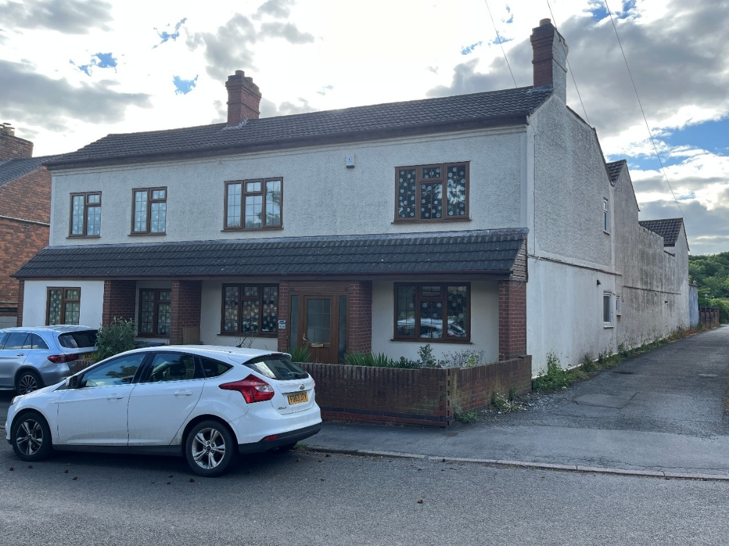

Updated Proposal from Resident
The resident has proposed the use of an articulated boom lift ("Artic Boom") as the most feasible solution. Further details about the equipment can be found at Appendix A.
This equipment:
  - Is electric-powered and therefore expected to operate quietly.
  - Can be moved or driven to allow passage for vehicles if required.
  - Would avoid the need for a full closure of the track.

The resident has also indicated:
  - Willingness to carry out the work during night hours, when usage of the track is minimal.
  - An estimated duration of 5 nights to complete the repainting.
  - All necessary safety measures will be taken, including securing tools and materials to the boom platform to reduce risk of falling objects.

Considerations
- Access: While partial obstruction may occur, the proposed equipment allows for flexibility and temporary movement to accommodate access needs.
- Noise and Disruption: Use of an electric boom lift should keep noise disruption to a minimum. Night-time work may further reduce impact on allotment users.
- Safety: The resident has proposed appropriate safety measures, though any permission given by the Council should be subject to confirmation of adequate public liability insurance and risk assessment by the appointed contractor.

Clerk Recommendation
To give permission in writing for the resident to appoint a contractor to use an articulated boom to undertake repair works to their property for no longer than 5 nights, subject to the following conditions:
- Confirmation of contractor’s public liability insurance and a safety risk assessment.
- The equipment used must be movable at short notice to allow emergency or essential access.
- The Council must notify all tenants on Main Street of the planned works and provide contact details for queries or concerns – if any concerns are raised, it needs to go back to Council for further consideration
- Any damage to the access track resulting from the equipment must be made good by the resident or their contractor.

Appendix A

