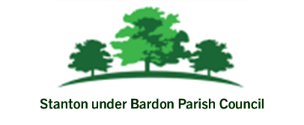

Date: 23rd July 2025 To: All Councillors From: Parish Clerk

Report to Council: Resident Request for Ivy Removal at Rear of Property onto Recreation Ground

Background
In November 2024, the Parish Council undertook works at the Recreation Ground to remove tree branches overhanging from Council land into the rear garden of a resident's property on Luke Jackson Way. This work was carried out in response to a complaint from the resident and was completed by a contractor appointed by the Council.
Following the completion of this work, the resident has contacted the Council again to raise concerns that vegetation along the rear boundary has not been fully cleared. In particular, it was reported that ivy continues to grow through the fence, which the resident believes is causing damage.

Ownership and Responsibility
- The Recreation Ground is owned and maintained by the Parish Council.
- The boundary fence is understood to be the property of the resident, as it forms part of her garden enclosure.
- Vegetation growing on Council land may become an issue where it causes a nuisance or physical damage to neighbouring properties.

Advice from LRALC
The Parish Council sought guidance from the Leicestershire and Rutland Association of Local Councils (LRALC). The advice received is as follows:
"As the responsible landowner and as a 'good neighbour', the Parish Council should seek to find a resolution to this matter. I suggest this further complaint is considered at a Parish Council meeting and for Council to decide on a way forward. If Council have a grounds maintenance contract in place for the recreation ground, they may wish to consider ongoing maintenance of the currently unmanaged area of woodland, to prevent any further issues arising."

- Take No Further Action
The Council may consider the ivy to be a natural occurrence and part of the normal vegetation within the Recreation Ground boundary.
- Undertake Limited Vegetation Management
Appoint a contractor to remove ivy along the shared boundary, limited to the section adjoining the resident’s property, to prevent potential further encroachment or damage.
- Consider Ongoing Maintenance Plan
Review the current grounds maintenance contract and consider including the unmanaged area of woodland at the rear of the Recreation Ground to allow for proactive control of vegetation growth.

Photos of Fenceline

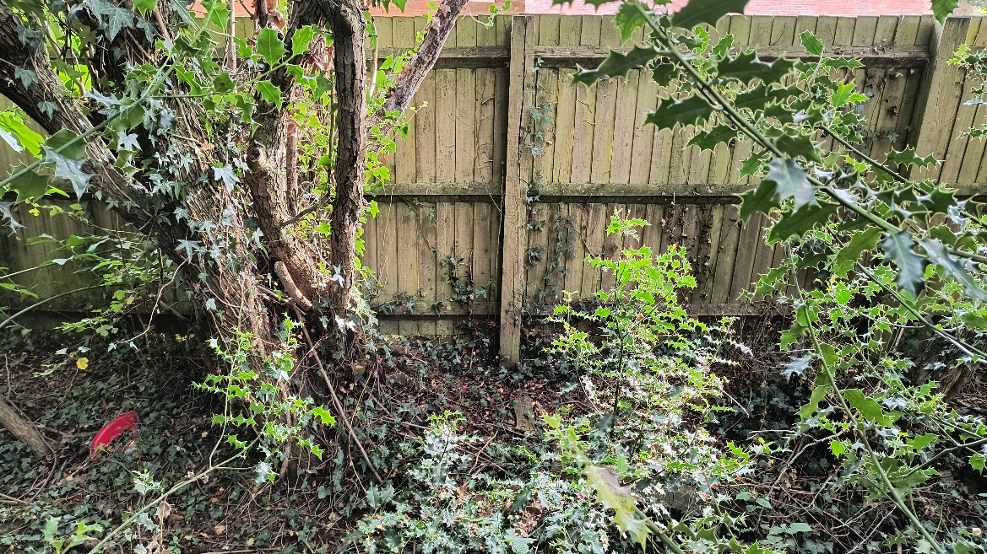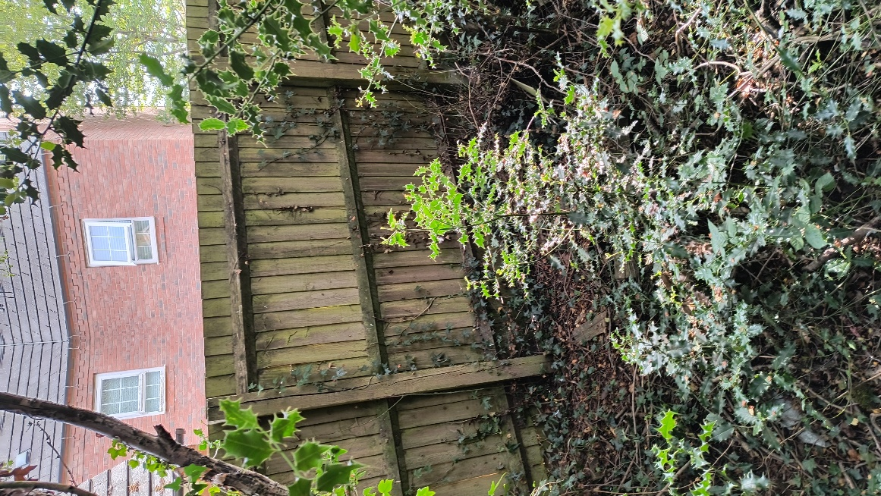

Financial Implications
Should the Council decide to proceed with vegetation removal, a quote will be obtained from an approved contractor. This can be funded from the existing grounds maintenance budget, subject to available funds.

Legal and Risk Implications
The Council has a duty to manage its land in a way that does not cause a nuisance or damage to adjoining properties.
Care should be taken not to encroach onto or damage the resident's property during any clearance work.

