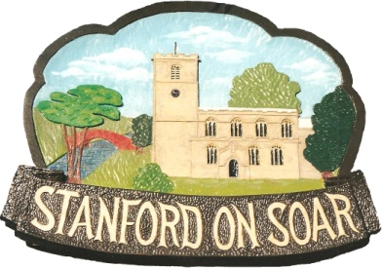
Stanford on Soar Parish Council

Councillors are summoned to attend the
Meeting of the Parish Council to be held
in Normanton on Soar Village Hall
on 14 November 2024 at 19:00

Agenda

1. Apologies for Absence

2. Declaration of Interests

3. Open Session (limited to 15 minutes)

4. Minutes of the meeting held on 15 August 2024

5. Borough and County Council Matters

6. Traffic and Highway Maintenance
(a) Flooding in the Village
(b) Leake Lane Speed Limit
(c) Bus Stop at Old School House

7. Conservation Areas
(a) Information about Conservation Areas by Andrew Langley from Rushcliffe Borough Council
(b) Proposal to create a Conservation Area in Stanford on Soar

8. Village Sign
(a) Refurbishment of Village Centre Sign

9. Defibrillator at the SSAFA Norton House - Update

10. Adoption of Sexual and General Harassment Policy

11. Planning
- 24/01426/FUL - Stanford Hall, Melton Road, Stanford On Soar - Erection of a ground mounted solar PV renewable energy generation system for a 40 year temporary period. – PC no objection, pending RBC decision.
- 24/01175/AGRIC - Barn Farm, Leake Lane, Stanford On Soar - Lean-To (NorthWest) extension to existing Stock Barn - roof to be a continuation of and at the same roof pitch as the existing barn, made of the same roofing material (corrugated fibre cement - natural grey, with occasional plastic lights). Constructed of steel framing with concrete panel sides to 2 m and Yorkshire Boarding above. 1x Galvanised steel gate to match existing barn – RBC permitted development.
- 24/00131/FUL - Five Oaks Farm, Main Street, Stanford On Soar - Application for the partial demolition of agricultural Barn 5 and canopy between Barns 1 and 6, sheeting to walls of agricultural Barns 5, 6 and 7 – PC neutral response, pending RBC decision.
- 23/00147/FUL - Plot Of Land North Of Meadow Lane, Stanford On Soar - Retention of summerhouse – Pending appeal decision.

12. Finance
(a) Bank Reconciliation
(b) Payments
(c) Budget and Precept setting

13. Environment
(a) Buildings to put forward for listing status
(b) Trees and TPOs

14. Social Events

15. Correspondence
(a) NALC Pay Rates for 2024/25
(b) Greater Nottingham Strategic Plan

16. Councillor Reports and Next Agenda Items

17. Meeting Dates for 2025

Rebecca Hague
Stanford on Soar Parish Clerk Date: 05.11.2024

