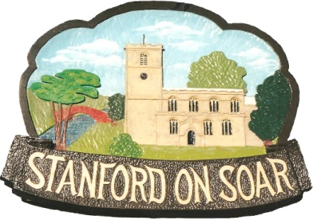
Stanford on Soar Parish Council

Councillors are summoned to attend the
Meeting of the Parish Council to be held
in Normanton on Soar Village Hall
on 27 February 2025 at 19:00

Agenda

1. Apologies for Absence

2. Declaration of Interests

3. Open Session (limited to 15 minutes)

4. Minutes of the meeting held on 14 November 2024

5. Borough and County Council Matters

6. Traffic and Highway Maintenance
(a) Flooding in the Village
(b) Leake Lane Speed Limit
(c) Bus Stop at Old School House
(d) Condition and Replacement of Village Entry Sign – Meadow Lane

7. Planning
- 25/00185/PAQ - Five Oaks Farm. Main Street, Stanford On Soar - Prior approval application under Class Q to allow the Conversion of 3no. Agricultural Barns to 7 Dwelling houses (CLASS C3) – To be discussed.
- 24/02045/FUL - Underhill Farm, Leake Lane, Stanford On Soar - Erection of a new dairy building, to house a new parlour and associated plant work, along with areas to facilitate cow management and treatment, associated hardstanding and access – PC no objections, pending RBC decision.
- 24/02006/AGRIC - Underhill Farm, Leake Lane, Stanford On Soar - Livestock housing building – PC no objections, RBC prior approval not required.
- 24/01426/FUL - Stanford Hall, Melton Road, Stanford On Soar - Erection of a ground mounted solar PV renewable energy generation system for a 40 year temporary period. – PC no objection, RBC permission granted.
- 24/00131/FUL - Five Oaks Farm, Main Street, Stanford On Soar - Application for the partial demolition of agricultural Barn 5 and canopy between Barns 1 and 6, sheeting to walls of agricultural Barns 5, 6 and 7 – PC neutral response, RBC permission granted.
- 23/00147/FUL - Plot Of Land North Of Meadow Lane, Stanford On Soar - Retention of summerhouse – Pending appeal decision.

8. Village Sign
(a) Replacement Village Sign – Updated Quote

9. Environment
(a) Conservation Area - Update
(b) Buildings to put forward for listing status
(c) Trees and TPOs

10. Finance
(a) Bank Reconciliation
(b) Payments
(c) Appointment of Internal Auditor

11. Social Events

12. Correspondence

13. Councillor Reports and Next Agenda Items

14. Date of Next Meeting and Annual Parish Meeting Arrangements

Rebecca Hague
Stanford on Soar Parish Clerk Date: 20.02.2025

