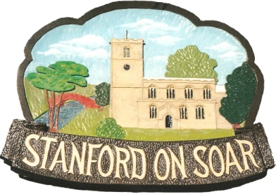
Stanford on Soar Parish Council

Residents are invited to attend the Annual Parish Meeting
to be held in St John the Baptist’s Church, Stanford on Soar
on 22 May 2025 commencing at 19:30

Agenda

1. Welcome & Apologies for Absence
2. Minutes of the Annual Parish Meeting held on 16 May 2024
3. Chairman’s Report

4. Parish Council Finances

5. Planning and Environment

6. Update from Rushcliffe Borough Councillor and Nottinghamshire County Councillors

7. Update from DMRC and NRC

8. Update from James Naish MP

9. Open Session and Questions

Refreshments will be served after the meeting.

Frances McKim
Chairman - Stanford on Soar Parish Council Date: 09 May 2025

