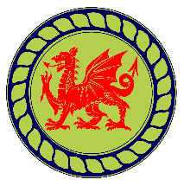
Canolfan Porthllwyd
Conway Road
Dolgarrog
LL32 8JU
Dolgarrog
Community Council
AGENDA

Dolgarrog Community Council – Community Centre
11th June 2026 6pm.

Briefing from NWWT regarding their current work and plans for the year. (15 mins) to be followed by a Q&A of no longer than 15 minutes.

Then the meeting will open at 6.30pm.

- ﻿﻿Apologies for absence.
- Declarations of interest
- Approval of minutes from the previous meeting – May 2026
- Matters Arising:
4.1 Maintenance: Door lock - Pete
4.2 Update on poppies: storage, changing and maintenance -Jackie
4.3 Film Premiere
4.4 Update on lease –Clerk.
4.5 Audit Report 2024/2025

- Clerk’s Schedule: discuss appropriate items.

- Financial Report – Expenses and Income Account provided with meeting pack. Also summary of annual accounts for information only.

- Any other business – to be notified to Clerk no later than 5pm 10th June
7. Planning matters – None
8. Date and venue of next meeting – proposed 2nd or 6th July. 6pm.

