**Canolfan Porthllwyd**

**Conway Road**

**Dolgarrog**

**LL32 8JU**

Dolgarrog

Community Council

**AGENDA**

**Dolgarrog Community Council Meeting**

MONDAY 7th March 2025 6.30pm

PRE MEET – 5.30pm - Conwy Borough Council – EDF representatives to discuss road options/closures later this year.

1. ﻿﻿Apologies
2. ﻿﻿Code of conduct declaration of interest
3. ﻿﻿Minutes of 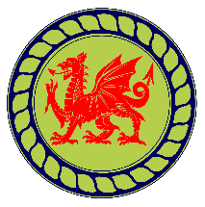Previous Meeting
4. Matters Arising
5. ﻿﻿Finance: Financial Officer Report and Feedback
6. ﻿﻿Correspondence – questions on - see Clerk Appendix A
7. ﻿﻿Planning Applications
8. Any other business

8.1 Nature Networks – establishment of steering group

8.2 Update on building – electrical report and roof

8.3 100th Anniversary of Dam disaster – specific role allocation

8.4 Proposal for a council let litter pick

1. Date of Next Meeting