**Canolfan Porthllwyd**

**Conway Road**

**Dolgarrog**

**LL32 8JU**

Dolgarrog

Community Council

**AGENDA**

**Dolgarrog Community Council Meeting**

MONDAY 3rd March 2025 6.30pm

1. ﻿﻿Apologies
2. ﻿﻿Code of conduct declaration of interest
3. ﻿﻿Minutes of 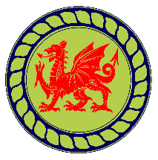Previous Meeting (and actions)
4. ﻿﻿Finance: Financial Officer Report and Feedback
5. ﻿﻿Correspondence
6. ﻿﻿Planning Applications
7. Any other business

7.1 Training

7.2 Safeguarding Policy

7.3 Updating Standing Orders

1. Date of Next Meeting