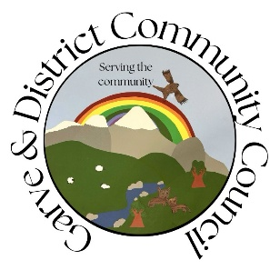

**GARVE & DISTRICT COMMUNITY COUNCIL**

**ORDINARY MEETING AGENDA**

**TUESDAY 16th SEPTEMBER 2025**

**7.00 PM**

**This meeting will be held via webcam.**

**Members of the public are very welcome to attend Community Council meetings and take part in the discussions**

**under the guidance of the Chairman. This meeting will be recorded and will be archived and available for viewing for twelve months thereafter.**

1. Introductions and Apologies
2. Declarations of interest
3. Approval of the draft minutes of the last ordinary meeting held on Tuesday 19th August 2025 and matters arising from the minutes including traffic issues
4. Treasurer’s report
5. AOB from Community Council members
6. AOB from members of the public
7. Screening reports, scoping reports and consultations

8. Building warrants, planning issues and licensing issues

9. Dates of future meetings

*(Ordinary meetings are usually held on the first Tuesday of every month unless stated otherwise)*

Zoom details to join online. Joining link: <https://bit.ly/GDCC-Zoom>  
Meeting ID: 812 0501 2050  
Passcode: 898894  
  
  
issued at 09:50 on 9 /9/25

[www.gdcc.scot](http://www.gdcc.scot)

[www.facebook.com/gaveCC](http://www.facebook.com/gaveCC)

[contact@gdcc.sco](mailto:contact@gdcc.sco)t