**Minutes of Meeting**

**Wednesday 13th November 2019. Fortrose Leisure Centre**

1. **Welcome and Apologies**

**Present:** Tom Heath (TH), Iain Brown (IACB), Lucy Tonkin (LT), Anne Phillips (AP), Susan Pringle(SP), Rebecca Rawlinson (RR), Trish Wilson (TW)

Councillor Gordon Adam (GA-THC)

**Apologies:** Archie MacLeod (AM), Leanne MacKenzie (LM) Councillor Craig Fraser (CF-THC), John Murphy (Police Scotland)

1. **Minutes of Last Meeting**

The minutes of the October meeting of FRCC were approved. (Proposed IACB/Seconded LT)

1. **Matters Arising**
   1. **Proposal for Skateboard Park-Rosemarkie.**  Sarah Atkin has arranged a provisional meeting between Kate Forbes (MSP) and Ruaraidh Ross. Rosemarkie Amenties Association are continuing discussions with THC in respect of using a small part of the Rosemarkie Playing field for the project.
   2. **Empty Council owned Houses.** No action in the last month. GA to establish current position**. Action GA**
   3. **St**.**Andrew’s Walk Bin.** We continue to press for a bin on the lower reaches of St.Andrew’s walk. Katriona Taylor of THC has offered a site visit on a date to be arranged. Action TH
   4. **Fatal Road Accident – Blackstand Junction.** Following communications between Sarah Atkin on (behalf of FRCC), the Police and THC we have been advised that the following actions will be taken by THC.

* Road Paint to be redone around junction
* Cut down some vegetation to improve view to left when turning right out of junction.
* Highlight junction on the road surface as you come left from Killen- either slow on road or rumble strips.
* No timescale has yet been set for the works.

1. **Correspondence and Points from the Public**
   1. **Shuttle Bus:** A member of the public has written suggesting a route change to the shuttle bus to Chanonry Point. This is to be discussed with THC.
   2. **Black Isle Tourism (BIT)** have written to each Community Council requesting a contact person to help in drawing together a the network of footpaths on the Black Isle. AP will represent FRCC.
   3. **Pump Track:**  A proposal for a Pump Track in Fortrose has been received with a request for FRCC support. In principle FRCC supports this and any other activity which will engage young people. We will however seek advice from Fortrose Academy before taking any other action. It is possible that we could apply for support for such a project from the “Cashback for Communities” scheme. Action TH
   4. **Damaged Gabion Baskets:** Following recent high seas, FRCC has notified THC of newly damaged gabion baskets in the section of coastal defence adjacent to the recent works by the Rosemarkie Campsite.
   5. **Coastal Erosion:** FRCC has notified Scottish Water of significant erosion following failure of Coastal defence which it believes may be the responsibility of Scottish Water.
   6. **Community Minibus:** A member of the Public has brought to our attention the promotion run by the Press and Journal who are offering a Minibus to the Community Group making the best case for it. FRCC is aiming to coordinate local efforts to secure the prize.
   7. **Feddon Hill Play Area:** FRCC have written again to O’Brien properties in respect of the play area in Feddon Hill which has been neglected for months if not years and is believed to be their responsibility to maintain.
2. **Police Report**
   1. The text of the Police Report from this period reads:

The following are the crimes, offences and antisocial behaviour and other incidents of note dealt with between 08/10/2019 and 13/11/2019:

* 11/10/19 – 13/10/19 – Damage caused to window at Fortrose Academy between the above dates.
* 12/10/19 – 2 x windows damaged at Fortrose Pavilion.
* 14/11/19 – Fortrose Academy entered during the night and fire alarm activated.
* 17/10/19 – Further 2 x windows damaged at Fortrose Pavilion.
* 17/10/19 – 8 x windows damaged at Fortrose Academy. 4 youths traced in the area on Police attendance. **Enquiry ongoing with these youths regarding this incident and all the other damage caused**.
* 18/10/19 – Personal amount of a controlled substance recovered at Fairy Glen car park.
* 30/10/19 – Concern calls received regarding a male wild camping on Rosemarkie Beach. Male spoken to and no concerns raised.
* 07/11/19 – Window damaged at Fortrose Town Hall.11/11/19 – Damage caused to Public Toilets, Mill Road, Rosemarkie. Occurred between 20/10/19 – 21/101/19.

1. **Treasurers Report.**

1] Continued concern about financial viability:

At 13 November 2019, seven months into the 12- month year to 31 March 2020, there is a trading balance of £248.92 to finance the community council for the rest of the year; for five months.   
More accurately for eight months as the grant from Highland Council is not paid before 1 July.

In the previous 12-month period, when Highland Council first reduced their annual operating grant from £1,502  to a meagre £676, there was a trading surplus for the year, a surplus made possible by £275 in compensation  from the bank of and a net £343 from active fund-raising. Through good diligence which was enhanced in previous years by a now withdrawn realistic annual operating grant from Highland Council, there remains, (31 August), a cash-at-bank credit balance of £3,659.

2]Although this retained surplus may fund losses for a few years, in order that the community council can continue to represent and to assist the community it serves, it is essential,  (1) to engage in fund raising activities and (2) to encourage voluntary donations.  Suggestions for both were sought: suggestion paper to be tabled.

3] The September meeting agreed that the community council in addition its ongoing association with St Boniface  Fair, financial and participation support – either or both - should continue to be given to is given to promoting  Chanonry Point and its Dolphin Bus; lamppost hanging floral baskets; Christmas lights and decorated tree;  British Legion Poppy Appeal and Remembrance Service; Tidy Our Royal Burgh volunteers and the Senior  Citizens’ luncheon.

[4] As discussed and agreed, the Community Council agreed to extend its participation and its support of Highland    
Cathedral, a book for children on Fortrose Cathedral, to pre-finance the cost of a run-on print run of 500    
additional copies.  Anu potential loss being under-written by the promoters of the book.

1. **Planning/Licensing/Consultations**
   1. **New Planning Applications** 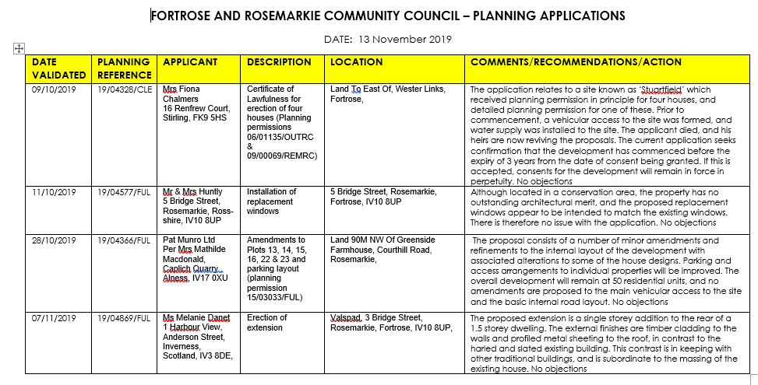
   2. **Update on other applications**

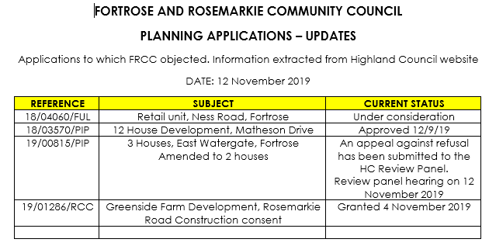

* 1. **Fortrose Campsite Consultation on New Lease:** FRCC has submitted a response in respect of the Consultation by THC on the proposal to issue a new 30-year lease on the Fortrose Campsite. This response is available on the FRCC Facebook page and on the FRCC website.
  2. **Planning Portfolio FRCC:**  It was agreed that RB would take on the Planning role within FRCC. THC planning office to be advised. **Action TH**

1. **Common Good.**
   1. **New Shed at Town Hall.** The local Boy Scouts have offered to erect a new shed to replace the existing derelict unit adjacent to the Town Hall provided the materials were provided. The shed is to be used for storage of items owned by community groups including the Scouts. It was agreed that on receipt of necessary details FRCC would make an application to the Common Good to fund the project. Councillor Adam indicated that he thought it likely that the Common Good would support the application. Action IACB.
   2. **Meeting Room Table:** It was agreed that FRCC would make application to the Common Good Fund for repairs to the Meeting room Table. GA indicated that such application is likely to looked on favourably. It was noted that the table is used by play and other groups so that protection of the repaired would be required. Action IACB
2. **Community Issues**
   1. **Antisocial Behaviour-Beach Party Nuisance/Local Vandalism**. With a strong initial input from Sarah Atkin the Rector of Fortrose Academy issued an excellent letter to all parents of students at the Academy advising them of the problems and seeking their help in tackling these issues. It is our understanding that the letter we generally well received and out thanks to the Rector his help.
   2. **Rosemarkie Beach High Path**. AP met with Philip Waite (Footpaths Officer THC) to inspect the recently completed work on the High Path. Our thanks to THC for performing this work and for removing the fallen tree across the access steps to the path. Nick Richard of THC will perform a safety assessment of other trees overhanging the path and beach. AP to coordinate
   3. The view was expressed that in recent years FRCC has in general been reactive to events rather that initiating action to improve the wellbeing of the Community. It was agreed within FRCC that we need to do more to stimulate and initiate projects.
   4. **Community Christmas Tree:** The Community tree will be erected adjacent to the War Memorial in Fortrose in time for a festive “Lights on” on 14th December. Street lights will be erected where possible by the same time.TW to coordinate
   5. **Highland Foodbank:** There will be a Collection of items for the Highland Foodbank over the weekend of 28/29 December. LT to coordinate
   6. **Community Bench:** Black Isle Men’s Shed have offered to make a bench for the Community provided they can recover material costs. We are seeking possible locations for such a bench before proceeding. Members of the Public are invited to make suggestions. Action TH.
3. **AOCB**
   1. **Prioritisation of Road Repairs:** In recognition of the inadequacy of THC budget for road repairs GA outlined a new procedure where local Highland Councillors will set priorities in conjunction with the Roads Dept.
4. **Next Meeting**
   1. The next full meeting of FRCC will be held in Fortrose Leisure Centre on Wednesday 11th December at 1900.
   2. It is planned to have full meetings on the second Wednesday of each month throughout the year.
   3. There will be a special meeting to discuss finance and fund raising on Wednesday 20th October in the Leisure Centre.