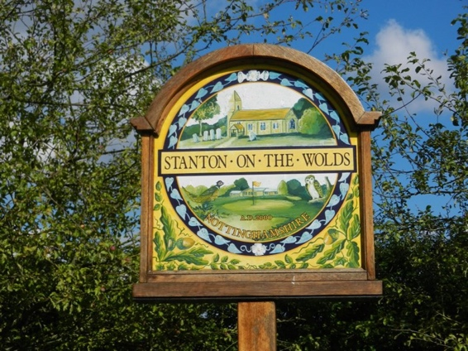
Stanton

on the Wolds

Parish Council

(Rushcliffe Borough Council, Nottinghamshire)

Clerk: position vacant

(c/o Chairman Robert Day E-mail: robert.day@stanton-on-the-wolds.parish.email)

The next meeting of the parish council will take place on Wednesday September 7th 2022 and will be held at Stanton on the Wolds Parish Church and will start at 7.00 pm

The agenda for the meeting is:

- Appoint a new Clerk (Proposed Michelle Law)
- Apologies for absence
- Declarations of interest
- Minutes of meeting held on July 6th, 2022
4. Open session for the public, limited to 15 mins
5 Clerk’s report
6. New clerk position and banking responsibilities
7. Notts county council and Rushcliffe borough council members report
8. Correspondence
9 Planning
10 Environment
11. HM Queen Platinum Jubilee – update on proposal to purchase bench
12. Finance including accounts to pay
13. Date of next meeting November 2nd, 2022 at 7.00pm

Robert Day
Chairman

Date of issue: Friday 12th August 2022

