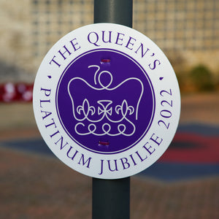 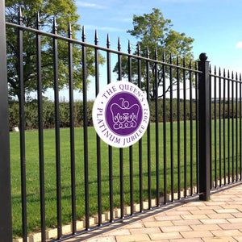

# Platinum Jubilee 2022 Lamp Post Sign

## CELEBRATE THE QUEEN'S PLATINUM JUBILEE 2022 WITH RBLI'S JUBILEE LAMP POST SIGNS

Made and fulfilled by veterans at Britain's Bravest Manufacturing Company in Aylesford, Kent.

* 1ft x 1ft (30cm) circular design
* 100% recyclable
* Constructed from 4mm thick Correx- suitable for prolonged all-weather outdoor use
* Features The Official Queen's Platinum Jubilee Logo
* Each sign comes with 2x 370mm purple zip ties, suitable for securing to most lamp posts, signs, railings etc.
* Up to 40% discount if ordered in bulk
* Available to order in quantities of 1, 10, 25, 50, 100, 250, 500 and 1000. For greater quantities, please get in touch for a bespoke quote.

If you require payment by BACs or cheque, please [download and complete this order form.](https://cdn.shopify.com/s/files/1/0257/2340/4342/files/RBLI_Platinum_Jubilee_Order_Form.pdf?v=1645017492)

10 x **£47.99**

25 x **£111.99**

50 x **£211.99**

Plus Shipping £10.99

