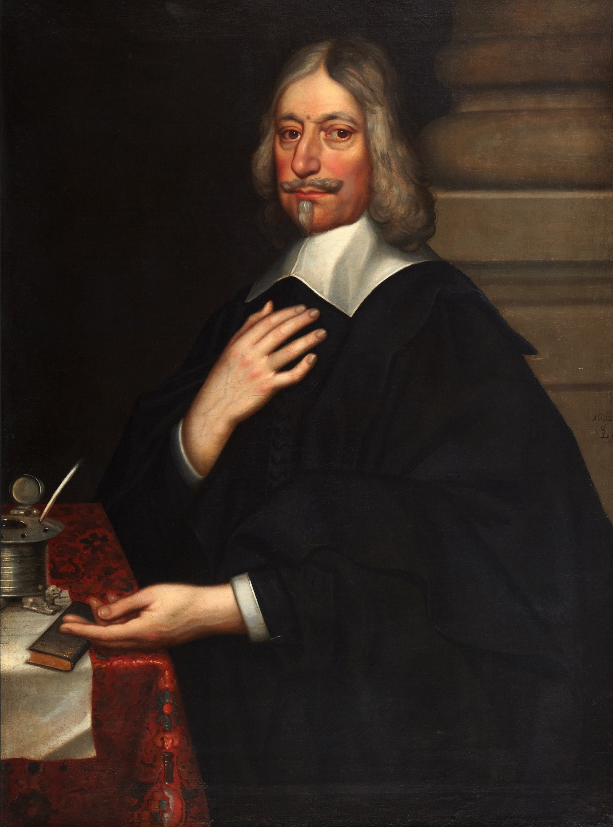

**GIFT AID DECLARATION**

**Boost your donation by 25p for every £1 you donate**

Gift Aid is reclaimed by the charity from the tax you pay for the current tax year. Your address is needed to identify you as a current UK taxpayer.

In order to Gift Aid your donation you must tick this box and give your address:

◻I want to Gift Aid my donation of £___________ and any donations I make in the future or have made in the past 4 years to:

**LEIGHTON LIBRARY TRUST CHARITY**

(Charity number SC003010)

I am a UK taxpayer and understand that if I pay less Income Tax and/or Capital Gains Tax than the amount of Gift Aid claimed on all my donations in that tax year it is my responsibility to pay any difference.

**My Details:**

Title ____ First name or initials __________________________

Surname ___________________________________________________

Home address _____________________________________________

______________________________________________________________

Postcode __________________

Signature _____________________________ Date ______________

Please notify the Charity if you:

◻ want to cancel this declaration

◻ change your name or home address

◻ no longer pay sufficient tax on your income and/or capital gains

If you pay higher rate Income Tax and want to receive the additional tax relief, you must include all your Gift Aid donations on your Self-Assessment tax return or ask HM Revenue and Customs to adjust your tax code.

**PRIVACY**: The personal details above will be held securely and will be used only for the purpose of claiming Gift Aid

|  |
| --- |
| ***image2.jpegRobert Leighton (1611-1684)***  *Principal of the University of Edinburgh*  *Bishop of Dunblane and Archbishop of Glasgow pictured holding one of his six editions of his favourite book, ‘The Imitation of Christ’ by*  *Thomas à* *Kempis, all of which can still be seen in the*  *Leighton Library* |

|  |  |  |  |  |  |  |  |  |  |
| --- | --- | --- | --- | --- | --- | --- | --- | --- | --- |
| **Become a Friend of the Leighton Library today and help sustain this historic national treasure for tomorrow…….**  The Leighton Library houses the book collection of Robert Leighton, Bishop of Dunblane from 1661 to 1670. On his death in 1684 he left his collection of around 1400 books *“to the Cathedrall of Dunblane in Scotland...for the use of the clergie of that Diocess”.* The oldest book dates from 1504.  The Library opened in 1688, became a subscription library in 1734 but borrowing and regular opening ceased in the mid-nineteenth century. It re-opened in 1990 after refurbishment and in 2023 is being extensively restored.  You can find more information at [www.leightonlibrary.org.uk](http://www.leightonlibrary.org.uk) which has a ‘donate’ facility.  **Becoming a Friend of the Leighton Library**  The Trustees wish to keep access to the Library free rather than charge entry. Donations from visitors contribute only a proportion of the total annual running costs and Friends’ subscriptions make a critical contribution to the remainder of these costs.  Friends of the Library will:   * receive newsletters about the collection and the continuing development plans for the Library * be invited to exclusive Friends’ events * be accorded exclusive private guided visits for themselves and guests   If you would like to become a Friend of the Leighton Library, please complete the form and send it to:  The Treasurer, Leighton Library Trust Charity,  c/o Cathedral Office, The Cross, Dunblane FK15 0AQ  If you are able to Gift Aid your donation, please also complete the Gift Aid form. The completed forms can be sent by mail, or you can scan them and attach them to an email to: [leightonfriends@gmail.com](mailto:leightonfriends@gmail.com) | **Friends of the Leighton Library: Sign-up Form**  Please enrol me as a “Friend of the Leighton Library” and keep me informed of Friends’ events and future development plans.  The annual subscription for **2025** is a donation of **£30.** Additional amounts are welcome.  Name (s): _____________________________________________  Address (incl. postcode): _________________________________  _____________________________________________________  Email address: _________________________________________  A regular monthly donation of £5 from 125 Friends would meet the basic annual running costs. Please consider a regular payment via standing order for the amount you wish to subscribe:  Monthly @ £5/month [ ] £10 [ ] £25 [ ] £_____ [ ]  Or a one off donation £_______ [ ]  I will pay this amount by:   |  |  | | --- | --- | |  | standing order, OR | |  | cheque (payable to Leighton Library Trust Charity) | |  | Internet banking; details below |     Signature: _______________________________ Date: ____________  If paying by standing order or internet banking, please pay to:  Account name: Leighton Library Trust Charity  Sort code: 80-22-60 Account number: 18606269  If paying by cheque, please make payable to ‘Leighton Library Trust Charity’ and send to:  The Treasurer, Leighton Library, c/o Cathedral Office, The Cross, Dunblane FK15 0AQ  Please note that newsletters and other notices will be sent to you by email  **PRIVACY:** The personal details above will be held securely and used only for the purpose of communications from the Leighton Library.   |  |  | | --- | --- | |  | If you are a UK taxpayer and able to sign the gift aid form also, we can claim from HMRC an additional 25p for each £ that you pay as a subscription or donation. | |