Community And Enterprise Resources
Head Of Roads, Transportation & Fleet Services – Colin Park
Enquiries to: Area Manager, 7th Floor, Council Offices, Almada Street, Hamilton, ML3 0AA

Telephone No: 0303 123 1015

Temporary Restriction To Use Of Road

Notice is hereby given that under Section 14 (2) of the Road Traffic Regulation Act 1984, as amended by the Road Traffic (Temporary Restrictions) Act 1991, use of the following road by the undernoted classes of vehicle will be prohibited for the stated period of time.

Name of Road Manse Road, Stonehouse
Between Gibb Court
and Glebe Cemetery
Type of closure Road closure
Period of Closure 09:30 on 24 July 2023
To 13:00 on 24 July 2023
Reason for Closure Bridge inspections for turbine route
Classes of Vehicles Prohibited All Classes

Alternative routes shown on plan below will be as follows: -

The diversion is via King Street, Townhead Street, Strathaven Road and Manse Road.

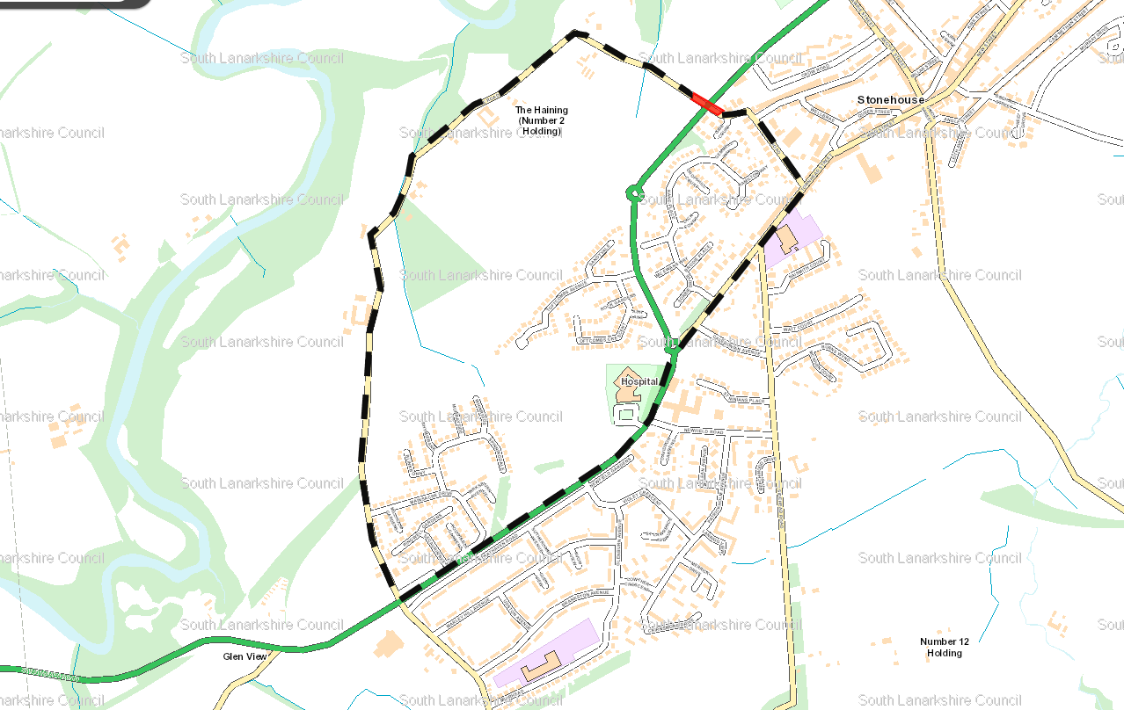

Key Extent of closure Diversion Route

Signed 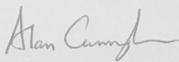 Date 7 July 2023

pp Area Manager

For more information or if you want this information in a different format or language, please contact the Hamilton Area Office on 07795 455 423 or email:– debra.meldrum@southlanarkshire.gov.uk

