Temporary closure – Queen Street, Stonehouse

04/09/2023 until 08/12/2023

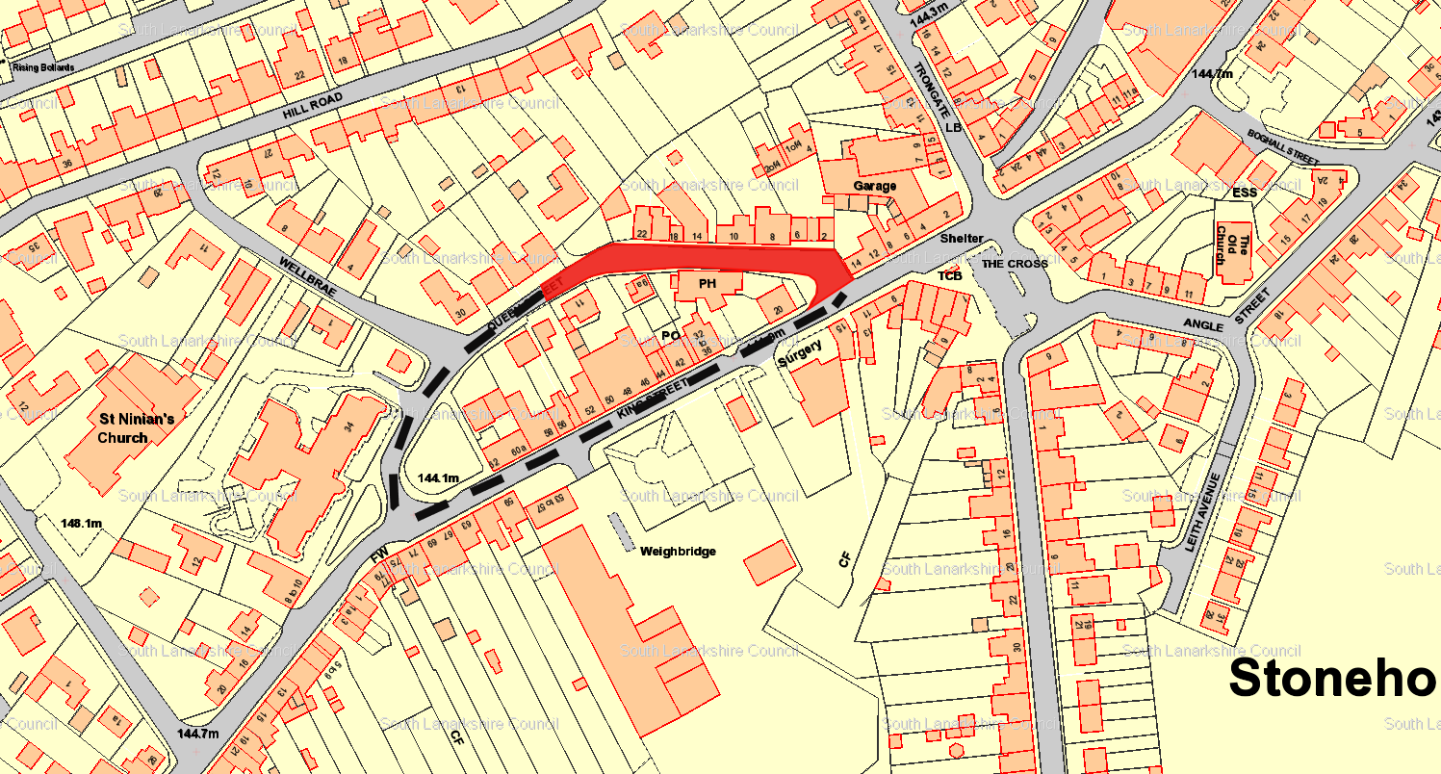

Diversion Route
Queen Street and King Street.

