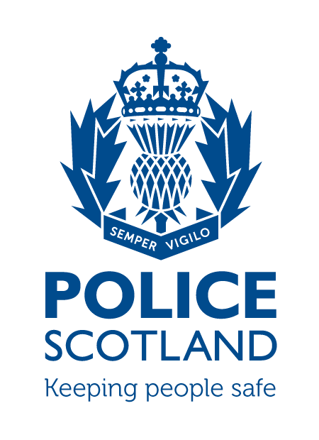
Criminal Activity December 2022
Beat Area BD01 & ME02 –
Bonnyrigg, Lasswade, Poltonhall & District

During the month of December 2022 in the beat areas BD01 & ME02 – Bonnyrigg, Lasswade, Poltonhall & District – there were 242 calls to Police Scotland.

Solvency rates for Midlothian can be found on the Police Scotland Quarterly Scrutiny Report which is available to counsellors.

INCIDENTS OF NOTE

Around 10pm on Friday 2nd December, on Hazel Drive, a male was assaulted by a group of males. Police enquiries are ongoing.

On Saturday 3rd December, on High Street, Bonnyrigg, an unknown male entered a retail premises and committed theft on three occasions throughout the day. Police enquiries are ongoing.

Around 6pm, on Tuesday 6th December, on Rosewell Road, a male was assaulted by an unknown male. Police enquiries are ongoing.

Around 9pm on Thursday 15th December at Auld Coal Drive, unknown person(s) broke into a property and stole jewellery. Police enquiries are ongoing.

Around 12pm on Friday 16th December two youths stole and damaged computer items from Lasswade High School. Police enquiries are ongoing.

Between 1-9pm on Wednesday 21st December at Broomieknowe Park, unknown person(s) broke into a property and stole jewellery. Police enquiries are ongoing.

Around 12pm on Friday 23rd December at High Street, Lasswade, a male vandalised two windows and assaulted a male. The male was traced by Police, arrested and charged with the three offences. A report has been submitted to the Procurator Fiscal.

Around 11pm on Tuesday 27th December on High Street, Bonnyrigg, an unknown male assaulted another male. Police enquiries are ongoing.
Shopliftings
There has been 3 shopliftings reported to Police within the Bonnyrigg, Lasswade and Polton Hall districts in December.
If any person has any information about the incidents listed above, or indeed any other crime, please contact your Community Policing Officers PC Jonny Cassidy & PC Chris Howarth via 101 or email:

BonnyriggCPT@scotland.police.uk

Additional Information

Information regarding crime can be passed to Crimestoppers on 0800 555 111 or through an Online Form - both of these routes are completely anonymous and available 24 hours a day, 365 days a year.

Police Scotland use social media to circulate the latest news, events and information to the public via Twitter (@LothBordPolice and @MidLothPolice) and Facebook (www.facebook.com/LothiansScottishBordersPoliceDivision and www.facebook.com/MidlothianPolice).

