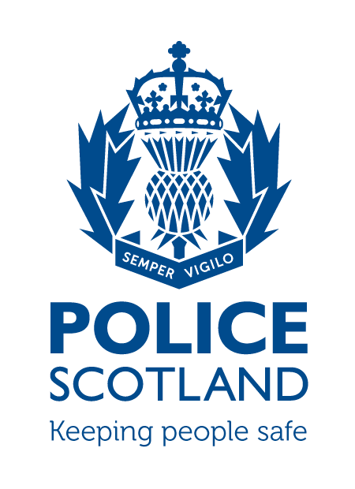
Criminal Activity February
Beat Area BD01 & ME02 –
Bonnyrigg, Lasswade, Poltonhall & District

During the month of February 2024 in the beat areas BD01 & ME02 – Bonnyrigg, Lasswade, Poltonhall & District – there were 257 Calls made to Police.

Crime statistics can be requested through a freedom of information request.

INCIDENTS OF NOTE

On Thursday the 1st of February 2024, Police received an anonymous call regarding motorbikes which had been dumped in the Cockpen area of Bonnyrigg. Community Officer attended and forensically recovered the bikes. The bikes were stolen from the Penicuik area one week prior. Enquiries are still ongoing.

On Saturday the 3rd of February 2024, Officers stopped a vehicle due to its poor manner of driving. The 38 year old driver was subject to a breath test which was passed, however, a 24 year old male passenger was searched under the Misuse of Drugs act due to having residual white powder on his clothing. He found in possession of cocaine. The male was issued with a recorded Police warning.

Around 2230 hours on Saturday the 3rd of February 2024, Youths smashed two offside windows of a Lothian Bus on Cockpen Road. Thankfully, no one was injured however the bus had to be pulled off service and will need to undergo costly repairs. Enquires are still ongoing.

On the evening of the 4th of February 2024, Police received a call regarding youths throwing stones at cars on Cockpen Road. Police attended the area however there was no trace of any youths. No vehicles were damaged as a result of the youths actions.

Around 0015 hours on Monday the 5th of February 2024, Community officers traced a vehicle parked within the car park behind cheeky chicken (just off Dobbies Road). The vehicle was showing as being stolen from the Gorebridge area the previous day. The vehicle was forensically uplifted.

Police have received calls regarding youths setting fires in the Kings Park Area on the 6th, Polton Street on the 8th, and Lasswade High School on the 9th. One youths was identified for the Lasswade High School incident and was charged by Community Officers for wilful fire-raising. Since this incident, Police have not received any report of fires set by youths.

Around 0330 hours, Friday the 9th of February 2024, a window was smashed at an address on Moorfoot View. Enquires have not established any suspects.

On Friday the 9th of February 2024, Police executed a warrant at Poltonhall industrial estate. A stolen car was found and has been forensically uplifted. Enquires are still ongoing.

Around 1530 hours, Saturday the 10th of February 2024, Youths have damaged a common stair door on Auld Coal Road. Enquires have not established any suspects.

Around 1100 hours, Tuesday the 13th of February 2024, a male has entered the Bonnyrigg and Sherwood Trust charity Shop and has taken a customer’s handbag. CCTV shows a male in his 30’s entering and uplifting the bag, before leaving the shop. Enquiries are still ongoing.

On Sunday the 18th of October, between 1800 and 1930 hours, Community officers carried out a speed check at Cockpen Road and Eskbank Road in Bonnyrigg. Although the majority of vehicles were obeying the speed limit, 3 drivers needed to be warned regarding their speed and a further two drivers were issued with a Speeding ticket of 3 Points and a £100 fine.

On Sunday the 18th of February 2024, a male has attended at Flavours, Staiside Court, Bonnyrigg, and has stolen approximately £25 worth of confectionery. Enquires are still ongoing.

Between Wednesday the 21st and Thursday the 22nd of February 2024, a vehicle was damaged on Broomieknowe. It appears as if the vehicle has been keyed. Enquires did not establish any suspects.

On Friday the 23rd of February 2024, a warrant was carried out at an address in Campview Road. A Large quantity of drugs, including heroin, Amphetamine and fake diazepam, along with a 4 figure quantity of cash was seized from the locus. A 40 year old male was arrested and charged for drugs offences.

Around 0145 hours on Saturday the 24th of February 2024, a vehicle was stopped on Cockpen Road due to a poor manner of Driving. Enquires established the 17 year old driver did not have a valid driving licence, was no insured on the vehicle and had taken the vehicle without permission from the owner. The male was charged with the driving offences.

Around 0005 hours, Wednesday the 28th of February, Police came across a vehicle which had crashed into Melville Dykes Roundabout. Enquiry’s showed the 50 year old male driver failed to slow in time for the roundabout. The male driver was charged with careless driving and reported to the procurator fiscal.

On Wednesday the 28th of February 2024, Police were made aware of a van which was smelling of cannabis on Littlewood Grove. Community officers attended and both the driver and 23 year old male passenger were detained for a drugs search. The passenger was found to be in possession of cannabis. He was issued a Recorded Police Warning for possession of Cannabis.

On Thursday the 29th of February 2024, a vehicle has stuck a 26 year old while he was crossing the road. The 70 year old male driver was issued with a ticket for careless driving. The pedestrian was taken to hospital as a precaution however did not have any serious injuries.

If any person has any information about the incidents listed above, or indeed any other crime, please contact your Community Policing Officer PC Euan Lennox via 101 or email:
BonnyriggCPT@scotland.police.uk

Additional Information

Crimestoppers
Do you have information on criminal activity in your area? Please call crimestoppers on 0800 555 111 or through an Online Form - both of these routes are completely anonymous and available 24 hours a day, 365 days a year.

Police Scotland use social media to circulate the latest news, events and information to the public via Twitter (@LothBordPolice and @MidLothPolice) and Facebook (www.facebook.com/LothiansScottishBordersPoliceDivision and www.facebook.com/MidlothianPolice).

