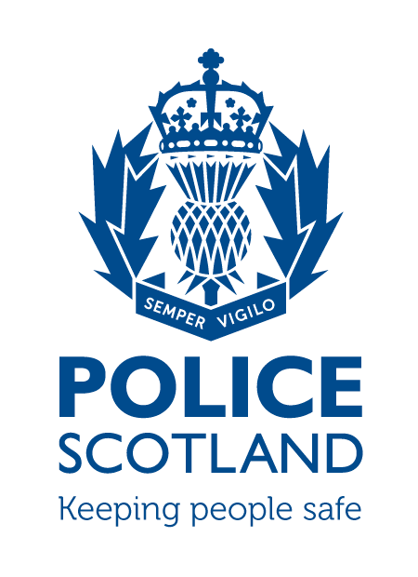
Criminal Activity March
Beat Area BD01 & ME02 –
Bonnyrigg, Lasswade, Poltonhall & District

During the month of March 2024 in the beat areas BD01 & ME02 – Bonnyrigg, Lasswade, Poltonhall & District – there were 323 Calls made to Police.

Crime statistics can be requested through a freedom of information request.

INCIDENTS OF NOTE

Around 1330 hours, Friday the 1st of March, Community Officers observed an off road bike driving on the footpaths at Burnbrae Road North. The driver was identified by Officers as a 14 year old male. The youth was charged and reported for driving offences and his bike was seized.

Around 0930 hours, Wednesday the 6th of March, a 43 year old male has entered Tesco Express, Rosewell Road and began shouting, swearing and asking members of staff for a fight. The male left once staff informed him the Police were called. Police attended and identified the male from CCTV. The male was issued a recorded Police Warning for threatening and abusive behaviour.

Around 1315 hours, Wednesday the 6th of March, Roads Policing stopped a vehicle due to its manner of driving on Cockpen Road, Bonnyrigg. The driver of the vehicle was subject to a Drugs wipe, which he failed. The driver was arrested and taken to the Police station to provide bloods for analysis.

Around 2330 hours, Wednesday the 6th of March, a 45 year old male has entered the Melville inn though a cellar door. Staff have found him within, where the male stated he was looking to see if they were open. He thereafter left. Police enquiries have since linked the male to a number of thefts in the Edinburgh and Lothians area. The male was traced and charged for this incident with being within the curtilage of a building with intent to steal.

On the evening of Sunday the 10th of March, several vehicles on Polton Avenue Road has their tyres slashed. Police enquires are still ongoing.

Around 1330 hours, Monday the 11th of March, Officers have been behind a vehicle on Melville dykes road that has been driving in a poor manner. Officers signalled for the vehicle to stop, which it initially failed to. The driver eventually pulled into Elginhaugh car park on Gilmerton Road. The driver was subject to a breath test that he failed. He was taken to the Police station where he blew over 4x the legal limit. He was charged with drink driving and was held until sober.

Between 1700 hours on Wednesday the 13th of March to 0900 hours on Thursday the 14th of March, a property on Broomieknowe Gardens was broken into by snapping a lock on a rear door. Multiple items from within were taken. Scenes of Crimes officers attended for forensic opportunities and enquiries are ongoing.

Between Thursday the 14th of March and Friday the 15th of March 2024, a Portable Cabin near to Dobbies Garden Centre was broken into via an insecure window. The alarm for the cabin was taken, however, nothing else from within appears to be missing. Enquiries have not established any suspects.

Around 0030 hours, Friday the 15th of March, a 52 year old male has stolen items from an external freezer at Gigi’s restaurant, Lothian Street. The male was identified by Police and was charged with theft.

Around 0430 hours, Saturday the 16th of March, two males have attempted to break into a shed at Cameron Crescent. The males were disturbed by the occupier. The males threw a bush towards the occupier and ran off from the area. Police enquires have not established any suspects.

On Monday the 18th of March, Police received a call of a vehicle that had been on Polton Drive for over a month. Officers attended and noted the Registration did not relate to the vehicle. Further checks showed the vehicle as being previously stolen. The vehicle was uplifted.

On the evening of Wednesday the 20th of March, a vehicle was keyed on Auld Coal Drive. Police enquires are still ongoing.

Around 0100 hours on Friday the 22nd of March, a car has collided with two parked cars on Eskdale Drive. Police attended and the driver of the vehicle failed the road side breath test. He was taken to the Police station where he blew over 3x the legal limit. He was charged with drink driving and was held until sober.

Around 1745 hours, Friday the 22nd of March, two youths were spotted on a off road motorbike near Chesters court and later on Rosewell Road. The youths were riding on public foot paths. On Saturday the 23rd around 1845 hours, Police received a similar call regarding a quad bike in the hope field estate They have not yet been identified however intelligence has been submitted.

On the evening of Sunday the 24th of March, the back window of a vehicle was smashed on Maryfield Place. Enquiries are still ongoing.

If any person has any information about the incidents listed above, or indeed any other crime, please contact your Community Policing Officer PC Euan Lennox via 101 or email:
BonnyriggCPT@scotland.police.uk

Additional Information

Crimestoppers
Do you have information on criminal activity in your area? Please call crimestoppers on 0800 555 111 or through an Online Form - both of these routes are completely anonymous and available 24 hours a day, 365 days a year.

Police Scotland use social media to circulate the latest news, events and information to the public via Twitter (@LothBordPolice and @MidLothPolice) and Facebook (www.facebook.com/LothiansScottishBordersPoliceDivision and www.facebook.com/MidlothianPolice).

