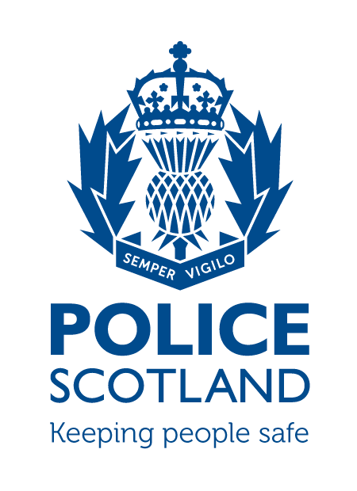
Midlothian Community Council Report
July 2025
Beat Areas BD01 and ME02
Bonnyrigg

During the period 01/07/2025 to 31/07/2025 in the beat areas BD01 and ME02 there were 270 calls made to Police with 64 crime reports raised.

Incidents of Note

On 03/07/25 youths damaged a vehicle that was parked in Polton Avenue Road, Bonnyrigg.

On 04/07/25 2 x shopliftings reported at Morrisons, Burnbrae Road, Bonnyrigg

On 05/07/25 drink driver in High Street, Bonnyrigg

On 06/07/25 an attempt was made to force entry to a property in Eldindean Road, Bonnyrigg

On 09/07/25 a warrant was executed at a property just off Eskbank Road, Bonnyrigg and drugs found. The occupier has been charged.

Between the 12/07/25 and 18/07 /25 a vehicle parked in the car park at Lasswade High School was vandalised, its window was smashed.

On 19/07/25 two males were found on the scaffolding at Moorfoot View, Bonnyrigg, they had no reasonable excuse for being there. They were searched and found in possession of offensive weapons.

On 25/07 a youth damaged the sign outside the CO-OP, he then tried to set fire to a bin in King George V park and was abusive towards a member of the public. He was traced and charged.

On 26/07/25 a motor bike was stolen from Farm Avenue, Bonnyrigg.

On 27/07/25 at Burnbrae Road a male was found in possession of cannabis.

On 30/07/25 a property was broken into in Bannockrigg Loan, Bonnyrigg and a vehicle stolen.

During the month of July numerous drivers were charged with Road Traffic Offences at various locations in Bonnyrigg and Lasswade, these offences include dangerous driving, driving with no insurance, being drunk in charge of a vehicle, driving with a false plate and failing to stop after an accident.

If any person has any information about the incidents listed above, or indeed any other crime, please contact your Community Policing Officer PC Fiona Cunningham via 101 or email: 1503903CPT@scotland.police.uk

Additional Information

Crimestoppers

Do you have information on criminal activity in your area? Please call Crimestoppers on 0800 555 111 or through their online form - both of these routes are completely anonymous and available 365 days a year.

Social Media
Police Scotland use social media to circulate the latest news, events and information to the public via X (@PSOSMidlothian & @PoliceScotland) and Facebook (Police Scotland Midlothian & Police Scotland).

