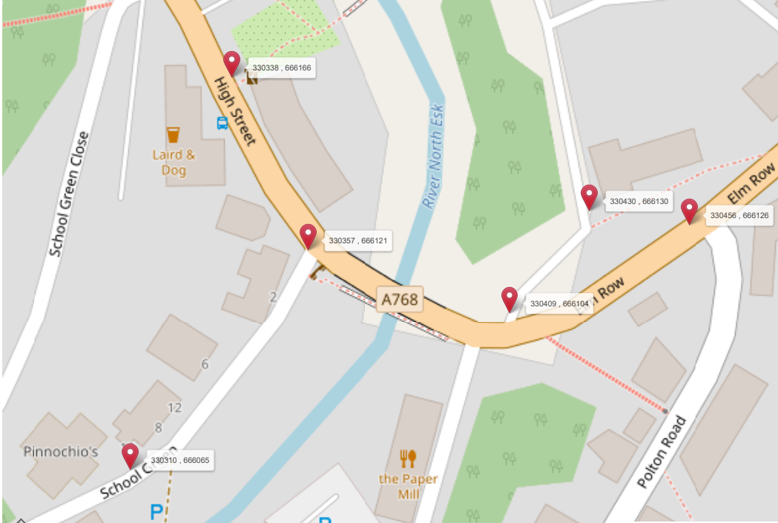

Working Area

Parking Restrictions`