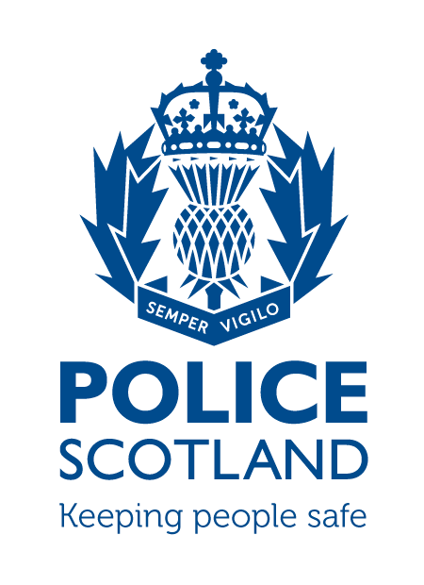
Criminal Activity January 2021
Beat Area BD01 & ME02 –
Bonnyrigg, Lasswade, Poltonhall & District

During the month of January 2021 in the beat areas BD01 & ME02 – Bonnyrigg, Lasswade, Poltonhall & District – there were 61 recorded crimes reported, of which 39 have been solved to date, with a solvency rate of 64%

During this time period, there were 256 calls to Police Scotland.

INCIDENTS OF NOTE

Between 5pm on Wednesday 30th December and 1220pm Friday 1st January a window to a business property was smashed by unknown persons. Police enquiries are ongoing.

About 5pm on Sunday 3rd January on Rosewell Road there was a breach of Covid-19 Regulations. The party was dispersed by officers.

About 12:30am on Tuesday 5th January on Gold Course Road, unknown person(s) attempted to break into a garage. Police enquiries are ongoing.

Between Monday 4th and Tuesday 5th January on Lower Broomieknowe two males broke into a garage and stole two mountain bikes. Both males were charged and reported to the Procurator Fiscal. Bikes were recovered and returned to their owner.

About 2am on Saturday 9th January a male attempted to break into a property n Eldindean Terrace. The male was traced by Police, charged and reported to the Procurator Fiscal.

About 11pm on Saturday 9th January threatening calls were made to an address at Waverley Crescent. A male was traced by Police, charged and reported to the Procurator Fiscal.

About 11:30pm on Saturday 9th January a vehicle was stopped by officers due to the smell of drugs. Two passengers of the vehicle were found to be in possession of cannabis. Both persons issued Police Warnings.

Between the evening of Thursday 7th and early morning of Friday 8th an unknown vehicle has damaged another vehicle on Polton Street. Police enquiries are ongoing.

About 7:20pm on Saturday 16th January Police stopped a vehicle on Dobbies Road for a proactive drugs search. Police recovered £560 worth of controlled drugs. Two males were charged and reported to the Procurator Fiscal.

About 8:40pm on Saturday 16th January a vehicle was being driven dangerously within the Polton Road area. The vehicle then made off from Police. The driver off the vehicle was traced by Police, charged for numerous driving offences and a report submitted to the Procurator Fiscal.

About 9:20pm on Saturday 16th January Police stopped a vehicle in the car park of Lasswade High School, Police searched the vehicle and found a small amount of cannabis. The driver of the vehicle was issued a Recorded Police Warning.

About 1pm on Tuesday 26th January on Burnbrae Road there was a breach of Covid-19 Regulations within a house. The numerous persons were dispersed by officers.

About 8:30am on Friday 29th January on High Street, Bonnyrigg officers noted a vehicle to not hold valid insurance. The vehicle was seized by officers and the driver of the vehicle was charged and reported to the Procurator Fiscal.

About 3:45pm on Saturday 30th January in Park Crescent two males were fighting, one male had a knife in his possession. One male was arrested and charged. A report was submitted to the Procurator Fiscal.

About 11:20pm on Saturday 30th January on Waverley Crescent a male was witnessed to damage three tyres on a Nissan van. Police enquiries are ongoing.

There have been numerous calls relating to Covid-19 breaches in the Bonnyrigg area particularly within Burnbrae Primary School and Lasswade Rugby Club where large groups have been playing football. Police have been pro-actively patrolling these and other areas in response to this.

If any person has any information about the incidents listed above, or indeed any other crime, please contact your Community Policing Officers PC Jonny Cassidy & PC Chris Howarth via 101 or email:

Jonathan.Cassidy@scotland.pnn.police.uk
Christopher.Howarth@scotland.pnn.police.uk

Additional Information

Information regarding crime can be passed to Crimestoppers on 0800 555 111 or through an Online Form - both of these routes are completely anonymous and available 24 hours a day, 365 days a year.

Police Scotland use social media to circulate the latest news, events and information to the public via Twitter (@LothBordPolice and @MidLothPolice) and Facebook (www.facebook.com/LothiansScottishBordersPoliceDivision and www.facebook.com/MidlothianPolice).

