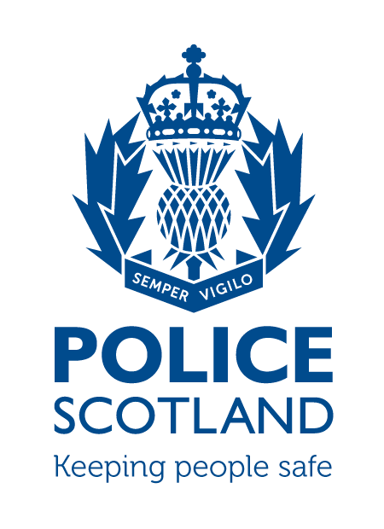Criminal Activity December 2021
Beat Area BD01 & ME02 –
Bonnyrigg, Lasswade, Poltonhall & District

During the month of December 2021 in the beat areas BD01 & ME02 – Bonnyrigg, Lasswade, Poltonhall & District – there were 70 recorded crimes reported, of which 26 have been solved to date, with a solvency rate of 37%

During this time period, there were 297 calls to the BD01 and ME02 area of Police Scotland.

INCIDENTS OF NOTE

About 2:30pm on Thursday 2nd December at High Street, Bonnyrigg, unknown youths attended and vandalised a door. Enquiries are ongoing.

About 9pm on Thursday 2nd December at Old Market Place, Bonnyrigg, a group of youths threw stones at windows causing damage. Three youths have been charged and a youth offending report has been submitted to the youth justice officer.

About 12:30pm on Sunday 5th December at Dalhousie Drive a vehicle struck a fence of a property, causing damage and made off from the scene. Enquiries are ongoing to trace the driver.

About 3:30pm on Sunday 5th of December at Waugh Path, Bonnyrigg, an unknown group of youths smashed a window of a property by throwing a brick. Enquiries are ongoing.

About 6pm on Sunday 5th of December at Lasswade Centre two youths stole toilet paper and then set it on fire outside of the building. Both youths have been charged and a youth offending report has been submitted to the youth justice officer.

About 1:30am on Saturday 11th of December at The Royal Oak, a disturbance broke out resulting in a window being smashed by unknown person(s). Enquiries are ongoing.

About 9:30pm on Saturday 11th of December at Gloria’s, High Street, Bonnyrigg, a youth vandalised a window. The youth has been charged and a youth offending report has been submitted to the youth justice officer.

About 9am on Tuesday 14th of December at Saw Mill Terrace, Police observed a male driving a vehicle under the influence of drugs. The male was conveyed to St Leonards Custody Centre and a report was submitted to the Procurator Fiscal for various driving offences.

About 11pm on Tuesday 14th December at The Anvil, High Street, Bonnyrigg, a male vandalised a window. The male was charged and a report was submitted to the Procurator Fiscal.

About 7pm on Sunday 19th December at Rosewell Road, a group of 10 youths were fighting resulting in a vehicle being vandalised. Enquiries are ongoing.

About 7pm on Tuesday 21st December at Sherwood Terrace, a group of youths threw items at a window causing damage. Enquiries are ongoing.

About 9:30pm on Tuesday 21st of December at The Polton Inn, Polton Road, Lasswade, a disturbance broke out resulting in a window being smashed. Police attended and two males were arrested and reported to the Procurator Fiscal for assault and vandalism.

About 6pm on Tuesday 28th of December, a vehicle was parked on Dundas Street when it was struck by another vehicle and damaged. Police enquiries are ongoing.

Youth Disorder
There has been numerous reports of youths causing a nuisance in the community including setting off fireworks, throwing eggs and other items at properties and setting fires.
In response to this local community officers, Midlothian Community Action Team and the School Liaison Officer have been working with local schools to identify those responsible and report concerns for their behaviours to partner agencies.

Shopliftings
There has been no reported shopliftings to Police within the Bonnyrigg, Lasswade and Polton Hall districts in December.
If any person has any information about the incidents listed above, or indeed any other crime, please contact your Community Policing Officers PC Jonny Cassidy & PC Chris Howarth via 101 or email:

Jonathan.Cassidy@scotland.pnn.police.uk
Christopher.Howarth@scotland.pnn.police.uk

Additional Information

Information regarding crime can be passed to Crimestoppers on 0800 555 111 or through an Online Form - both of these routes are completely anonymous and available 24 hours a day, 365 days a year.

Police Scotland use social media to circulate the latest news, events and information to the public via Twitter (@LothBordPolice and @MidLothPolice) and Facebook (www.facebook.com/LothiansScottishBordersPoliceDivision and www.facebook.com/MidlothianPolice).

