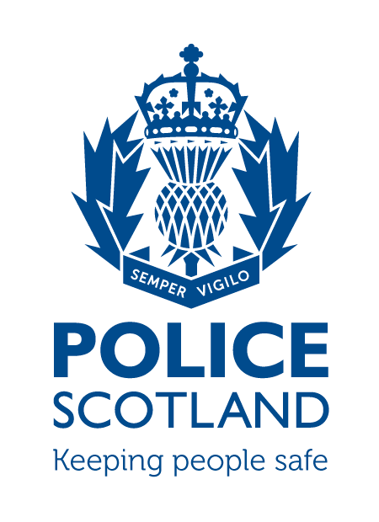
Criminal Activity April 2021
Beat Area BD01 & ME02 –
Bonnyrigg, Lasswade, Poltonhall & District

During the month of April 2021 in the beat areas BD01 & ME02 – Bonnyrigg, Lasswade, Poltonhall & District – there were 55 recorded crimes reported, of which 18 have been solved to date, with a solvency rate of 33%

During this time period, there were 257 calls to the BD01 and ME02 area of Police Scotland.

INCIDENTS OF NOTE

At 5:55pm on Saturday 3rd April in Moorfoot View, Bonnyrigg, a male was drunk and causing a disturbance within the street, the male was arrested and conveyed to custody. A report was submitted to the Procurator Fiscal.

At 7pm on Saturday 3rd April at St Ann’s Path, Lasswade there was an ongoing party within the garden breaching covid regulations. Police attended gave suitable advice and dispersed the party.

At 10pm on Monday 5th April at Dundas Street, Bonnyrigg, a male assaulted another male and shouted racist comments at him. The male was arrested and a report submitted to the Procurator Fiscal.

Between 10:45-11:45am on Tuesday 6th April on High Street, Bonnyrigg, a blue Mazda CX5 was vandalised by an unknown liquid being thrown onto the driver’s door. Police enquiries are ongoing.

At 3pm on Sunday 11th April on Hawthornden Avenue, Bonnyrigg, a male assaulted two persons by kicking and punching them. The male was arrested and conveyed to custody. A report was submitted to the Procurator Fiscal.

Between 10pm on Monday 12th and 8am on Tuesday 13th April on Cameron Crescent a bike was stolen from a garden. Police enquiries are ongoing.

At 8pm on Tuesday 13th April at Sherwood Court, Bonnyrigg, a male assaulted another male using a wooden plank and then threatened the male whilst brandishing a knife. The male was arrested and a report was submitted to the Procurator Fiscal.

Between 8pm on Thursday 8th April and 11am on Sunday 11th April at Lothian Street, Bonnyrigg, a bag containing clothing has been stolen from within a property. Police enquiries are ongoing.

At 4:30pm on Sunday 11th April at Douglas Crescent, Bonnyrigg, a male was stopped by Police and searched for drugs. £130 worth of drugs were seized from the male. The male was charged and a report submitted to the Procurator Fiscal.

At 4:20am on Saturday 17th April at Stevenson Place, Lasswade, a Seat Leon was stolen and crashed into a bridge a short distance away. The driver was traced by Police, charged with numerous Road Traffic offences and a report submitted to the Procurator Fiscal.

At 3pm on Tuesday 20th April at Dalhousie Medical Practice a male became verbally abusive with staff and acted in an aggressive manner. The male was traced by officers and issued a Recorded Police Warning.

Between Tuesday 20th and Thursday 22nd April at West Mill Road, Bonnyrigg, two bikes were stolen from within a garage. Police enquiries are ongoing.

Between 5pm on Thursday 22nd and 2:30am on Friday 23rd April at Gladstones Gait, Bonnyrigg two bikes were stolen from within a garden shed. Police enquiries are ongoing.

At 6:20pm on Friday 23rd April at King George V Park three males were fighting within the car park resulting in a serious assault taking place. One male was arrested and a report was submitted to the Procurator Fiscal.

If any person has any information about the incidents listed above, or indeed any other crime, please contact your Community Policing Officers PC Jonny Cassidy & PC Chris Howarth via 101 or email:

Jonathan.Cassidy@scotland.pnn.police.uk
Christopher.Howarth@scotland.pnn.police.uk

Additional Information
Information regarding crime can be passed to Crimestoppers on 0800 555 111 or through an Online Form - both of these routes are completely anonymous and available 24 hours a day, 365 days a year.

Police Scotland use social media to circulate the latest news, events and information to the public via Twitter (@LothBordPolice and @MidLothPolice) and Facebook (www.facebook.com/LothiansScottishBordersPoliceDivision and www.facebook.com/MidlothianPolice).

