St.Andrews & N.E. Fife Ramblers Newsletter April 2018
(http://www.standrewsnefiferamblers.com)

The 6 monthly newsletter format has been changed to provide more information about what has been happening in the Group in past 6 months, any known future activities that may be of interest to members and to include some photographs of our recent walks. As full details of our walks are provided in the Area Programme issued to all members, and can also be accessed from our Group website and/or Area website and/or Ramblers Scotland website, we are not including them in the Newsletter.
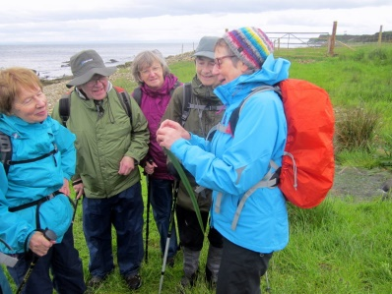
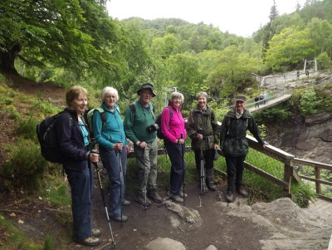
Despite some very poor weather
(first in over 10 years) for our
annual holiday last June in
Strathpeffer, 29 of us enjoyed a
lovely time with a varied
programme of walks, and a
comfortable hotel in Strathpeffer.

It has not put us off for 2018, where again Jim Coates is arranging a fun week in June, with a similar number signed up for Melrose. Although booking through Jim is closed now, if would like to come and can arrange own
accommodation, contact Jim on 01337 831113.

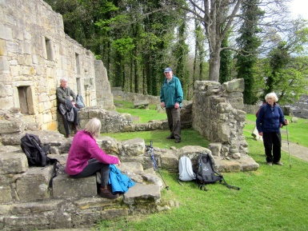
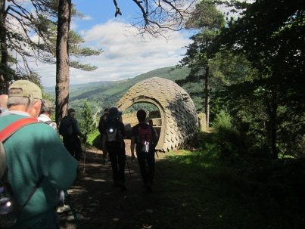
A recent survey of our regular
walks indicated that there was
little difference in support for
Wednesdays, Saturdays or
Sundays, so we are continuing in
Summer 2018 with biweekly
weekend walks—2 Saturdays to 1
Sunday walk, and 1 monthly Wednesday walk, designed to be easier, shorter and more local walks to the weekend ones. If you have ideas on this, please feel free to attend the Walk Planning meetings or submit them to me.

Membership & Walks Support
Like most Groups, our numbers are slowly falling but with 99 members at latest count, and walks continuing to be enjoyed by around half the members, the only real concerns are the drop in attendance in our Summer walks and the limited number of Walk Leaders. We would appeal to anyone who has not led a walk to consider giving it a go, as it has the major advantage that Leaders decide on the walks and the route that they like; also there is a lot of satisfaction in leading a walk, knowing you are helping other members to enjoy walking. Ramblers Scotland has started running courses on Walk Leadership and our own Leaders are always happy to help new Walk Leaders. Come along to next Walks Planning meeting, even just to get a flavour of choosing and organising our walks programme.

We often wonder whether the 50% of our members who do not come to our walks are still walking, since there are many members who may not feel fit enough but wish to continue to support Ramblers, and sometimes come along to our Christmas Lunch. It is great that they still help Ramblers and can occasionally enjoy the fellowship of old friends in the Group. There may be some members, however, who prefer to walk on own or with other Groups as they do not feel our Programme meets their needs. If so, please let us know how we might add walks you would like.

During the winter, a few members attended a very successful First Aid Training Day, organised by Ramblers Scotland. These are likely to be repeated and advised to members through the website and by email. If do not have access to either, let me know if would like to be informed.

Changes to Group Organisation
At recent AGM, whilst not many changes, 2 important ones should be noted. Jane Houston has taken on Press Correspondent and sure members will have noted her excellent Group reports in the local press. Currently, Jane is working with St Andrews in Focus and the equivalent magazine for Cupar to place articles in future publications, so look out for them. Jane also represented the Group, along with Bob Stirrat, at recent Town & Gown social interaction between local Groups and St Andrews University.
Michael Hammond has taken over Webmaster so watch out for improvements to our website in future months. Both Jane and Michael are always looking for items, photos so please pass on anything of interest.

New Walks Leaflets
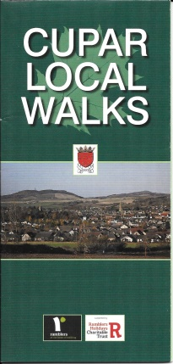
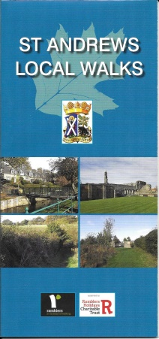
After an extremely successful fund-raising effort, we have been able to
recently publish new Local Walks Leaflets for both St Andrews and
Cupar, with the St Andrews one being significantly upgraded. A
number of members are now storing and distributing these, and links to
the leaflets are now on our website and a number of others. If have been
unable to obtain copies, please let myself or other Committee members
know and we can arrange for you to get them. And yes, they are free of
charge!

Area Organisation
The Forth Valley, Fife and Tayside Area is our local Ramblers Area, for which most members will appreciate the twice yearly combined Area Walks Programme. Additionally, the Area does a lot of work coordinating with Ramblers Scotland, particularly on walks access issues. Please report any access issues or queries to myself and can arrange Area follow-up or advice.
Our own Jim Forret is the Area Secretary and Ian Bruce is the guy who manages the Area Website (http://www.fvft-ramblers.org.uk/), which has a lot of useful information on Area Groups and walks, including Walks Map and Finder. Ian is also responsible for converting our Group walks into the Area Programme.

Scottish Council
The Council oversees the activities of Ramblers Scotland and every year we send 2 representatives to the annual meeting, which includes dinner, interesting guest speaker, overnight stay and the Council Meeting; always a fun event with chance to meet other Scottish ramblers. In 2018, Stewart & Linda Collier will attend the Council for us in March in Aberdeen. Although we have not submitted any items for the agenda, there are sure to be points of interest for all ramblers and these will be reported on in due course.

2018 Christmas Lunch
As we have to organise this before issue of Winter Newsletter, any suggestions for location within our area would be welcomed. As usual, it will be held on first Saturday of December.

2018 Scottish Gathering
The annual volunteer-led walking weekend, The Gathering, organised by Ramblers Scotland will this year be held in Perth from Friday 4 to Monday 7 May. Full details, including booking form, can be found on the Ramblers Scotland website. The walks will take in East Perthshire, Tayside and North Fife on the Saturday, Sunday and Monday. The main festival ‘hub’ will be The Station Hotel in Perth, which will be the departure/return point for the walks. The hotel will also host the evening entertainment throughout the weekend. For the first time, there will be gentle ‘stroller’ walks this year, visiting local historical points of interest at a slower, more relaxed pace. The event costs £20 per person - covering transport to/from walks, plus the evening entertainment.

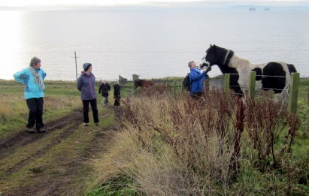
Let me know how can improve this newsletter for future

Happy summer walking!

Will Aitken, Secretary & Walks Coordinator

