St.Andrews & N.E. Fife Ramblers Newsletter April 2019
(http://www.standrewsnefiferamblers.com)

Our newsletter aims to keep members informed about our Group’s activities during the past 6 months, illustrated by a few photographs from our recent walks, and also to highlight some forthcoming events that may be of interest. You will find full details of our summer walks in the Area Programme and also on our Group, Area and Ramblers Scotland websites.

Membership and Communication
We have approximately 97 members at present, including a few new walkers who have joined us in recent months. At the AGM in November most office bearers agreed to continue in their existing roles, while Carol Philip, Christine Arnold and Colin Brown replaced those standing down as Committee Members. There is a concern that members who don’t have email are not receiving Ramblers information, as the postage costs and secretarial work involved in sending this out manually would be prohibitive. To try to help with this we are encouraging non-email members to seek out a Group email ‘buddy’ who can share this information with them.
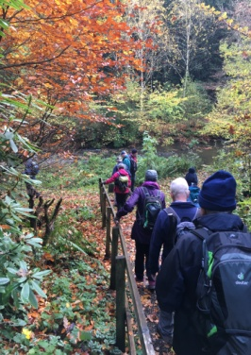
Following the introduction of the General Data Protection Regulation (GDPR) last May, and after much discussion, the Committee prepared a Group policy on data protection and management which was approved at the AGM and subsequently incorporated into the Constitution. The main change that most members will notice is that we no longer take a walk register; this has been replaced with a logbook which simply records the numbers attending each walk. We have also resumed taking photographs e.g. for the website and newsletter, but those attending can always opt out of these if they wish. Many thanks to Will Aitken for the hours spent in producing a workable document from often conflicting guidance!

Walks and Walk Leaders
Weekends and Wednesdays have all seen a slight reduction in numbers walking, with an average of 12 people per walk, although on a couple of days we have had as many as 24. It is pleasing to report that our leisurely Wednesday walks continue to attract members who still enjoy walking with us now and again, and everyone appreciates the opportunity to socialise afterwards in a nearby cafe.
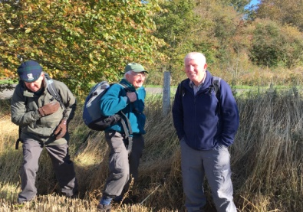
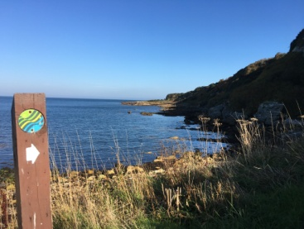
Our summer programme follows the usual format with Wednesday walks once a month and Saturday/Sunday walks every fortnight. At our walks planning meeting we recruited two new Walk Leaders, as well as those ‘regulars’ who consistently lead one or more walks in each programme. We also had more walks offered than we needed so there are some in reserve for next time. A couple of sections of the new Pilgrims’ Way (still to be formally opened) have been included. We are ever grateful to all of our Walk Leaders without whom there would be no programme, and we still want to encourage others to come forward. There is a Walk Leaders’ Guide and our experienced Leaders will also gladly help in getting you started.

Group Holiday in Dunoon: Monday 27th – Friday 31st May 2019
Since the last newsletter Jim Coates has arranged a 4-night Group holiday, staying at the Esplanade Hotel in Dunoon. At the time of writing 29 members and friends have booked and there is still some limited availability. Please contact Jim directly if you are interested in coming. Many thanks to Jim for his persistence in securing this holiday for us.

Training
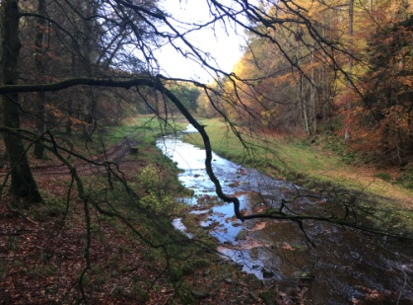
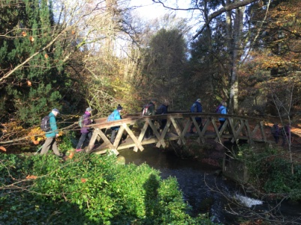
In September five of our members attended a most enjoyable two-day introductory Navigation Skills course, delivered by Roger Mitchell of Cupar Scouts. Grid references, compass bearings, timings and route planning were all covered on the first day. The following week we ventured out on a blustery, rainy day to put these skills into practice on a walk around Cupar, before seeking respite and lunch at the Mayfield, now sadly closed. Thanks to Stewart and Linda Collier for arranging this course. Further training opportunities – all entirely voluntary! - will be offered to members as they arise.

Publicity
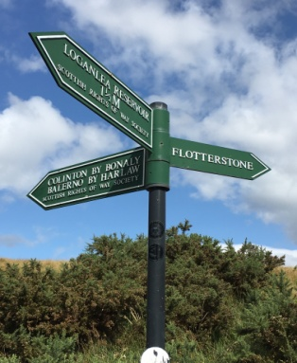
The local newspapers continue to publish just about everything your Press Correspondent submits. I have to thank those members of the Group who have provided interesting material – some intentionally and some not! – for my walk reports. These are now included on our website. A few members send photos from our walks to our Webmaster, Michael Hammond; he would welcome more of these, not only as a record of our walks, but as a way of perhaps encouraging interest in the Group from non-members. Our local Walks Leaflets for St Andrews and Cupar are still proving popular, with St Andrews Tourist Office regularly requesting new supplies.

Group Christmas Lunch 2018
A great turnout of 38 members and friends enjoyed a convivial afternoon with excellent fare at Elmwood Golf Club at the beginning of December. Suggestions for the venue for 2019 are invited.

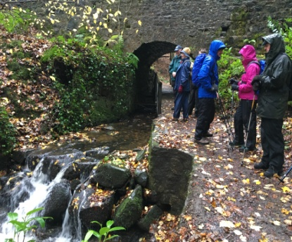
Area and Scottish Organisation
Jim Forret continues in his role as Area Secretary for Forth Valley, Fife and Tayside Ramblers which, amongst its many other activities, produces the combined Area Walks Programme that we all enjoy receiving every 6 months. The Area Website (http://www.fvft-ramblers.org.uk/) contains plenty of useful information on Area Groups and walks, including Walks Map and Finder. The Scottish Council, which oversees the activities of Ramblers Scotland, takes place in March 2019 in Dunblane. This year our representatives are Jim and Alison Forret.

Scottish Gathering 3rd – 6th May 2019
This year The Gathering, the annual volunteer-led walking weekend organised by Ramblers Scotland, will be held at Melrose. Full details and a booking form can be found on the Ramblers Scotland website.

Do let me know if there is anything else you would like to see in the next newsletter.

Enjoy your walking this summer!

Jane Houston, Press Correspondent

