The Ramblers - St Andrews & N.E. Fife Group

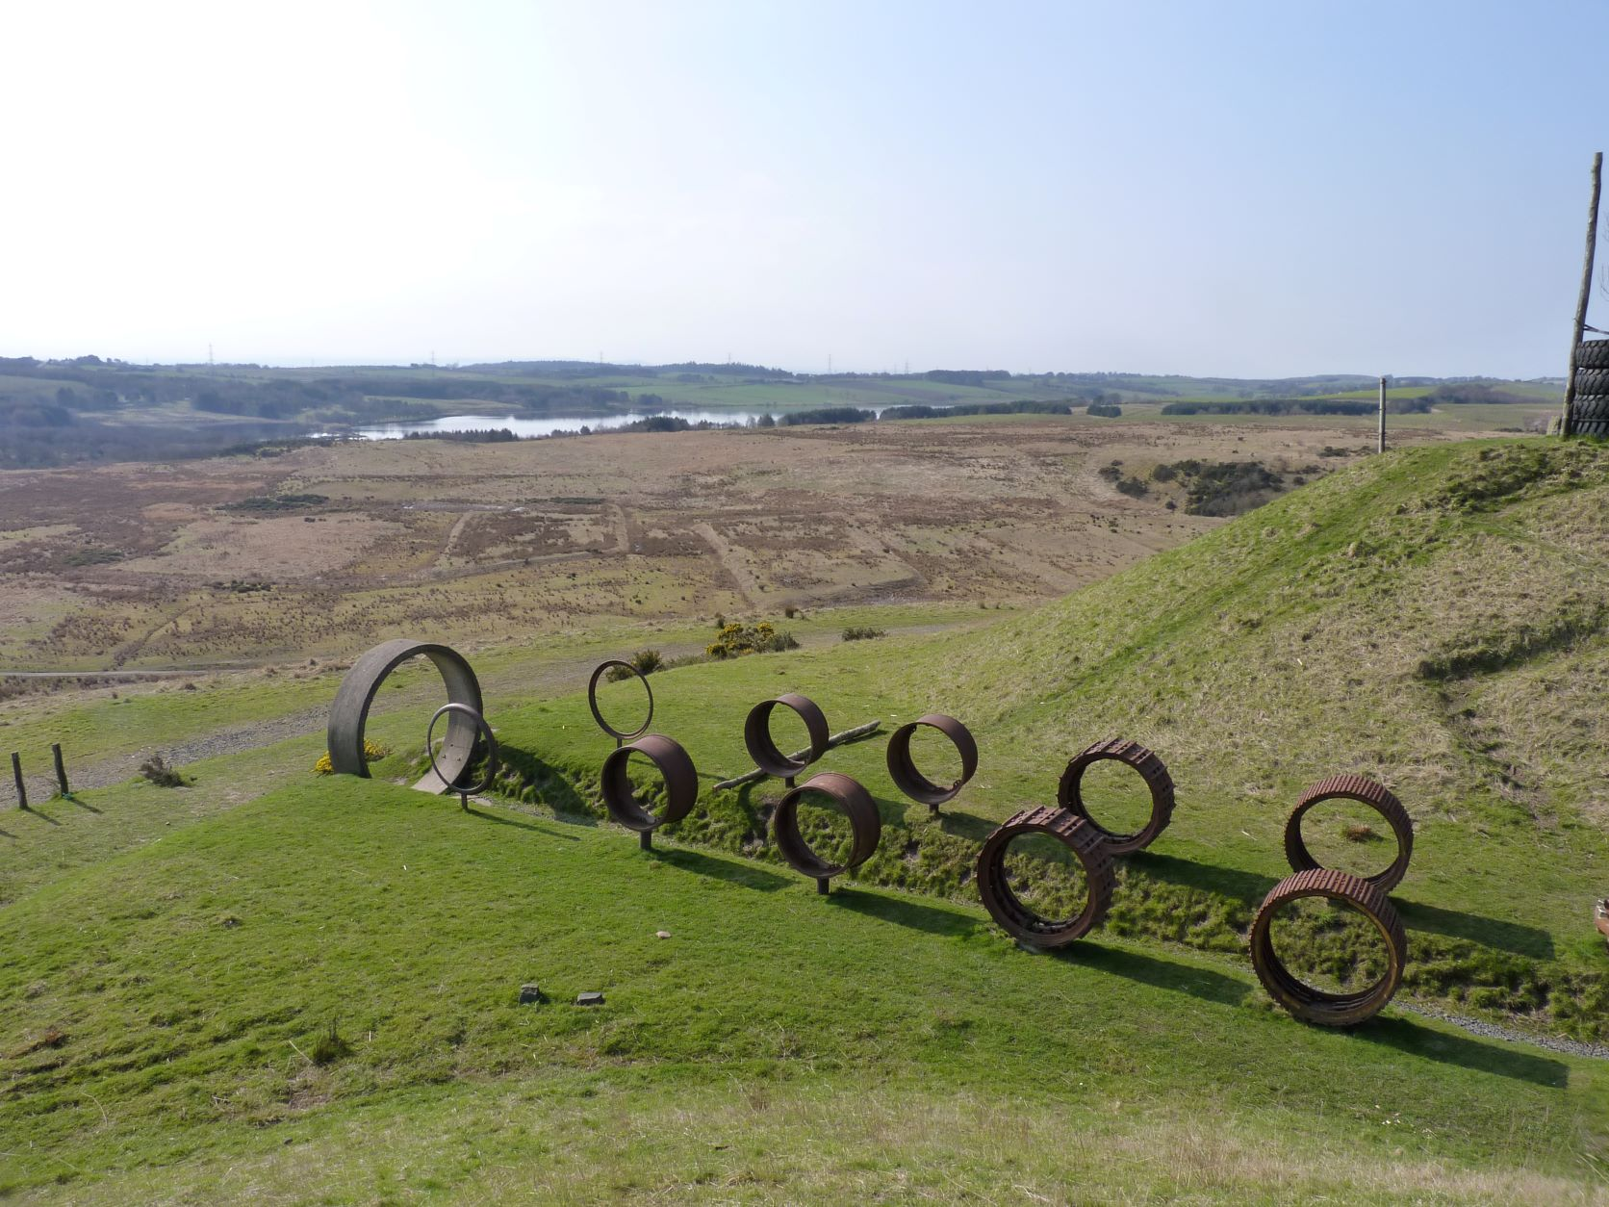
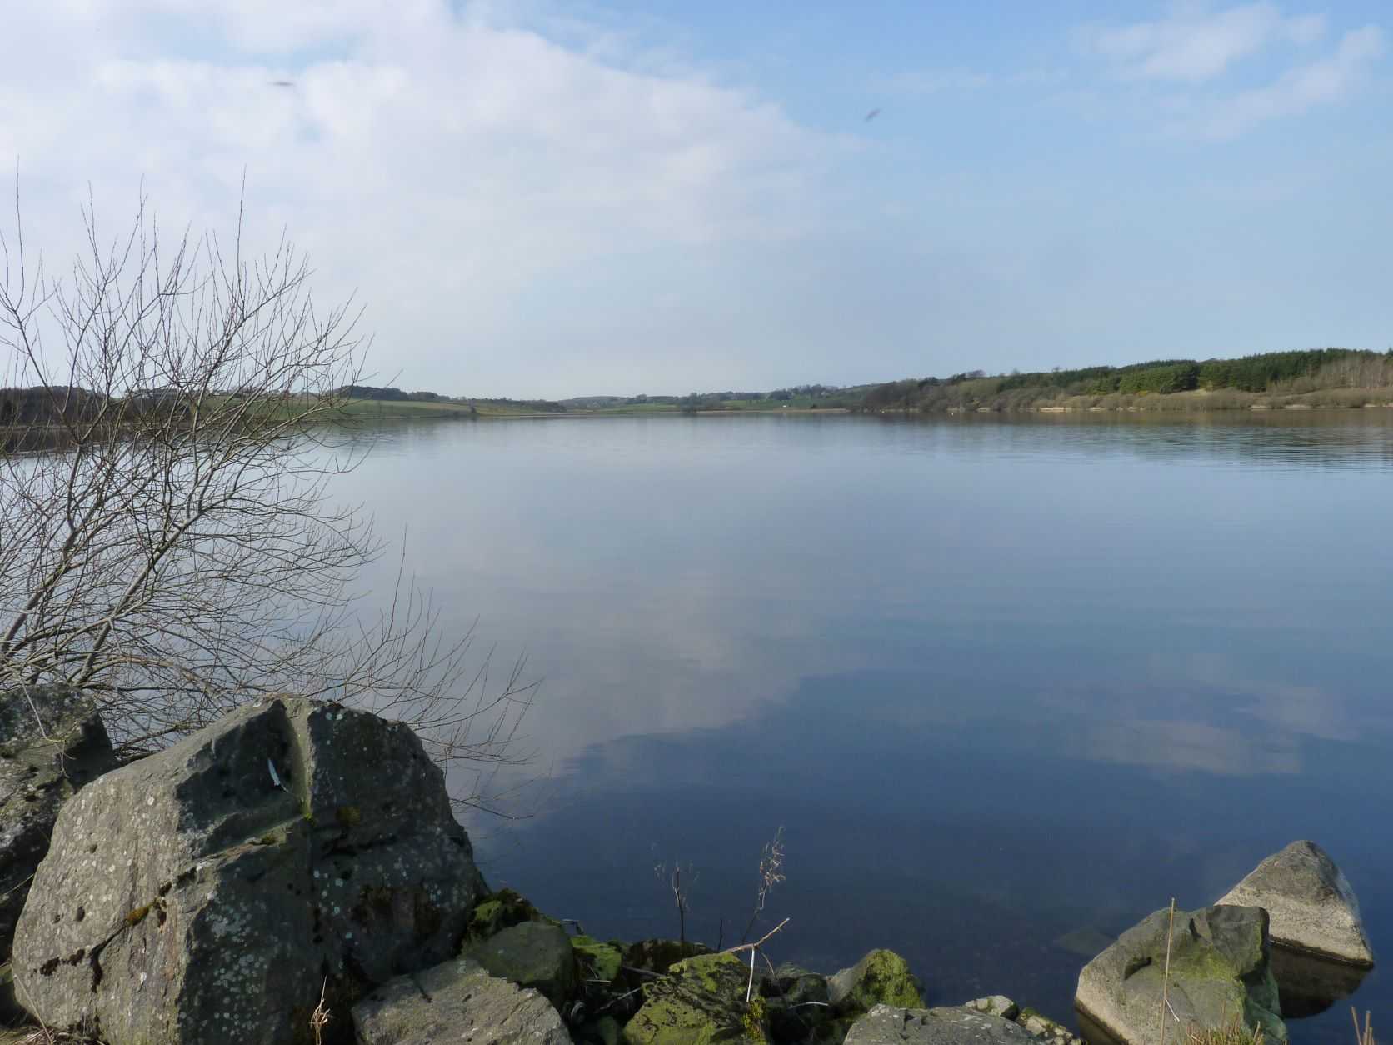
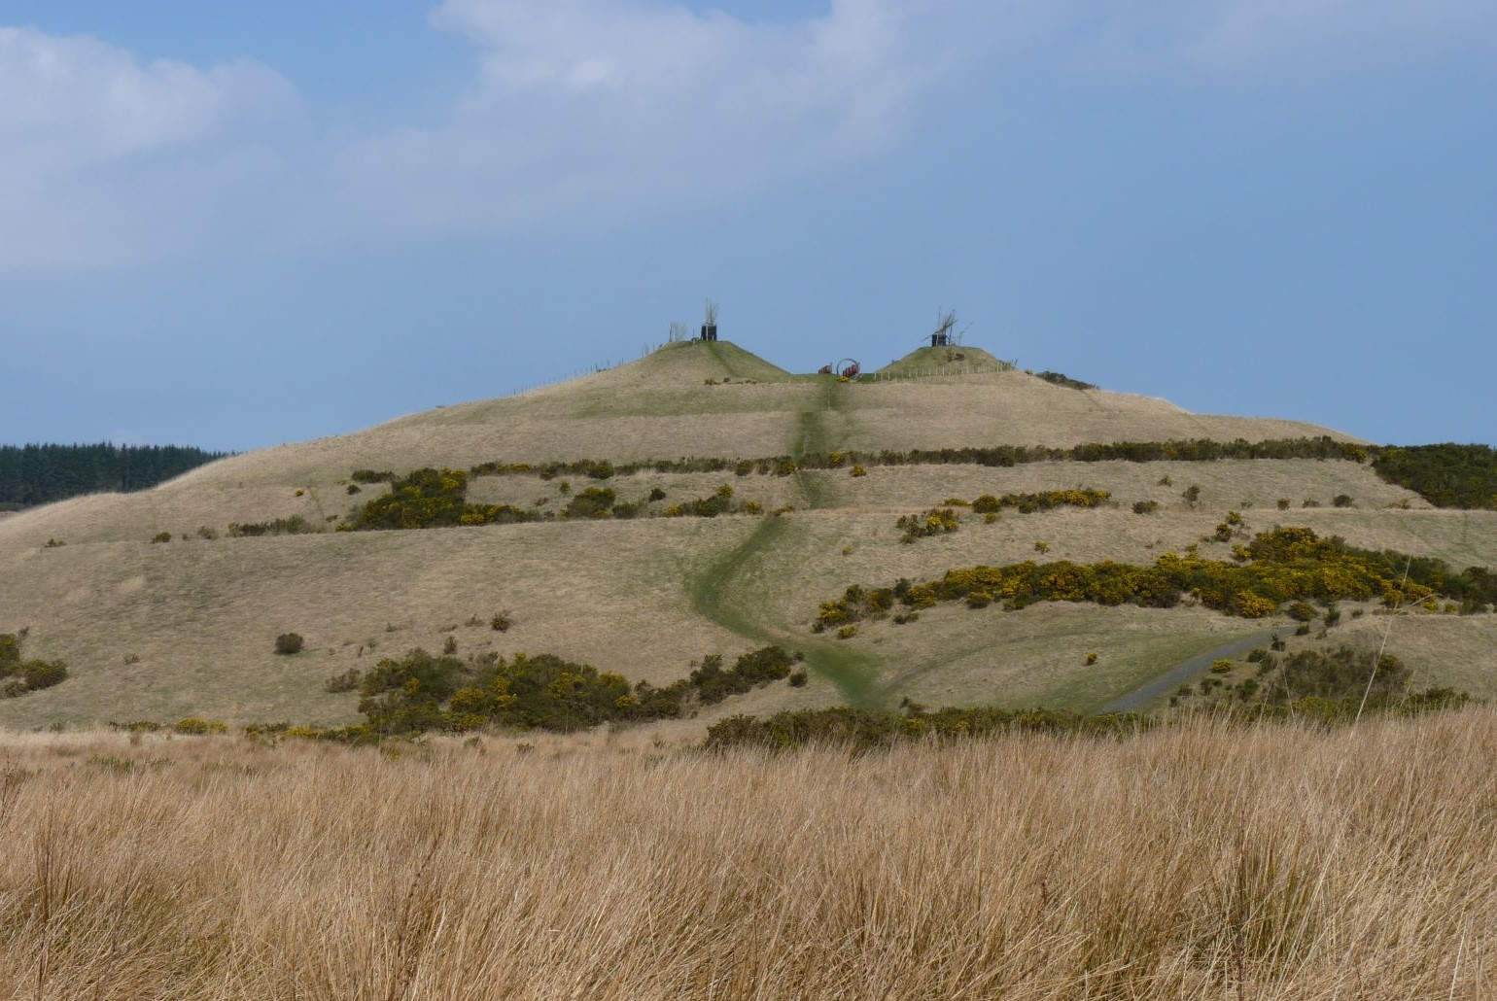
Eight St Andrews & North East Fife Ramblers embarked on an intriguing walk at the end of March, exploring the former opencast mining area of St Ninian’s in central Fife with its distinctive artificial hills. The area was also the site of the thriving agricultural and later mining village of Lassodie. Setting out from Kingseat we briefly followed the Fife Pilgrim Way, crossing the causeway at the eastern end of a completely calm Loch Fitty and then heading across the slightly marshy open ground towards the 3-peaked hill of St Ninian’s East. We opted for the gently ascending spiral pathway – which gives the hill its nickname ‘walnut whip’ – rather than the direct but steep track to the summit. We stopped near the top for a coffee break, enjoying both the warm spring sunshine and the expansive views over the rather desolate landscape. Continuing to the summit we explored the avenue of old pipe sections, digger scoops and engine wheels forming the first and only stage of an abandoned public artwork project originally designed by the landscape architect Charles Jencks. Shortly after we began our descent one of our number discovered his glasses were missing and he returned to the top to retrieve them. When he failed to reappear, the rest of us went back up to the summit, where he was nowhere to be seen. There followed an interval of mild chaos when the walk leader (aka your correspondent) somehow managed to ‘misplace’ the whole group, as we pursued each other around the spiral pathway. Two phone calls later we were finally reunited, as were our colleague and his spectacles, and we took the steep shortcut down the side of the hill and on to St Ninian’s West. This offered no gentle option and we climbed slowly up the steep, but fairly short, track for lunch near the summit. The remainder of the walk – thankfully without further incident! – consisted of a pleasant flat track back to Loch Fitty, where we crossed over the causeway once again and made our way back to Kingseat. The day was complete with a visit to a nearby farm shop and café where we enjoyed our customary reward of tea, coffee and cake before making our way home.

Details of our walks – which are open to guests as well as members of Ramblers – can be found on our website www.standrewsnefiferamblers.com

