St.Andrews & N.E. Fife Ramblers Newsletter October 2018
(http://www.standrewsnefiferamblers.com)

The new format for our 6 monthly newsletter has been continued. It includes information about what has been happening in the Group in the past 6 months, any known future activities that may be of interest to members and a few photographs from recent walks. Full details of our forthcoming walks are provided in the Area Programme and also on our Group, Area and Ramblers Scotland websites.

Holiday in Melrose June 2018
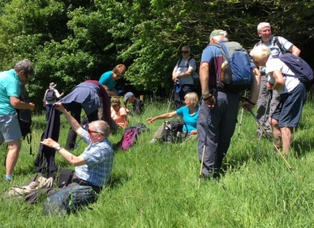
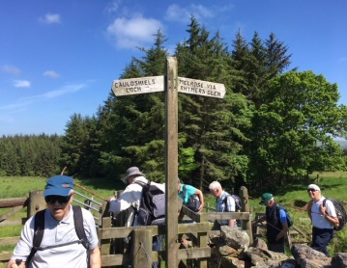
In June just under 30 of us spent a
splendid 4 days walking in
Melrose where (unlike last year)
we enjoyed very sunny weather at
the start of this summer’s
heatwave. Many thanks to Jim
Coates for arranging this holiday
and researching the wide variety of walks on offer. Despite his best efforts Jim has not been able to obtain suitable hotel accommodation for the same week next year. There was not enough interest in a long weekend proposed instead, so unfortunately there are no Group holiday plans at present.

Walks and Walk Leadership
At our Winter Walks Planning Meeting the Committee agreed some criteria for our monthly Wednesday fellowship walks, with the aim of making them accessible to more members. These easy walks will be no more than 40 minutes’ drive from Cupar or St Andrews, grade D, D+ or C and a maximum of 5 miles, all with the aim of finishing at a cafe. Weekend walks will continue every fortnight as usual, with two Saturdays to one Sunday.

As always, we are very grateful to the small number of Walk Leaders who regularly volunteer to lead one, two or sometimes three walks in each of our summer and winter programmes. Seven members of our Group attended a one-day Walk Leadership course in July provided by Ramblers Scotland. The course, which is aimed at experienced and inexperienced walk leaders alike, was delivered in an entertaining and practical way and all those who took part thought they gained helpful pointers and ideas for leading future walks. However, you certainly don’t need to complete this course before taking on the role of Walk Leader, as our experienced Leaders will gladly help in getting you started. Please give this some thought if you haven’t yet led a walk.

Training
It has been a busy time for training events, as we now have seven members who are Emergency First Aiders; and a further six members are booked on a two-day Introductory Navigation Skills course taking place in September. Thanks to Stewart and Linda Collier for arranging these events. Jim Forret and Will Aitken also attended a training day in June at Lochore Meadows on monitoring the new Fife Pilgrim Way, once it is launched. Their role will be to carry out a path survey on the Ceres to St Andrews section twice per year and report any maintenance issues they find to the Fife Coast and Countryside Trust. They will not be required to do any maintenance work themselves! There will be opportunities for other Group members to become involved with this and attend similar training days in the future. If you do not have access to email and/or the website, please let Will Aitken know if you would like to be informed about any future training events.

Publicity
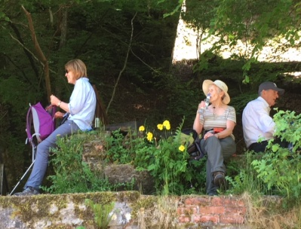
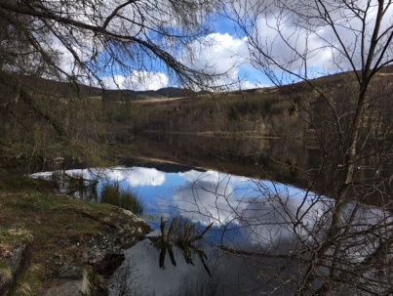
Your Press Correspondent
has continued to submit
regular walk reports to the
local papers, and has been
amazed that these have
been published without
editorial intervention,
including a very full report
on our holiday in Melrose.

In March we obtained good coverage of the launch of our new Walks Leaflets for St Andrews and Cupar in both the local press and St Andrews in Focus. These articles also provided an opportunity to promote the benefits of walking with our Group, although sadly this did not attract any new members. The Walks Leaflets have been well received in both areas and several outlets have already asked for more copies. Please contact any Committee member if you would like copies of these leaflets.
NB. Rohan in St Andrews, who took a supply of leaflets, offers 10% discount to Group members on production of your Ramblers membership card.

Our Webmaster Michael Hammond would also welcome your photographs and anything else of interest from Group walks. Remember, it’s your website!

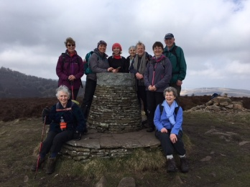
Area Organisation
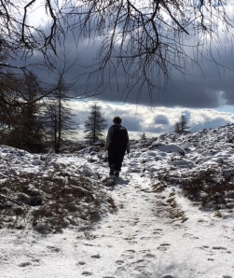
The Forth Valley, Fife and Tayside Area is our local Ramblers Area, for which most members will appreciate the combined Area Walks Programme which arrives through your letterbox every six months. Jim Forret continues in his role as the Area Secretary and Ian Bruce manages the Area Website (http://www.fvft-ramblers.org.uk/), which has a lot of useful information on Area Groups and walks, including Walks Map and Finder. Ian is also responsible for converting our Group walks into the Area Programme.

Scottish Council Meeting 2018
The Council oversees the activities of Ramblers Scotland and every year we send two representatives to the annual meeting, which includes dinner, guest speakers, overnight stay and the Council Meeting. Stewart and Linda Collier represented us in March this year in Aberdeen and reported back on an enjoyable and constructive weekend. The highlight was the Dick Balharry Memorial Talk given by Ben Dolphin, President of Ramblers, whose excellent talk included several photographs taken when he joined our Group walk led by Susan Richmond at Balcarres Estate in February this year. Fame indeed!

2018 Christmas Lunch
Our Christmas Lunch will be held on Saturday 1st December at Elmwood Golf Club, Stratheden, near Cupar. As always we look forward to enjoying the company of longstanding friends and supporters of our Group who no longer walk with us, as well as those who come along regularly during the year. Further details of the lunch arrangements are provided in the Area Walks Programme.
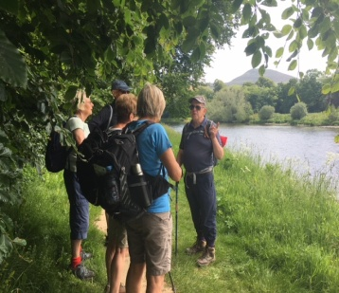
This is my first newsletter, deputising for Will Aitken, our Secretary & Walks Coordinator. I hope you find it interesting and would welcome any feedback on how it could be improved.

Here’s to good winter walking!

Jane Houston, Press Correspondent

