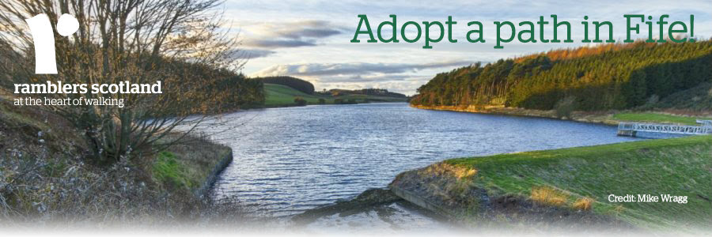
An exciting new 70-mile walking trail will open in Fife next year – and we’d love your help to keep it in check!
Fife Pilgrim Way will link Culross with St Andrews, following a route taken by pilgrims searching for miracles, forgiveness and adventure from the 11th to 16th Century.
We’re proud to be working with Fife Council and Fife Coast and Countryside Trust, who are applying the finishing touches to the way-marked path, ahead of its official opening in 2018.
They’d like Ramblers Scotland members to ‘adopt’ the Way, by auditing sections of the trail twice a year.
Volunteers would simply need to report any issues on their adopted sections, so Fife Council can decide if action is needed.

Volunteer to get involved ►

It’s a great opportunity for Ramblers to support the long-term success of a fantastic project.
You’d also be supporting our new Out There campaign, which aims to break down barriers to the outdoors, by getting more paths on the ground and on maps in Scotland.
Please register your interest before 31 January.
Together we can make Fife Pilgrim Way an even more wonderful asset to the Kingdom – and help many more people get out there in Scotland
Thanks
Jeannie Cranfield
Delivery officer
Ramblers Scotland

