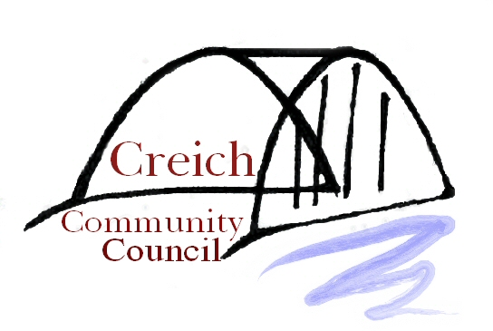
CREICH COMMUNITY COUNCIL

The next meeting of the Community Council
will be held on Tuesday 15th August 2023
in Rosehall Village Hall
at 7.30pm

Agenda

- Welcome/apologies
- Highland Broadband representative/s
- Minutes of June meeting/matters arising, if not on agenda
- Regular updates:
- Chair’s report – Keith Williams
- KOSDT - David Watson
- Resilience Plan update (if appropriate)
- Planning & Licensing)
(iii) TEC Services –
(iv) Financial report – Donna Gilchrist
(v) Rosehall – John White
(vi) Invershin/Bonar Bridge – Keith Williams
(vii) HC Councillor’s report – Cllr Baird
- Windfarm updates
- Correspondence
- Any other competent business
- Date, time and place of next meeting – (tbc)17th October 7.30pm in Bonar Bridge Hall
- Private session: Beinn Tharsuinn/Rock by Sea Fund applications (if appropriate)

Other relevant matters may be added/ agenda amended on the night.

Members of the public are welcome to attend

