

**Friends Donation Form**

Please complete in BLOCK CAPITALS

|  |  |  |  |
| --- | --- | --- | --- |
| **Your Information:** | | | |
| **Name:** |  | | |
| **Address:** |  | | |
|  | | Postcode: |  |
| **Email:** |  | Tel No: |  |

|  |
| --- |
| **Your Donation:** |
|  | |

I would like to become a **Friend of Culbokie Community Trust** and make a regular donation to support the ongoing work of the Trust

Please select one of the options below

|  |  |  |  |  |
| --- | --- | --- | --- | --- |
|  | I would like to make a **monthly** donation of £5 £10 £ other –tick or insert | | |  |
|  |  | | |  |
| **OR** |  | | |  |
|  | I would like to make an **annual** donation of £5 £10 £25 £50 £ other – tick or insert | | |  |
|  | | | |  |
|  |
|  | Please arrange a Standing Order with your bank, either directly on-line using the details below or by forwarding this form to your bank. **Please use the reference CCT Friend plus your surname.** | | |  |
|  | | | | |
| Bank of Scotland | | Sort Code: **80-22-60** | Account No: **12764768** | |
| The sum of £…. | | Starting on (date) | To be paid Monthly / Annually (delete one) | |
| Sort Code: | | Account Number: | Account Holder: | |
| Signed | | Name: | Print Name: | |

Thank you very much for becoming a Friend of CCT; your support is invaluable

Please see overleaf for how to increase the value of your donation

**In addition to setting up your Standing Order, please send a copy of this completed form, including the Gift Aid element overleaf if appropriate, to alison.petch2@gmail.com**

|  |
| --- |
| **Gift Aid – Making the most of your donation:** |

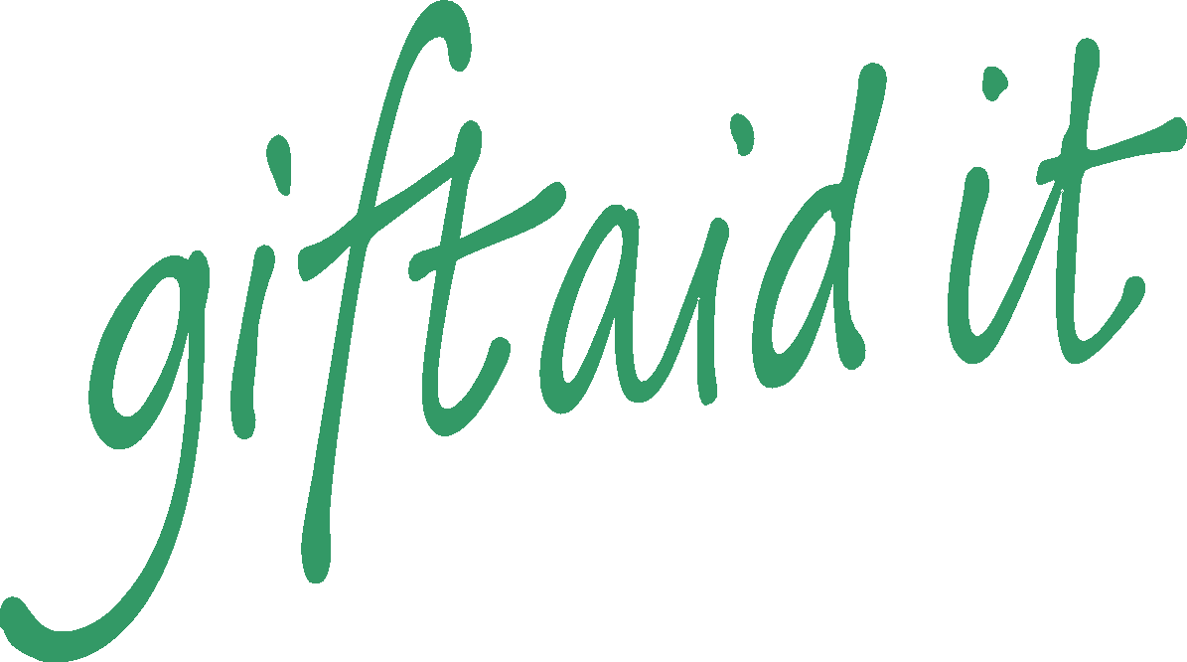

Gift Aid is a UK Government tax scheme. As an exempt charity The Culbokie Community Trust Ltd can reclaim basic rate tax on qualifying donations from UK tax payers.

If you are a UK taxpayer and eligible to Gift Aid your donation, please complete the form below and return to alison.petch2@gmail.com. This will increase your gift by £0.25 for every £1.00 given (at current rate), at no extra cost to you. Thank you.

I would like Culbokie Community Trust Ltd to treat all qualifying donations as Gift Aid donations.

Please treat as Gift Aid donations all qualifying gifts of money made from the date of this declaration, and in the past four years. I am a UK taxpayer and understand that if I pay less Income Tax and/or Capital Gains Tax than the amount of Gift Aid claimed on all my donations in that tax year it is my responsibility to pay the difference.

**Signature:** …………………………………………………………………

**Date:** ………………...............

Please notify Culbokie Community Trust Ltd via alison.petch2@gmail.com if you:

- Want to cancel this declaration

- Change your name or home address, or

- No longer pay sufficient tax on your income and/or capital gains.

|  |  |  |  |
| --- | --- | --- | --- |
|  | I would like my gift amount to be anonymous |  | I would like my name to be anonymous |