Community News Update from Sleat Community Council 1st April

With the meeting of the SCC being held tonight in Ardvasar Hall at 7.30pm, to maximise the available discussion time this update will cover a range of current topics relevant to Sleat. If you need to know more on any item, please get in touch.

Local Place Plan

SCC/SCT submitted the final version of the Sleat Local Place to Highland Council on 6th March. Copies were also sent to Ward 10 Elected member, Community Support HC, and the chairs of our two local community councils. This will now be comprehensively assessed by the LPP team and if fully approved will be added to the Highland LPP register. Sincere thanks again to all who contributed to this community aspiration masterplan for the next decade.

Our colleagues at Mallaig Community Council have asked that we present on the community planning, consultation, preparation and publication to their members. They are intending to produce a plan for their area and asked for our help. The chair, Andy Williamson will be travelling to Mallaig in the next week or two.

Public Transport-CalMac

CalMac’s summer season began last Friday 28th March and until at least the 15th of June it will be operated by single vessel initially MV Loch Bhrusda (12 cars) to 12th April and then MV Loch Fyne (36 cars). Reservations are now open, but all customers are advised to book as far in advance as possible. It is hoped MV Coruisk will return from Mull after 15th June to join LF, but this is still to be confirmed.

Initial discussions at an early stage to form a new ferry committee representing the communities, businesses and organisation on each side of the Mallaig-Armadale service. If you would like to express an interest, please contact the SCC secretary.

Roads

As residents will know SCC wrote to the Head of Roads and Infrastructure at Highland Council on 23rd January expressing concerns about the deteriorating condition of many of Sleat’s roads. After following up last week we had a response indicating that HC roads officials will be in touch to clarify what is proposed for Sleat work in the new financial year commencing today.

We were pleased to see remedial works have been completed on the Kilmore township road last week after the group of residents wrote to Kate Forbes MSP. Thanks are due to those involved.

This is what has been tabled for Sleat.

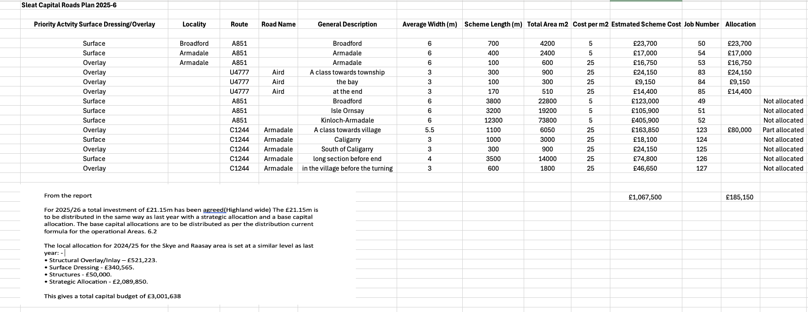

Residents should continue to report all road, pavement and lighting defects via the HC website here.

https://www.highland.gov.uk/report

Housing

From the Communities Housing Trust

Last chance! 2 bungalows still available

AND ONE SELF-BUILD PLOT-The last of three 1/4/2025

Due to changes in circumstance, we can now offer two (one under offer) 3 bedroom
family bungalows for sale at the new Kilbeg village
​**Apply Now - 1 property under offer**
​
- Two x 3 bedroom/6 person detached bungalow for discounted sale - £169,500*​
- Highly insulated and energy efficient spacious family home
- Open plan living design
- EPC: C and Council Tax band TBC
- Applications with local connections, or meeting island needs, will be prioritised

Read more here.

https://www.chtrust.co.uk/current-opportunities-295166.html

Planning

There were two planning applications in March as shown here.

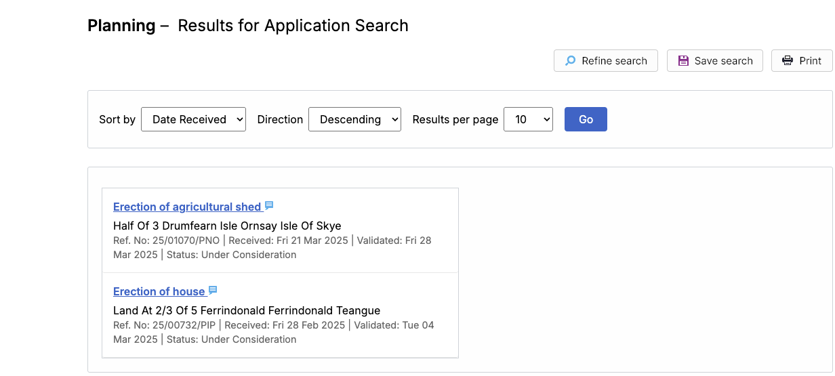

Residents are reminded that Highland Council offers a pre-application advice service from the planning team. If you are unsure if you need permission for any planning matter you can read more here. https://www.highland.gov.uk/info/205/planning_-_policies_advice_and_service_levels/785/pre-application_advice

Tourism

Highland Council are consulting on a Visitor Levy for the region. The consultation closed on 31st March with full information here. Or here https://bit.ly/4i1N4Wg SCC submitted a paper in March with the Council reviewing all comments and responses.

Please note:

This information is known to be correct at the time of publishing and summarises key topics which we hope will be of value to the community. If you have any item that you would like clarity on or discuss further, in the first instance please email

info@sleatcommunitycouncil.org.uk

Our next meeting will be at An Crùbh on Tuesday 7th May at 1930.

