Community News Update from Sleat Community Council 3rd December 204

With the meeting of the SCC being held tonight, to maximise the available discussion time this update will cover a range of current topics relevant to Sleat. If you need to know more on any item, please get in touch. We hope you can join us tonight at Ardvasar Hall

Local Place Plan

Tonight’s meeting is the second of two SCC meetings which will report on the findings of Sleat’s LPP consultation from recent weeks. Over 700 comments were received which have been analysed (all anonymously) and collated under 12 key themes.
These are:

• Community
• Business development
• Crofting, farming and fishing
• Environment
• Estates
• Gaelic
• Housing
• Planning
• Sport and leisure
• Tourism
• Transport
• Water and energy

Tonight’s meeting will present the draft Local Place Plan in the format that it will be made available to the Highland Council and Elected Members.

We will make the draft document available on the SCC website soon.

Skye and Raasay Committee 25th November

The quarterly Skye and Raasay Committee can be viewed on the Highland Council YouTube channel here. https://www.youtube.com/watch?v=iYhJQQwebmA&t=2945s Topics covered Police and Housing Reports, the Portree link road and parking income, enforcement revenue and local benefits.

Committee confirms Public Conveniences Action Plan

Members of the Highland Council’s Community and Place Committee have given their support to an action plan focusing on the operating of public conveniences over the next 10 years.

Whilst not a statutory function, the Council is the main provider of public conveniences located throughout Highland, operating 74 sites.
The Approach and Action Plan presented to the Committee today sets out a strategy for investment in public convenience should funding become available.

Read more here. https://www.highland.gov.uk/news/article/16368/committee_confirms_public_conveniences_action_plan

Public Transport

CalMac are now in the process of developing the summer 2025 timetable for the Mallaig-Armadale service. Generally, it is assumed that the service provision will match the same as the previous season, that is to be cost-neutral. We have provided some suggestions for minor changes, and it is hoped that the timetables and bookings will be available in mid-January.

CalMac have refreshed their website with separate sections for corporate, merchandise and careers. The service status page has a new look. www.calmac.co.uk

Roads

Following a road traffic accident involving a deer crossing the Sleat Road Highland Council’s roads team have agreed to erect deer warning signs at either end of the road at the woodland section from Loch na Dal to Duisdalemore.

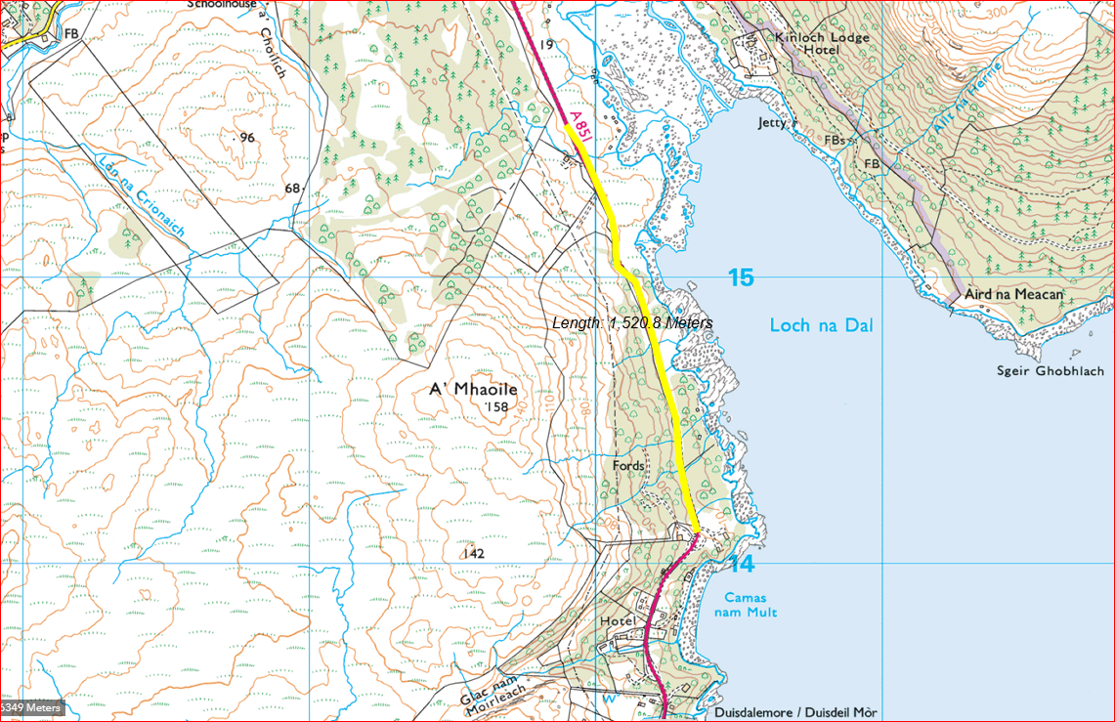



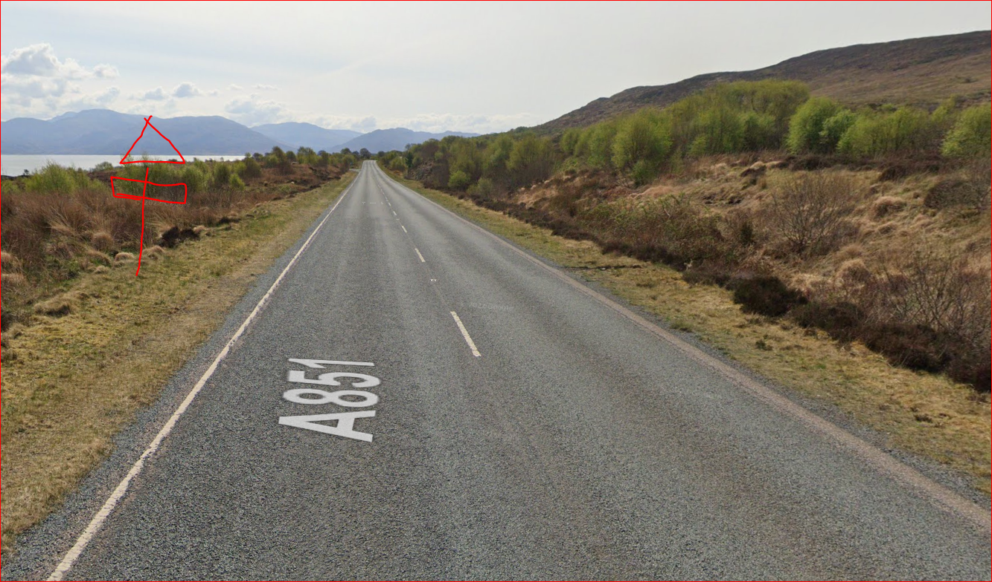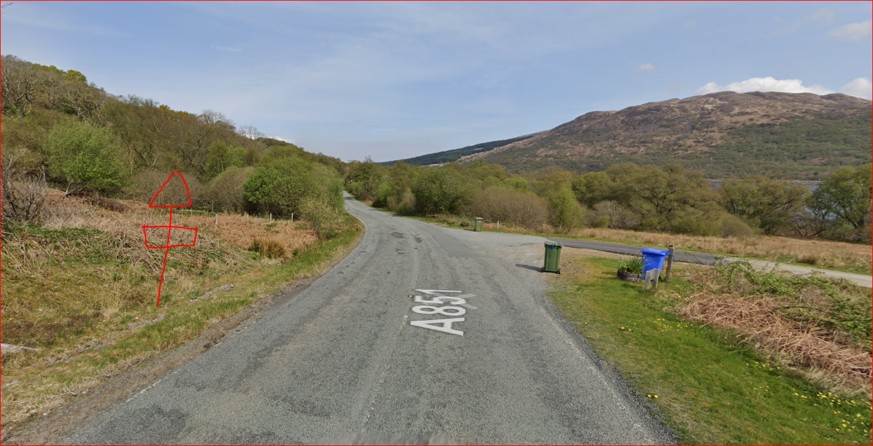

As part of this work Police Scotland provided road accident information in Sleat from Jan 1 to 19th November.

January 2024
1 not deer related

June 2024
1 not deer related

July 2024
1 not deer related

August 2024
1 not deer related
1 not deer related
1 not deer related

September 2024
1 not deer related
1 not deer related

October 2024
1 not deer related
1 deer related

There has been only 1 reported to us in October 2024 which stated a deer has been involved in the collision. Some officers haven’t attended the above calls as the call was for Police Information only so the information they pass to our control room can be limited they are merely making us aware their vehicle is in situ awaiting recovery.

There are no proposals for any major works on Sleat’s roads during the winter other that remedial work for potholes etc.

Given the condition of several township roads including stretches in Ardvasar, Teangue and Tarskavaig the community council will be writing to the Highland Council to ensure funding is made available for the 2025/6 FY.

Residents should continue to report all road, pavement and lighting defects via the HC website here.

https://www.highland.gov.uk/report

Housing

The Communities Housing Trust still has housing opportunities at Kilbeg.

Read more here https://www.chtrust.co.uk/current-opportunities-295166.html

Planning

There was just one planning application in November and that was for a self-catering cabin for in a private dwelling in Duisdale.

Please note:

This information is known to be correct at the time of publishing and summarises key topics which we hope will be of value to the community. If you have any item that you would like clarity on or discuss further, in the first instance please email

info@sleatcommunitycouncil.org.uk

Members at the community council wish you all a very Happy Christmas.

