Community News Update from Sleat Community Council 4th March

With the meeting of the SCC being held tonight in Tarskavaig Hall at 7pm, to maximise the available discussion time this update will cover a range of current topics relevant to Sleat. If you need to know more on any item, please get in touch.

Local Place Plan

At tonight’s meeting members of the community council intend to sign off the Local Place Plan and submit it on Wednesday 5th March to the Highland Council’s LPP team and officials of the Development Plans team. As was required under regulations in January we sent the LPP to Skye and Raasay’s four elected members and our neighbouring community councils of Broadford & Strath and Kyleakin & Kylerhea for feedback or comment. None were received.

You can read the final version of the LPP at this link. https://web-cdn.org/s/1219/file/Local-Place-Plan-2024/LocalPlacePlanForSleat.DRAFT_1.2.pdf

The LPP is your aspiration for the future. Thank you to the hundreds of people and organisations that have contributed to the Plan.

Members tonight will also update on the forthcoming ‘Highland Local Development Plan’.
https://www.highland.gov.uk/info/178/development_plans/1101/highland_local_development_plan

Public Transport-CalMac

It was announced last week by CalMac that there will be some significant changes to the early summer season timetable that commences 28th March. For Mallaig-Armadale this will mean a single vessel service with MV Loch Bhrusda (just 12 cars) until 13th April after which MV Loch Fyne will redeploy to Mallaig to continue a SINGLE vessel service until 15th May. It seems planned that Loch Fyne and Loch Bhrusda from 16th May will provide a two-vessel service until 16th June. MV Coruisk is required for service in Mull it is unlikely she will return until around 17th June. Revised timetables are being prepared, and some sailings cannot yet be booked. All customers are advised to book as far in advance as possible when bookings are open.

You can read CalMac’s Community Update here. https://web-cdn.org/s/1219/file/News-Items/Community-update-February-2025.pdf

It is likely that further changes to service provision will occur. Watch CalMac’s website for updates.

An Slèiteach

The next issue of An Slèiteach will be published online Wednesday. A small amount of paper copies will be available at Armadale Stores for wider distribution.
It will be 12 pages long, full of news from the Community Trust and Sleat Community Council. (It is planned for the next edition that paper copies will be available £1.00 (in addition to the online edition), the charge being for printing expenses. This is a trial run to enable those without internet to see the newsletter. Copies will be available at Armadale Stores and An Crùbh.) Subject to change.

CalMac Community Litter Pick 1st March

More than 20 people including many CalMac staff spent nearly three hours collecting marine litter and rubbish from around the shores of Armadale and Ardvasar on March 1st. The community is grateful that officials from Highland Council have arranged to collect the large pile.

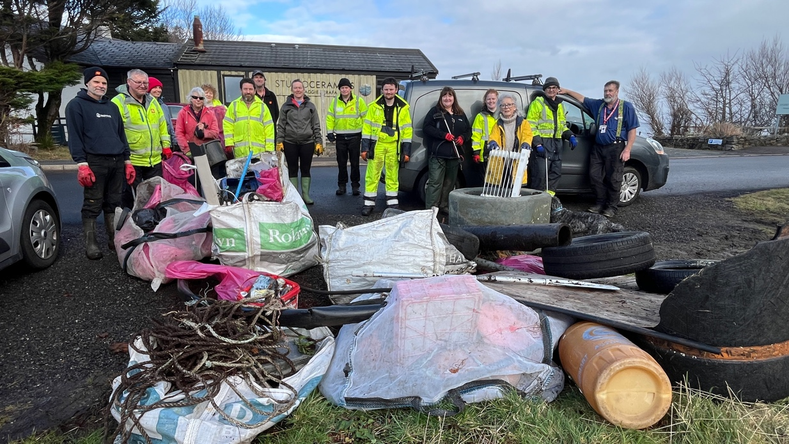

Roads

On 22nd January following the previous day’s SCC meeting the chair wrote to the Head of Roads and Infrastructure at Highland Council concerning the rapidly deteriorating state of the roads in Sleat. This asked of two items, an urgent inspection by officials of the roads including township roads and following that funding provision be made available for the forthcoming financial year 2025-26. A letter was also sent by Kilmore residents to Kate Forbes MSP regarding their township road. SCC received no reply to our letter yet in late February the Kilmore group received an email via the MSP’s office the following.

‘Subject: RE: VIP for Approval - (Case Ref: KF21873) - FS-Case-680989939

Dear Kate Forbes MSP

‘I refer to your email dated 22 January 2025 on behalf of your constituents regarding the condition of the road on Kilmore Hill on the Isle of Skye, IV44 8RG.

I can confirm the Council is aware of the potholes on Kilmore Hill, unfortunately due to the recent winter weather conditions the Roads Team have been unable to action any repairs to them. The Roads Team are hopeful that the hot box can be used soon, and the stretch of road has been added to the list for repairs to be carried out.’

Your sincerely
Tracey Urry
Head of Road & Infrastructure
Highland Council

As residents will know SCC asked the community to send in pictures and videos of roads and verges in their area. We had a fantastic response which resulted in significant media coverage from Radio Skye, the Press and Journal, Lochaber Times, WHFP and BBC Alba. We have had no further contact from Highland Council.

On 17th February at the Skye and Raasay Committee the Capital Roads Plan was approved by elected members. Just over £3m has been made available for Skye and Raasay. You can watch the discussion here on YouTube here.

https://www.youtube.com/watch?v=YTS2ttpIGxc&t=8850s

The item begins at 1hr 17m 50 secs

The roads plan report is found here.

https://www.highland.gov.uk/download/meetings/id/84603/item_6_-_area_roads_capital_programme_202526

This is what has been tabled for Sleat.

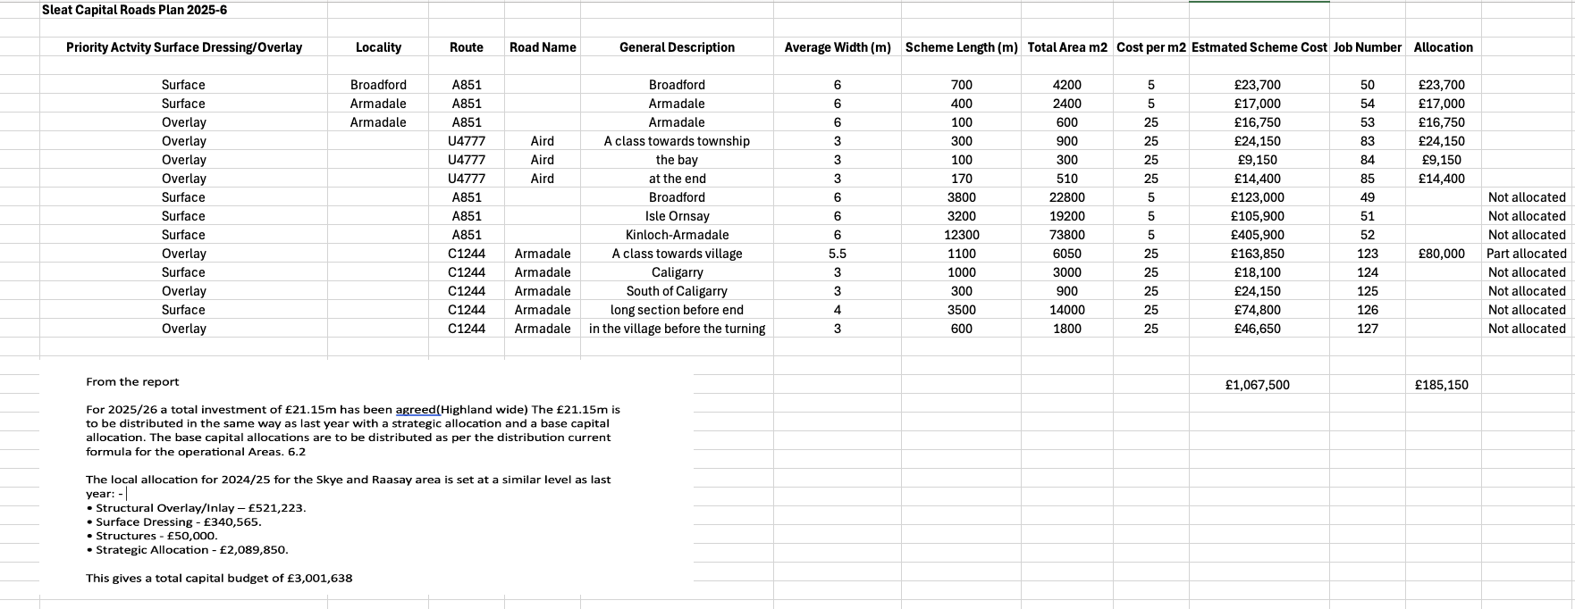

Residents should continue to report all road, pavement and lighting defects via the HC website here.

https://www.highland.gov.uk/report

Housing

From the Communities Housing Trust

Due to changes in circumstance, we can now offer two (one under offer) 3 bedroom
family bungalows for sale at the new Kilbeg village
​**Apply Now - 1 property under offer**
​
- Two x 3 bedroom/6 person detached bungalow for discounted sale - £169,500*​
- Highly insulated and energy efficient spacious family home
- Open plan living design
- EPC: C and Council Tax band TBC
- Applications with local connections, or meeting island needs, will be prioritised

Read more here.

https://www.chtrust.co.uk/current-opportunities-295166.html

Planning

There were four planning applications in February as shown here.

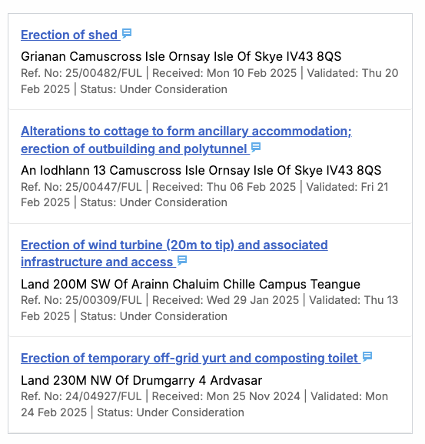

January Planning Applications

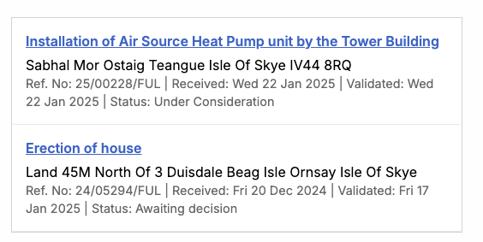

Residents are reminded that Highland Council offers a pre-application advice service from the planning team. If you are unsure if you need permission for any planning matter you can read more here. https://www.highland.gov.uk/info/205/planning_-_policies_advice_and_service_levels/785/pre-application_advice

Tourism

Highland Council are consulting on a Visitor Levy for the region. The consultation closes
on 31st March with full information here. Or here https://bit.ly/4i1N4Wg

Please note:

This information is known to be correct at the time of publishing and summarises key topics which we hope will be of value to the community. If you have any item that you would like clarity on or discuss further, in the first instance please email

info@sleatcommunitycouncil.org.uk

Our next meeting will be at Ardvasar Hall on Tuesday 1st April at 1930.

