Community News Update from Sleat Community Council 7th January 2025

NOW CANCELLED DUE TO WORSENING WEATHER CONDITIONS

With the meeting of the SCC being held tonight (weather permitting), to maximise the available discussion time this update will cover a range of current topics relevant to Sleat. If you need to know more on any item, please get in touch. We hope you can join us tonight at An Crùbh at 1900.

Local Place Plan

Tonight’s meeting will update on the final stages for the publication of Sleat’s Local Place Plan and will include mapping of comments made at two drop-in sessions on 12th December at An Crùbh and at the SCT offices. Large maps of Sleat were presented, and residents were asked to write their aspirations for future development, of all kinds, on the maps. You can see the list here: https://web-cdn.org/s/1219/file/Local-Place-Plan-2024/Additonal-Comments-mapping-sessions-on-12-Dec-2024.docx

You can read the latest version of the LPP at this link. https://web-cdn.org/s/1219/file/Local-Place-Plan-2024/LocalPlacePlanForSleat.DRAFT_1.1.pdf

The LPP is your aspiration for the future. Thank you to the hundreds of people and organisations that have contributed so far.

Public Transport

CalMac are now in the process of developing the summer 2025 timetable for the Mallaig-Armadale service. Generally, it is assumed that the service provision will match the same as the previous season, that is to be cost-neutral. We have provided some suggestions for minor changes, and it is hoped that the timetables and bookings will be available in mid-January.

MV Lochnevis remains in dry-dock due to engine issues and so a passenger only service is on the Mallaig route until 9th January inclusive. Pending sea trials, the vessel is expected to resume normal service on 10th January to the Small Isles and Armadale.

Another reminder if that there are no bus services to and from Sleat on Saturdays and Sundays during the winter. Just this week some visitors arrived on the passenger charter expecting to see a bus to Broadford.

Roads

There are no proposals for any major works on Sleat’s roads during the winter other that remedial work for potholes etc.

At tonight’s meeting SCC members have tabled an agenda item that will express concerns at the continuing deterioration of roads in Sleat including township roads and the A851. We have asked residents to see photos and comments of their areas so this can be included in a letter to council officials calling for Sleat to be included in the roads budget for 2025/6.

Residents should continue to report all road, pavement and lighting defects via the HC website here.

https://www.highland.gov.uk/report

Housing

The Communities Housing Trust still has housing opportunities at Kilbeg. If anyone is interested, please contact CHT.

We wrote this morning to confirm this and this the response from the Housing Manager.

Good morning, Robert
Thank you for your email.
All the properties at the new development at Kilbeg were allocated, however, two of the purchasers have decided not to go ahead, so we have two properties still available for discounted sale. As these are 3-bedroom properties, ideally we would like to sell these homes to families. However, if there is anyone who is interested, they should submit an application form to us and we will consider each application on their individual circumstances.
https://www.chtrust.co.uk/current-opportunities-295166.html
Kind regards
Helen

Helen Mackie
Housing Manager

Planning

There were three planning applications in December as shown here.

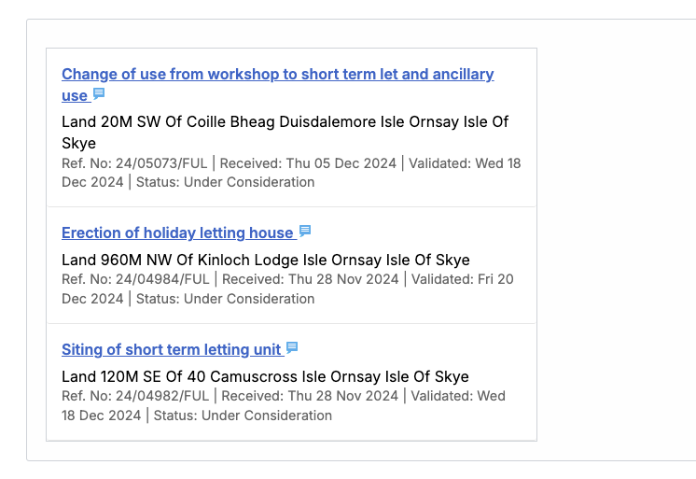

We have reported recently that two planning applications for private housing have been submitted for a three-house site at the former Kinloch pitch area. One property is already under construction and the second application is shown as the second item in the panel above.

A Planning Enforcement Notice for a domestic property in Sleat has now passed the deadline for the removal of three unauthorised shipping containers placed without planning permission. No appeal to Scottish Ministers was made against this enforcement by the required date This is now an offence and currently Highland Council enforcement officials are reviewing the case and the action they will take to remove the units which are deemed to impact neighbouring properties amenity.

Residents are reminded that Highland Council offers a pre-application advice service from the planning team. If you are unsure if you need permission for any planning matter you can read more here. https://www.highland.gov.uk/info/205/planning_-_policies_advice_and_service_levels/785/pre-application_advice

As far as we are aware there has been no further communication on the ongoing surveys for renewable energy projects on land in Sleat owned by Clan Donald Lands Trust.

Sleat Nature Group

Marine Litter Survey - call to arms!

Sleat Nature Group are conducting our next quarterly Marine Litter Survey of Ostaig Beach on Saturday 11 Jan*. .. come and help identify the litter that is drowning our beaches!
Ideally, we need around 8-10 people for the survey, and it is expected to take approx 2-3 hours (just come for as long as you can).
Meet on the beach at 10.00 am.
Wear appropriate clothing & footwear and bring gloves.

(*in the event of very bad weather, this will be Sunday 12th. Expect updates on Friday evening if so.)

The survey is part of Loughborough University’s 50 Years of Litter on Skye project, and our qualitative and quantitive results will feed data into that project and to the Marine Conservation Society/SIF surveys.

The survey will be followed by a community beach clean of the rest of Ostaig beach, from 1-3pm — all welcome.

Tourism

Visitor Levy Scheme Consultation Webinar – Tuesday 14 January, 7-8:30pm
Community Council Representatives and members of the public are invited to a webinar on Tuesday 14 January from 7-8:30pm which will outline Highland Council’s proposed Visitor Levy Scheme, currently undergoing public consultation until 31st March 2025 www.highland.gov.uk/vlconsultation
The webinar is open to all interested parties and to register a place, please click here
Further info can be found at www.highland.gov.uk/visitorlevyconsultation
Please send any enquiries to visitorlevyconsultation@highland.gov.uk

If you own or operate a tourism business SCC encourages you to put a link on your website or social media pages to www.skye.scot This is a visitor information portal, ad free, and designed to give key tourist information on Skye and Raasay, including driving on our roads, emergency information and transport. The website is a collaboration by several Skye community councils including Sleat.

Please note:

This information is known to be correct at the time of publishing and summarises key topics which we hope will be of value to the community. If you have any item that you would like clarity on or discuss further, in the first instance please email

info@sleatcommunitycouncil.org.uk

Members at the community council wish you all a very Happy New Year

