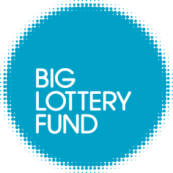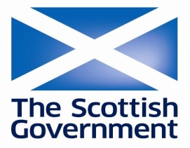

Communities and Families Fund

Up to £10,000 available for groups working in your community...

If you need funding to help give families and children the best start in life then it’s easier than you think!

What is it?
The Communities and Families Fund is a grants programme funded jointly by the Scottish Government and the Big Lottery Fund in Scotland. The fund will support local projects that help families and communities give children the best start in life.

Organisations can apply for a grant of between £250 and £10,000 for a 12 month project that will meet at least one of the following outcomes:

- Improve the quality of life of children (pre-birth to 8) through greater access to early learning, play and child and maternal health support

- Enable communities to shape and deliver support for families

What types of projects can be funded?
We are concentrating funding on projects that benefit children, or parents and families of children, who are 8 years and under. Examples of the types of local projects that we want to fund include:

- Parenting support and development projects

- Community play projects

- Projects that support better nutrition for young children

- Community-based family support and childcare projects
Who can apply?
You can apply for funding if you are a voluntary and community organisation, a statutory body or a community council.

Projects we’ve helped fund
Urban Roots
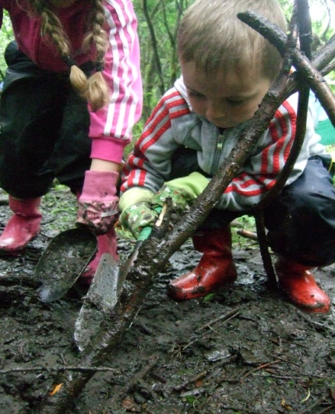
A community led environmental project on the Southside of Glasgow will shortly be promoting the great outdoors by launching a programme of wild activities on a local patch of recently reclaimed woodland. The programme of events will ensure whole families are involved, with core activities aimed at parents and children age 5 – 8. These activities will highlight the benefits of active outdoor play and include; picnics, performances, a fathers group and family fun.

Having successfully applied for a grant from the Communities and Families Fund, Urban Roots, received £9,950 in funding and were able to pay for the equipment /materials, refreshments and sessional staff needed to run the programme.

6VT Youth Cafe

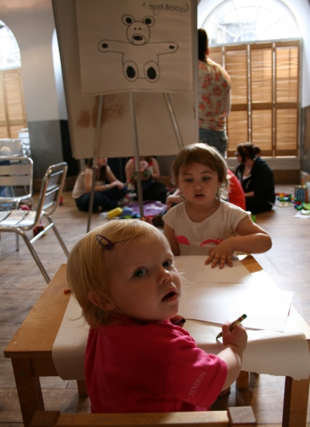
A young parent's class based in Edinburgh’s 6VT Youth Cafe recently received a £9,940 grant. This class for under 24's teaches basic parenting skills and promotes active play. As well as encouraging bonding and parent/child interaction, the classes will see children cared for within an onsite crèche, while parents learn un-distracted from a series of talks and workshops led by health workers and professionals.

Costs covered by the Communities and Families Fund grant included refreshments, room hire, publicity, sessional workers and equipment. It is hoped this class will create new social networks/friendships for young parents and help minimise isolation. In turn it should also raise awareness of common parenting problems and provide simple solutions.

If you’re interested in applying and with decisions in just 6 weeks, please visit:

www.biglotteryfund.org.uk/communitiesandfamilies

or call us on 0300 123 7110

