COMHAIRLE CHOIMHEARSNACHD SHLEITE
SLEAT COMMUNITY COUNCIL
Minutes of Annual General Meeting of Sleat Community Council held at Ardvasar Hall 22nd^{t} June 2023
Present:
Rob Ware
Tim Shone
Kate Duffus
Gordon Matheson
Dr Andy Williamson

In Attendance:
Duncan MacInnes, Veronica Barrington, Janette Maclure, Ludwig Appeltans (part)
Apologies: Paddy Mackay, Flora MacLean
The chair, Tim Shone welcomed those present to the meeting and introduced the five members of the Sleat Community Council. Flora MacLean was unable to attend. There were no declarations of interest by members.

The minutes of the previous AGM held on 21st June 2022 were approved. Tim said that he did not propose to go through the minutes, given that several items in this year’s Chair’s report were follow ups from the previous year.

Sleat Community Council
Chairman’s Report 22nd June 2023

Introduction
This report covers the period from 21st June 2022 to 22nd June 2023. This period includes one of the most difficult and stressful times in the recent history of this Community Council.
The Councillor mentioned in the last Chairman’s report continued his attacks on myself and the secretary, each attack seemingly more vehement, nasty and libellous. This came to a head in December 2022 when he had not attended a meeting for six consecutive months, without any acceptable reasons for his non-attendance. This was, and is, in contravention of the Highland Council Scheme of Establishment, which states that in this situation the Councillor WILL be removed from the Community Council. He was then informed that he had been removed from Sleat Community Council for not attending any meetings for six consecutive months, without acceptable reasons. Soon afterwards he was then given the opportunity to explain his absences to the Community Council during the January 2023 meeting at the Teangue Free Church Hall.
Immediately before this January meeting the councillor filmed a video outside the church despite being informed beforehand that this was not allowed by the Minister. He immediately posted the video online, but removed it once confronted by the Minster. Once inside the Church Hall he had his chance to outline why he had not attended the meetings. He took several minutes to explain his non-attendance and after due consideration his reasons were deemed not acceptable by a unanimous vote of the four full members, and his removal from the Community Council was confirmed. Shortly afterwards he left the meeting and has not attended any meetings since then. The unpleasant rhetoric towards myself and the secretary has ceased, at least for now.
Despite the above unfortunate issue, the Community Council has operated normally, and since December, harmoniously. We have been joined by three co-opted members Gordon Matheson, Dr Andy Williamson and Kate Duffus; we welcome them and their expert input. Unfortunately, we have lost one member, Veana Cleland who, with her husband, has left the area to be closer to family. Our thanks go to Veana for her years of service to the community as a Community Councillor. As a result of these additions and losses we now number six Councillors, which gives us some breathing space.

Purpose
This short explanation is usually inserted as a reminder to us all why we are here. The purpose of a Community Council is to act as a voice for the local area and its residents. This involves collecting the views of local people on a wide range of issues and making representations to the Highland Council and other organisations as necessary.

Issue
In addition to the problems with the former councillor there has been another issue raised by a member of the public. He arrived at my home unannounced and was a complete stranger to me. His main gripe was about our secretary and accused him as not being suitable. This was followed by a letter and another surprise visit, again his main issue was with the secretary. After trying to appease him after the first visit, the letter and second visit produced a mail from me to him pointing out that our secretary was not only suitable but highly accomplished and an excellent and respected member of the Community Council. Nothing has been heard from him since.

Membership
As mentioned above we now have six members, Chair, Secretary, Treasurer, plus three Co-opted members. No change to this is anticipated before all the Highland Region Community Councils are dissolved in October. Then anyone wishing to be considered as a Community Councillor must fill in a form and send to the Council. Sleat Community Council area can have a maximum of eight members, and a minimum of four. Should more than eight apply there will be a ballot arranged by the Highland Council. If there are between eight and four applications them everyone will be chosen without a ballot. If there are less than four applicants, then there will be no Community Council. The Community Council Election Timetable is attached to this report.

Meetings
The meetings in this period have progressed normally. The meeting in Tarskavaig Hall in November had only three Community Councillors present and was therefore not quorate, however the meeting continued for the benefit of the attendees, and as Gordon Matheson, Free Church Minister, and Ruraidh Stewart, Highland Councillor were both present.
Some meetings are now held in Teangue Free Church, and many thanks for this go to Gordon Matheson the resident Free Church Minister, and now a co-opted member of the Community Council. It is a beautiful room and always warm and welcoming.

Housing
The new builds at the old allotment site are now almost complete and are looking great. It is expected the development will be ready for occupation from late July. The Lochalsh and Skye Housing is inviting people to apply to the Highland Housing Register if they need accommodation. You can find more information here at this link.
https://www.highland.gov.uk/info/925/council_housing/244/apply_for_a_house/6
The new developments at the Iain Noble building are progressing well. Work could be completed in early 2024 and again contact for this site is here.
https://www.chtrust.co.uk/

Roads
The general condition of the roads on Skye is very poor. The north end roads are significantly worse than the roads in south Skye and much work has been done there. However, our roads are also in need of attention with Ardvasar village, Kinloch Farm straight, and Armadale Pier approaches all needing attention along with many, or most of the side roads. There has been repairs to potholes in many areas, but these are only temporary, and large expenditure is required before permanent improvements can be undertaken.
Surface dressing has been applied on the A851 on the black lochs area, the approach to the A87 junction and in Duisdale. Loose chippings are still present, and we encourage that everyone should drive slowly in these areas and adhere to the 20mph limit until signs are removed.
Ferries
The MV Coruisk was delayed for six weeks arriving for the Mallaig to Armadale route due to annual maintenance overruns, and vessel breakdowns elsewhere causing the Coruisk to be working on the Oban to Mull service until mid-May. The MV Loch Fyne has been running normally since the summer timetable started. Phase 1 of the Armadale Car Park works are complete with the relocation of the bus shelter, two EV charger points and two motorhome bays are planned for September.
CalMac continue to suffer from lack of vessels, and an ageing fleet causing frequent breakdowns and extended shipyard visits. The two vessels building at Ferguson’s yard on the Clyde are still not finished and are six years late and counting. The first one, Glen Sannox, is now due for completion late this year so will not be working until early next year. The costs to the taxpayer of these two vessels are spiralling to well over £300m, on a design and build contract of £97m.
CalMac also have four new vessels building in Turkey, which are presently on time and on budget. They also have chartered the MV Alfred from Pentland Ferries for nine months at a taxpayer cost of £1m per month. This vessel is currently working on the Ardrossan to Arran service.

Other local Organisations
The Community Council is represented on the Sleat Community Trust by Flora MacLean who reports back to the Community Council during our meetings. The Trust is very active and forward thinking and runs the very successful and popular local shop and the Tormore Forest enterprise.
The Deer Control Group is represented by me, but it has not had any meetings now for some time and will be discontinued in the near future. The Secretary has resigned, and the Chairman has left the area, just leaving a dormant bank account.
The two large landowners and employers in the area are the CDLT and FEI. The Distillery is also a good employer, as are Sonas Hotels and An Crubh. All of these are presently very busy as the summer season progresses.
An Crubh have recently opened a new motorhome service area which has been badly needed, and it is rare to pass without seeing a few vans using the facility.
FEI operate their Estate and other business out of Isle Ornsay, but also own Ardvasar Hotel having purchased it from Richard Jeffrey in 2017. They have now put this hotel up for sale and we eagerly await the new owners.
MacGillivray Motors next to the shop have now expanded their car hire business which complements the garage and MOT services they offer. As always, they are very busy.

Local Losses
The community has lost several local people. John MacKinnon died in August 2022, and his Uncle Donnie passed away soon afterwards. Well known Peter MacDonald died from natural causes, followed a little later by his wife Julie, Roger Bidwell of Point of Sleat and lately Ardvasar. Alistair MacDonald from Tarskavaig. More recently John Robertson, whose family live in Ferrindonald, very sadly died following a road accident in Glasgow, James Milne (James Taxi) passed away in Aberdeen, and John Duncan MacInnes’s mother Meg recently died in Lochcarron at the amazing age of 98. The community council offers its thoughts and prayers to the families of those we have lost this last year and hope they can find strength in the coming months and years.

Thanks
As always, I must thank all (except one of course!) of the other councillors for their assistance and support through what was at times a gruelling experience which will not be repeated. Special thanks from me, and the community, for the tireless work our secretary Rob Ware, does for the whole area. He spends many hours per week on our behalf without expecting or receiving any thanks. We would be much worse off, and ill informed, without his efforts. Flora MacLean as Treasurer does much more than counting the sparse cash we receive and gives constant support and sound advice. Our new co-opted councillors have already more than proved their worth and represent a deep fount of knowledge and experience rarely encountered.
Of course, thanks must also go to the community we are pleased to serve. Your support through the difficult times was more welcome than you know, and key to the correct outcome. We hope you continue to support us by attending when convenient and supporting from a distance when not.

Next Community Council
Please seriously consider applying for a position on the next Community Council. I feel it is important to get many applicants so that a ballot ensues and any person/s deemed unsuitable by the Community will be voted out. Even if elected you do not HAVE to accept the position as a Community Councillor, and only a maximum of eight can become Councillors. All the councillors would be happy to speak to any individual who may be considering becoming a councillor. The requirement is simply that you have to be a resident in Sleat and be on the electoral roll. In addition, details of the Scheme of Establishment and everything you might need to know is on our website at this link.
https://www.sleatcommunitycouncil.org.uk/governance
Tim Shone
22-06-2023
_________________________________________________________________________
Supplementary Information
Midway during the delivery of the Chair’s report, former Community Councillor Ludwig Appeltans arrived unannounced in the hall and sat in a chair behind those attending. As happened during his tenure as a community councillor Mr Appeltans appeared to be wearing recording and video apparatus. Councillor Williamson said that he was content for Mr Appeltans to attend the meeting, but asked him to put the equipment in his pocket, who declined. At this point Mr Appeltans left the hall and seemingly went into the adjacent car park. He was then seen affixing A4 typed correspondence on several vehicles owned by those present at the meeting. These were removed and recovered for the purpose of the record of this meeting. Mr Appeltans did not return.
For public information Ludwig Appeltans ceased to be a member of Sleat Community Council with effect from 11th January 2023.
_________________________________________________________________________
There was a short discussion after the chair’s report about the process of the forthcoming election processes for the new community council that we hope will be formed in January 2024.

Treasurer’s Report
Rob Ware presented the 2022/3 Treasurer’s Report which has been passed to the Highland Council and now approved. This process enables SCC to receive its annual grant.
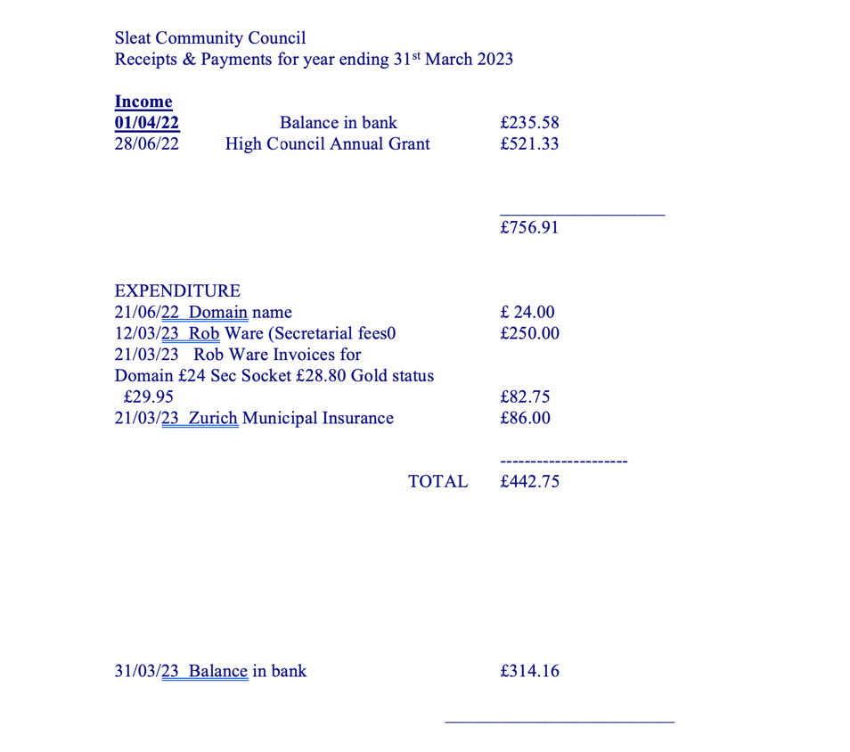
Rob added that Flora MacLean has asked if the SCC could donate to the Sleat and Strath Football Club, juniors, who are travelling to Spain in October for a tournament. There are Sleat children participating in the event. It was agreed between members that we ask Flora to facilitate the donation of £150 and see if the Sleat children might come to a meeting later in the year to tell us of their experience on the tour. Andy Williamson said that he was pleased to nootee that the team has already done a lot of fund-raising themselves.

Election of Office Bearers
Although this is the last year of the term of the current community council it is a requirement that office bearer’s election process is maintained.
- Tim Shone was proposed as Chair by Kate Duffus and seconded by Gordon Matheson
- Andy Williamson proposed Rob Ware as Secretary and Kate Duffus seconded.
- Andy Williamson proposed Flora Maclean as Treasurer and noted that she has served on this community council since 1986, and Gordon Matheson seconded that proposal.

Date of next AGM
The provisional date for the 2024 AGM will be decided by the incoming community council in January 2024. There are normally 9 meetings per year plus the AGM normally held in the last week of June prior to the summer recess. The regular meetings are held across different venue across Sleat including Ardvasar Hall, Tarskavaig Hall, An Crubh and the Sleat Free Church. Where possible all meetings are now being held in person.
AOCB
It was agreed that the intervention from earlier will be noted as a matter of tonight’s record.
Duncan MacInnes expressed his sincere thanks to the community council for their hard work and in particular ensuring residents, businesses and organisations are kept informed of a multitude of news and topics through the SCC’s channels. He added that it would a great shame if a new council could not be established in the autumn with a new term of office beginning in January of next year.
Public Discussion
This will be included in the Ordinary Meeting to follow.
The AGM was formally closed at 2030.

The Ordinary Meeting commenced at 2032
Tim Shone advised that the welcome, declarations of interests and apologies were covered in the AGM.
Record of Meeting
As the AGM had just finished it was decided that the ordinary meeting would consist of a public discussion. The minutes for the meeting held on 2nd May are to be found on the Agendas and Minutes page of the SCC website.
Rob outlined again the process for establishing a community council and will provide a summary for the next edition of the Sleat Community Trust newsletter.
Rob highlighted that at the May meeting the controversial topic of Highly Protected Marine Areas that had been the subject of a Scottish Government consultation that closed in April. This has been almost universally condemned by Scotland’s coastal areas as being unworkable. Gordon outlined his own thoughts that this would be a long process and at some point, SCC will take a view. He believed that at this time there was not enough information to form an opinion to publish in any form.
Rob spoke of the major issues going forward in Sleat with the new Highland Wide Development Plan effective from 2026 and more locally the Local Place Plan. Sleat Community Trust is looking to take a lead. Gordon gave a Trust view and how funding could be sourced for resources cost, e.g., project management manpower. This will be a strategic review of what happens through a ‘Sleat, the next 10 years’, as loosely termed. He updated on the Carloway community as a good example of what the community might want their Trust to do going forward. A funding application is sought but the timeframe is very tight for the LPP initiative. The prospect of new children’s play area is one item that could be included in a LPP, this could be in partnership with one or both local estates in Sleat. SCC would assist wherever we can, but the community council has no funds. Andy Williamson said that it is disappointing that the children’s play area at Armadale Castle and Gardens is closed for five months of the year and that the locals entrance fees are now prohibitive. There has been no response to this point from Clan Donald Lands Trust. There was a further view that how a public charity can be so bunkered in the community, one other described the approach as ‘a scandal’.
Andy added that the gardeners at CDLT are now collaborating with the school on improving the school gardens.
Rob confirmed that a donation would be made to the football trip.
After Veana Cleland left the area last month and terminated her membership of SCC. Rob read out the words of a card from her.
DONM 12th September, venue to be confirmed.
The meeting closed at 2100.

