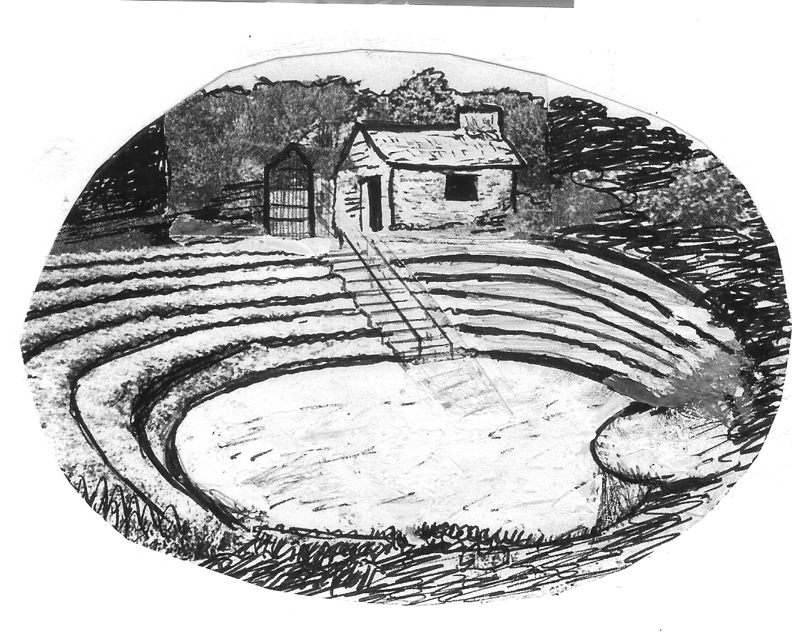
The St Newlyn East Pit
Registered Charity No. 1041357

Agreement for Hire of Pit for Formal Events

Introduction
St Newlyn East Preaching Pit is a heritage asset maintained for the community by St Newlyn East Parish Council and run on their behalf by the St Newlyn East Pit Management Committee.
The Pit was created from a former quarry by local preacher and quarryman, John Andrew, in 1852 as a memorial to the 39 miners who lost their lives in the 1846 flood at the East Wheal Rose Mine. The Pit is a Grade ii Listed structure and was restored by the committee in 2000, with a grant from the Heritage Lottery Fund and donations.

Facilities
The Pit consists of a terraced pit with a level base and a raised ‘pulpit’. It is mainly herb rich grass and as such is rather fragile and needs to be used with care. But it is an excellent open-air amphitheatre.
Stone steps lead to the base with a metal handrail. By the main entrance from Cargoll Road is the Tea Treat Hut which housed 2 boilers and a sink. The sink remains but there is no running water or power. There are 2 wooden trestle tables and a good supply of carpet pieces for sitting on and a dustpan and brush.
There is also no parking, toilet facilities, disabled facilities or first aid facilities

Conditions
The hirer agrees to:
- indemnify the Council against all public liabilities associated with their use of the Pit
- ensure that the Pit is left in a tidy condition after use
- control activities of visitors to the event to minimise damage to the Pit through excessive wear and tear, including alternative arrangements in case of adverse weather
- provide all necessary arrangements for the safe running of the event
- obtain all necessary licences and consents for the event (entertainment licence?)

Fees
We ask for a minimum donation of £25 for the use of the Pit for each event
Cheques to be made payable to: ‘St Newlyn East Pit Committee’
or by BACS:
Sort Code: 40-34-30 Acc No: 41184504 (Please state name in reference)
at least 2 days before the event date. Fees may be refundable if the event is cancelled due to adverse weather conditions

Other information
Address: Opposite Cargoll Vean, Cargoll Road TR8 5LB
OS Grid Ref.: SW 824 563
What3Words: ///hound.coverings.instance

Agreement
I agree to the terms of this agreement for the hire of St Newlyn East Pit on {Date} :
for the purpose of {Event}
On behalf of {Name of Organisation}
Name:

Signature:………………………………………………

Date: ………………………………………………………..

Forms to be returned to:
Colin Hawke
Chairman
2 Trenance Cottages
St Newlyn East
Newquay
TR8 5HU
07968 374254

